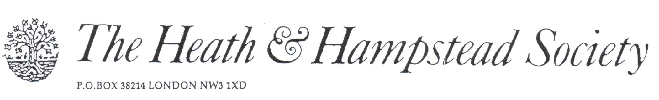
The Society examines all Planning Applications relating to Hampstead, and assesses them for their impact on conservation and on the local environment.

To London Borough of Camden, Development Control Team

Planning Ref: 2017/0739/P
Address: 12a Greenaway Gardens NW3
Description: Replacement dormer windows
Case Officer: Raymond Yeung Date: 16 March 2017

The replacement of original timber windows by p.v.c. substitutes is inappropriate in our Conservation Area, and we object to this application on that basis.

We note that a separate application 2017/1149/P for replacement windows elsewhere around the house indicates timber construction. We cannot understand why the same principle is thought acceptable here.

Please refuse

