- Listing
- Search the List
- List Entry
- Section Navigation
  - Map Search
  - Advanced Search
  - Minor Amendments
  - Download Listing Data
  - Non-Listed Sites
  - About The List
  - Enrich the List
  - Understanding List Entries

GARDEN WALL, RAILINGS AND GATES TO NUMBER 148

List Entry Summary
This building is listed under the Planning (Listed Buildings and Conservation Areas) Act 1990 as amended for its special architectural or historic interest.
Name: GARDEN WALL, RAILINGS AND GATES TO NUMBER 148
List entry Number: 1378817

Location
GARDEN WALL, RAILINGS AND GATES TO NUMBER 148, HAVERSTOCK HILL
The building may lie within the boundary of more than one authority.
County: Greater London Authority
District: Camden
District Type: London Borough
Parish:
National Park: Not applicable to this List entry.
Grade: II
Date first listed: 14-May-1974
Date of most recent amendment: Not applicable to this List entry.

Legacy System Information
The contents of this record have been generated from a legacy data system.
Legacy System: LBS
UID: 478173

Asset Groupings
This list entry does not comprise part of an Asset Grouping. Asset Groupings are not part of the official record but are added later for information.

List entry Description

Summary of Building
Legacy Record - This information may be included in the List Entry Details.

Reasons for Designation
Legacy Record - This information may be included in the List Entry Details.

History
Legacy Record - This information may be included in the List Entry Details.

Details
CAMDEN
TQ2784NE HAVERSTOCK HILL 798-1/52/788 Garden wall, railings and gates to 14/05/74 No.148
GV II
Garden wall, railings and gates. Early C19. Stuccoed low wall with cast-iron railings and stuccoed gateways to house entrance and garden; panelled doors, that to house entrance having cast-iron grille and lion mask knocker.
Listing NGR: TQ2755584925

Selected Sources
Legacy Record - This information may be included in the List Entry Details
National Grid Reference: TQ 27555 84925

Map
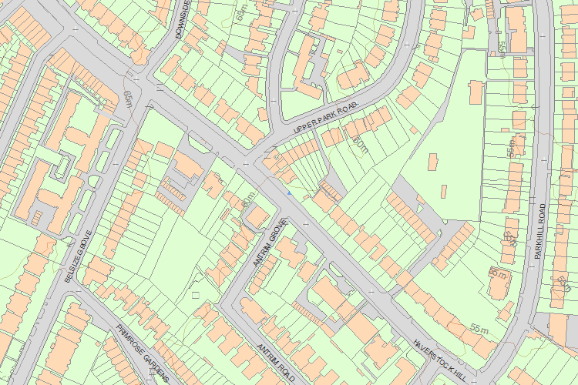© Crown Copyright and database right 2017. All rights reserved. Ordnance Survey Licence number 100024900.
© British Crown and SeaZone Solutions Limited 2017. All rights reserved. Licence number 102006.006.
Use of this data is subject to Terms and Conditions.
The above map is for quick reference purposes only and may not be to scale. For a copy of the full scale map, please see the attached PDF - 1378817 .pdf
The PDF will be generated from our live systems and may take a few minutes to download depending on how busy our servers are. We apologise for this delay.
This copy shows the entry on 16-Mar-2017 at 10:58:38.
End of official listing

