3 Willow Road, London NW3 1TH

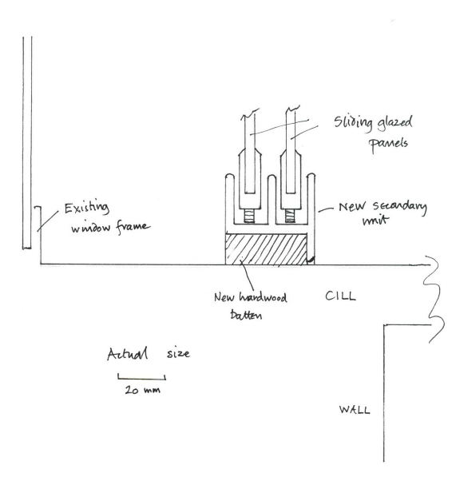Secondary double glazing drawing