103 CHETWYND ROAD NW5 1DA

PROPOSED SINGLE STOREY SIDE EXTENSION

PROPSED ALTERATIONS TO EXISTING REAR EXTENSION

PROPOSED NON STRUCUTRAL BICYCLE STORE

DESIGN AND ACCESS STATEMENT

FEBRUARY 2017

CONTENTS

1. EXISTING

2. INTRODUCTION

3. PROPOSALS - SHOP FRONT

4. PROPOSALS - COMINED CHANGE OF USE

5. ACCESSIBILITY

6. SUMMARY

1. EXISTING ELEVATIONS

103 Chetwynd Road is a semi detached residential dwelling house.

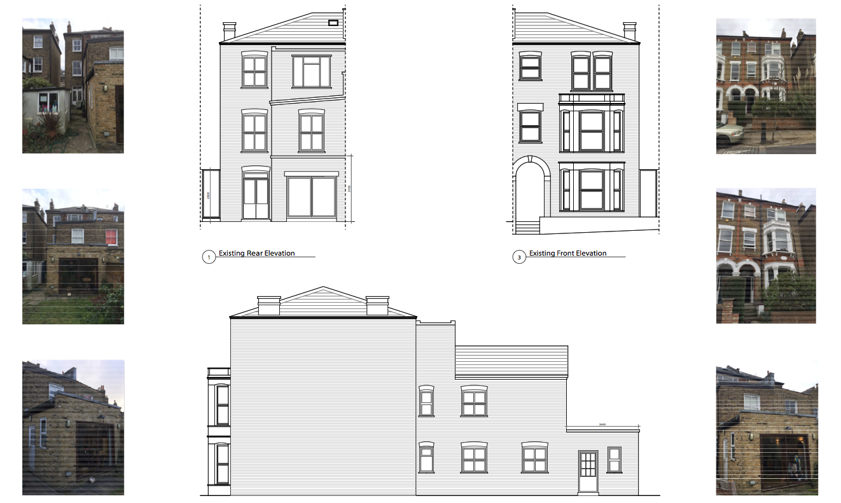

- PLANNING HISTORY
  - 2.1 There is a recently approved planning application relating to the to the adjacent property (No.101). Full details No: 2006/2030/P. Our proposal for the extension of No. 103 draws on the approved scheme received by N0. 101.
  - 2.2 There are other recent planning consents within the surrounding area for developments very similar to this proposal.
- PROPOSALS
  - 3.1 The proposal is shown on drawings PL-03 to PL-05 inclusive.
  - 3.2 The proposal consists of a single storey side extension and alterations to the existing rear wing of the property. The proposed side extension has been designed to be subservient to the existing property and is subsequently set back form the rear. The proposed materials are traditional and selected to work with the existing property vernacular and those of the neighbouring properties a like. The scale and arrangement of the proposed addition articulates new from old.
  - 3.3 Glazing to the existing rear and new proposed single storey side extension will bring natural light into the family living space, high quality architectural glazed units and frames will improve the buildings efficiency.
The proposal is for a rear contemporary Oriel bay window and integral skylight to be fitted to the existing rear elevation with proposed sliding patio doors to the side of this space to provide direct access to the garden.
The single storey proposed side extension is to be fitted
With a continuous roof light and with single full height doors, each to provide direct access to the garden and to the side access proposed bicycle storage. The proposal is also to include a high level horizontal Clerestory window to allow further natural light into the interior.
All the proposed architectural glazing is to be designed to match each other with similar details and profiles.

4. 3.4 The proposed non structural bicycle storage space to the side of the property is to be fitted with a corrugated plastic roof direct access by way of the existing side gate.
The existing side gate is to be retained and finished to match the adjoining property at N0.105 and the party wall is to built up with bricks similar to the existing to a height to match the existing gate.

3.5 Proposed Elevations

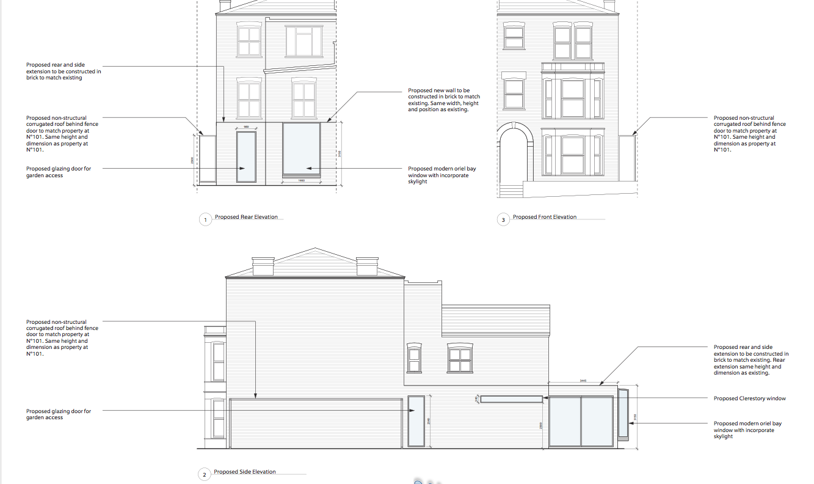

4.0 ACCESIBILITY
4.1 The proposal will create a kitchen / dining room / family area that serves the modern living style and gives more flexibility and possible adaptation for future occupants. Access is step free and level throughout the ground floor and rear garden.
Existing side access is to be retained with the addition of a proposed non structural bicycle storage area

5.0 SUMMARY
5.1 This modest extension improves this family home without compromising the main outside space. The scale and design of the proposed extension will not have an adverse affect on the adjoining property especially given the existing built development to No.101. The usable amenity of the property is maintained at its existing size, which is a benefit for the current and future occupants as well as the wider environment.

