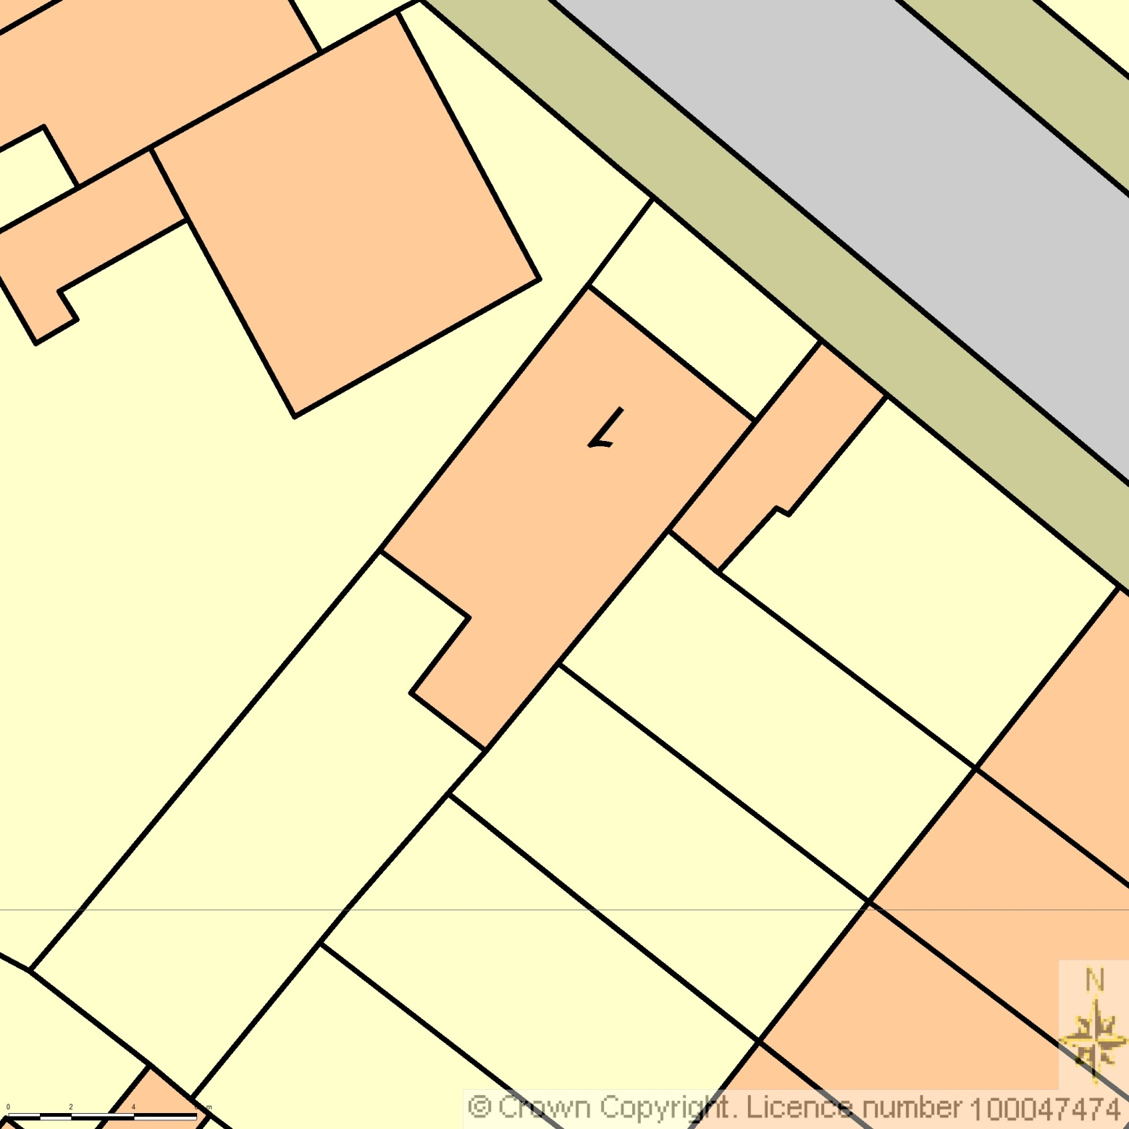BLOCK PLAN

AREA 36m x 36m

SCALE 1:200 on A4

CENTRE COORDINATES: 528858, 185511



Supplied by Streetwise Maps Ltd

www.streetwise.net

Licence No: 100047474

02/11/2016 19:35:36