NUMBERS 38 AND 40 AND ATTACHED AREA RAILINGS

List Entry Summary
This building is listed under the Planning (Listed Buildings and Conservation Areas) Act 1990 as amended for its special architectural or historic interest.
Name: NUMBERS 38 AND 40 AND ATTACHED AREA RAILINGS
List entry Number: 1244686

Location
NUMBERS 38 AND 40 AND ATTACHED AREA RAILINGS, 38 AND 40, ARLINGTON ROAD
The building may lie within the boundary of more than one authority.
County: Greater London Authority
District: Camden
District Type: London Borough
Parish:
National Park: Not applicable to this List entry.
Grade: II
Date first listed: 11-Jan-1999
Date of most recent amendment: Not applicable to this List entry.

Legacy System Information
The contents of this record have been generated from a legacy data system.
Legacy System: LBS
UID: 476623

Asset Groupings
This list entry does not comprise part of an Asset Grouping. Asset Groupings are not part of the official record but are added later for information.

List entry Description

Summary of Building
Legacy Record - This information may be included in the List Entry Details.

Reasons for Designation
Legacy Record - This information may be included in the List Entry Details.

History
Legacy Record - This information may be included in the List Entry Details.

Details
CAMDEN
TQ2983SW ARLINGTON ROAD 798-1/83/1855 (North East side) Nos.38 AND 40 and attached area railings
GV II
Pair of houses. c1840. No.38 red brick with rendered ground floor and parapet, slate roof and party wall stacks. 2 windows wide, 3 storeys and basements. Upper windows with glazing bars in moulded architrave surrounds, those to first floor with cast-iron balcony fronts. Panelled door in moulded architrave doorcase with rectangular top lights. No.40 rendered, with channelled ground floor and the upper floors scored to resemble ashlar. Slate roofs with party wall stacks. Moulded cornice to parapet. Sash windows with glazing bars. Panelled door set back under round-arched toplight. INTERIORS not inspected. SUBSIDIARY FEATURES: both houses have area railings with spear finials. Included as a well-preserved pair of houses.
Listing NGR: TQ2904283468

Selected Sources
Legacy Record - This information may be included in the List Entry Details
National Grid Reference: TQ 29042 83468

Map
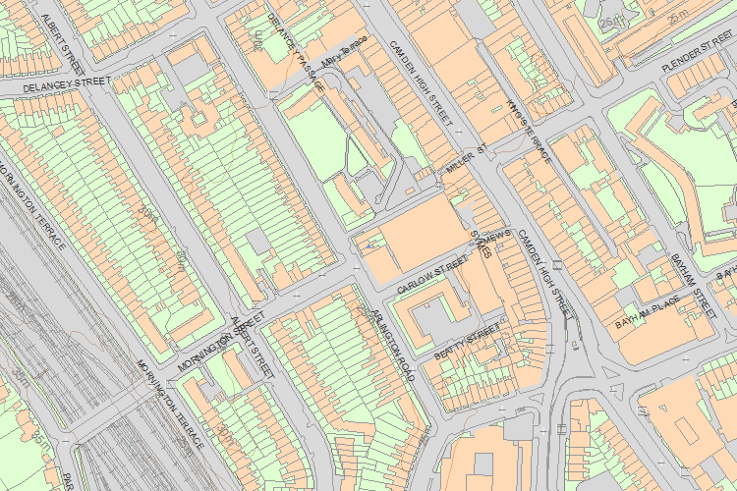© Crown Copyright and database right 2017. All rights reserved. Ordnance Survey Licence number 100024900.
© British Crown and SeaZone Solutions Limited 2017. All rights reserved. Licence number 102006.006.
Use of this data is subject to Terms and Conditions.
The above map is for quick reference purposes only and may not be to scale. For a copy of the full scale map, please see the attached PDF - 1244686 .pdf
The PDF will be generated from our live systems and may take a few minutes to download depending on how busy our servers are. We apologise for this delay.
This copy shows the entry on 17-Jan-2017 at 10:47:17.
End of official listing

