NUMBER 50 AND ATTACHED RAILINGS

List Entry Summary
This building is listed under the Planning (Listed Buildings and Conservation Areas) Act 1990 as amended for its special architectural or historic interest.
Name: NUMBER 50 AND ATTACHED RAILINGS
List entry Number: 1378808

Location
NUMBER 50 AND ATTACHED RAILINGS, 50, STANHOPE STREET
The building may lie within the boundary of more than one authority.
County: Greater London Authority
District: Camden
District Type: London Borough
Parish:
National Park: Not applicable to this List entry.
Grade: II
Date first listed: 14-May-1974
Date of most recent amendment: Not applicable to this List entry.

Legacy System Information
The contents of this record have been generated from a legacy data system.
Legacy System: LBS
UID: 478163

Asset Groupings
This list entry does not comprise part of an Asset Grouping. Asset Groupings are not part of the official record but are added later for information.

List entry Description

Summary of Building
Legacy Record - This information may be included in the List Entry Details.

Reasons for Designation
Legacy Record - This information may be included in the List Entry Details.

History
Legacy Record - This information may be included in the List Entry Details.

Details
CAMDEN
TQ2982SW STANHOPE STREET 798-1/93/1527 (East side) 14/05/74 No.50 and attached railings
GV II
Terraced house. c1804. Stucco with weatherboarded ground floor. 3 storeys and basement. 2 windows. Wooden former shopfront with pilasters carrying entablature with dentil cornice. Recessed doorway with blocked fanlight and panelled door with top panels glazed. Single sash to right. Upper floors with recessed sashes having vermiculated keystones. Parapet. INTERIOR: not inspected. SUBSIDIARY FEATURES: attached cast-iron railings with foliated finials to areas.
Listing NGR: TQ2907882489

Selected Sources
Legacy Record - This information may be included in the List Entry Details
National Grid Reference: TQ 29078 82489

Map
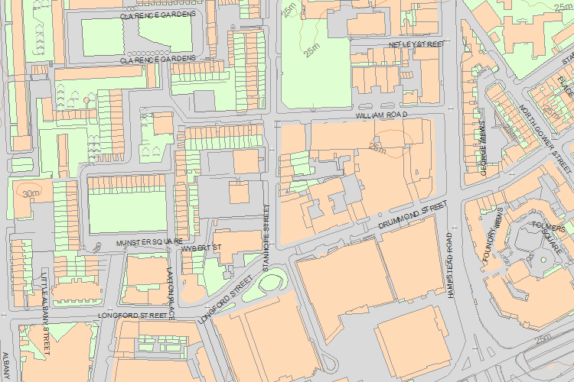© Crown Copyright and database right 2017. All rights reserved. Ordnance Survey Licence number 100024900.
© British Crown and SeaZone Solutions Limited 2017. All rights reserved. Licence number 102006.006.
Use of this data is subject to Terms and Conditions.
The above map is for quick reference purposes only and may not be to scale. For a copy of the full scale map, please see the attached PDF - 1378808 .pdf
The PDF will be generated from our live systems and may take a few minutes to download depending on how busy our servers are. We apologise for this delay.
This copy shows the entry on 24-Feb-2017 at 09:31:05.
End of official listing

