Delegated Report |  |  | Analysis sheet |  |  |  |  |  | Expiry Date: |  |  | 26/12/2016
 |  |  | N/A / attached |  |  |  |  |  | Consultation Expiry Date: |  |  | N.A
Officer |  |  |  |  |  |  | Application Number
Anna Roe |  |  |  |  |  |  | 2016/5931/P
Application Address |  |  |  |  |  |  | Drawing Numbers
Offices And Premises At 1st Floor  2 Hermit Place  London  NW6 4BZ |  |  |  |  |  |  | Please refer to draft decision notice.
PO 3/4 | Area Team Signature |  |  | C&UD |  |  | Authorised Officer Signature

Proposal(s)
Change of use from storage (B8) to residential unit (C3) (GPDO Prior Approval)

Recommendation: |  | Refuse Prior Approval
Application Type: |  | GPDO Prior Approval Class P Change of use of B8 to C3
Conditions or Reasons for Refusal: |  | Refer to Draft Decision Notice

Informatives:

Consultations
Adjoining Occupiers: |  | No. notified |  |  | 00 | No. of responses  No. electronic |  |  |  | 00  00 | No. of objections |  | 00
Summary of consultation responses: |  | N.A
CAAC/Local groups comments: |  | N.A

Site Description
Hermits Place is a mews on the north side of Belsize Road (formally Priory Mews). The area is characterised by two storey buildings in semi-industrial use.

The site is within the Priory Road Conservation Area, however it is not listed and there are no article 4 directions.

The site has a PTAL score of 6a. The nearest station is Kilburn High Road, located to the southwest, whilst the nearest bus stops are located on Kilburn High Road.

Relevant History
2 Hermit Place

2011/6119/P - Erection of second floor mansard roof extension with rooflights to provide additional Class B1 office space. Granted 26/01/2012.

The officers report reads ‘Hermit Place (6 units) has … industrial units which are used as such or converted into offices’, ‘the [application] property is in use as a car repair workshop’.

Existing plan no. HERM/01 shows the ground floor being used as a garage/workshop and the first floor in office use.

2003/1887/P - Erection of second floor mansard roof extension to provide additional Class B1 office
space. Granted 19/11/2003.

Again, the officer report states that ‘the property is being used as a car repair workshop’.

Relevant policies
National Planning Policy Framework, 2012
Chapter 4 (Promoting sustainable transport)
Chapter 10 (Meeting the challenge of climate change, flooding and coastal change)
Chapter 11 (Conserving and enhancing the natural environment)

The Town and Country Planning (General Permitted Development) (England) Order 2015
Schedule 2, Part 2 Class P

The Environmental Protection Act 1990(a) part IIA

The Contaminated Land Statutory Guidance issued by the SoS for Environment, Food and
Rural Affairs in April 2012

Assessment
The proposal
The proposal seeks to change the use of the application site from storage use (Class B8) to residential use (Class C3), to provide 1 no. self-contained residential units.
No external changes are proposed.
Procedure
The Town and Country Planning (General Permitted Development) (Amendment) (England) Order 2015 came into force on 15th April 2015 and introduced Class P, which allows for development consisting of a change of use of a building and any land within its curtilage from a use falling within Class B8 (storage or distribution centre) of the Schedule to the Use Classes Order to a use falling within Class C3 (dwellinghouses) of that Schedule.
This is subject to a number of conditions listed within sub-paragraph P.1 [(a)-(j)] and a subsequent condition in sub-paragraph P.2 requiring that before beginning the development, the development must –
- submit a statement, which must accompany the application referred to in paragraph (b), to the local planning authority setting out the evidence the developer relies upon to demonstrate that the building was used solely for a storage or distribution centre use on the date referred to in paragraph P.1(a) and for the period referred to in paragraph P.1(b);
- apply to the local planning authority for a determination as to whether the prior approval of the authority will be required as to —
- impacts of air quality on the intended occupiers of the development;
- transport and highways impacts of the development,
- contamination risks in relation to the building,
- flooding risks in relation to the building,
- noise impacts of the development, and
- where the authority considers the building to which the development relates is located in an
area that is important for providing storage or distribution services or industrial services or a mix of those services, whether the introduction of, or an increase in, a residential use of premises in the area would have an adverse impact on the sustainability of the provision of those services,

Paragraph W sets out the procedure for applications for prior approval under Part 3. This application is to ascertain whether the proposed change of use would constitute permitted development within the General Permitted Development Order (‘GPDO’) and whether prior approval is required.
Compliance with Paragraph P.1
Development is not permitted by Class P if —
- the building was not used solely for a storage or distribution centre use on 19th March 2014 or in the case of a building which was in use before that date but was not in use on that date, when it was last in use;
The proposal does not comply. The Council’s records suggest that the site is/has most recently been in use as a car repair workshop (class B2) with an ancillary office at first floor level.
The officer report for application ref. 2011/6119/P describes the site as a car repair workshop and the existing floor plan no. HERM/01 shows the ground floor being used as a garage/workshop and the first floor in ancillary office use.
Images from Bing street view (included in the appendix below) support the Council’s assertion that the property is/has been in use as a vehicle repair workshop. Similarly, the estate agents particulars (also included below) described the property as a ‘light industrial’ unit.
Planning permission is not required for a change of use from B2 to B8, however the VOA records submitted (ref. 00680000210018 March 2014; ref. 00680000200029 April 2005; ref. 00680000200029 April 2010) are not sufficient to demonstrate that the proposal was last in use as B8. Furthermore, the VOA records for April 2005 and 2010 contradict the sites planning history.
The Council have been unable to make contact with the agent to arrange a site visit or request further evidence.
- the building was not used solely for a storage or distribution centre use for a period of at least 4 years before the date development under Class P begins;
The proposal does not comply. VOA records submitted (ref. 00680000210018 March 2014; ref. 00680000200029 April 2005; ref. 00680000200029 April 2010) are not sufficient to demonstrate that the proposal was last in use as B8. Furthermore, the VOA records for April 2005 and 2010 contradict the sites planning history
- the use of the building falling within Class C3 (dwellinghouses) of that Schedule was begun after 15th April 2018;
The proposal complies. Although officers could not access the site itself a visit to Hermits Place suggested that the change of use had not commenced and it is considered that there is sufficient time for the change of use to occur before 15th April 2018.

- the gross floor space of the existing building exceeds 500 square metres;
The proposal complies. The floor space of the existing building measures 140sqm. The applicant has applied for part of the building to be changed from B8 to C3, this area measures 70sqm. However the legislation explicitly states ‘the gross floorspace of the existing building’ it does not make reference to the part of the existing building nor the area relevant to the application. The gross floor space is calculated by reference to the existing building rather than proposed development.
- the site is occupied under an agricultural tenancy, unless the express consent of both the landlord and the tenant has been obtained;
The proposal complies. There is no evidence to suggest it is occupied under an agricultural tenancy.
- less than 1 year before the date the development begins—
- an agricultural tenancy over the site has been terminated, and
(ii) the termination was for the purpose of carrying out development under this Class, unless both the landlord and the tenant have agreed in writing that the site is no longer required for agricultural purposes;

The proposal complies. There is no evidence to suggest that an agricultural tenancy over the site exists.
- the building is within—
(i) an area of outstanding natural beauty;
(ii) an area specified by the Secretary of State for the purposes of section 41(3) of the Wildlife and Countryside Act 1981(a);
(iii) the Broads; or
(iv) a National Park;
(v) a World Heritage Site;

The proposal complies. The site does not lie within any of these areas.

- the site forms part of –
(i)a site of special scientific interest;
(ii)a safety hazard area;
(iii)a military explosives storage area;

The proposal complies. The application site is not within a site of special scientific interest, a safety hazard area or a military explosives storage area.
- the building is a listed building or is within the curtilage of a listed building;
The proposal complies. The application building is not listed and neither is it within the curtilage of a listed building.
- the site is, or contains, a scheduled monument.
The proposal complies. The application site is not, nor does it contain a scheduled monument.
Compliance with Paragraph P.2
P.2 Development is permitted by Class P subject to the condition that before beginning the development, the developer must—
- submit a statement, which must accompany the application referred to in paragraph (b), to the local planning authority setting out the evidence the developer relies upon to demonstrate that the building was used solely for a storage or distribution centre use on the date referred to in paragraph P.1(a) and for the period referred to in paragraph P.1(b);
The developer has not complied with this condition. No statement has been submitted to the local planning authority by the developer or by the developer’s agent to accompany the application setting out the evidence the developer relies upon to demonstrate that the building was used solely for a storage or distribution centre use on the date referred to in paragraph P.1(a) and for the period referred to in paragraph P.1(b). Therefore the development is not permitted by Class P.
P.2 Development is permitted by Class P subject to the condition that before beginning the development, the developer must—
- apply to the local planning authority for a determination as to whether the prior approval of the authority will be required as to—
(i) impacts of air quality on the intended occupiers of the development;
The proposal complies. The Council’s Air Quality Officer has advised that air quality in the area is within national objectives and as such the applicant is not required to submit a full Air Quality Assessment.

(ii) Transport and highways impacts of the development,
In the absence of a S106 legal agreement the proposal does not comply with this condition. The site has a PTAL score of 6a which indicates that it is highly accessible by public transport. The nearest station is Kilburn High Road, located to the southwest, whilst the nearest bust stops are located on Kilburn High Road.
In line with Development Policy DP18 and Policy T2 of the emerging Local Plan, the new residential unit should be designated as being car free, i.e. the future occupants will be unable to obtain off-street parking permits from the Council. This arrangement should be secured by means of a Section 106 Agreement.
In accordance with the standards set out in the London Plan for 1 bedroom units this requires the provision of 1 space per unit, which gives a requirement for 1 space to serve the new unit. The submitted plan shows an area for cycle parking located at first floor level adjacent to the entrance to the flat. It is considered that this is of a suitable size to accommodate a cycle.

(iii) Contamination risks in relation to the building

The proposal does not comply. The Council’s Environmental Health (Contamination) officer has reviewed the application against Earth Environmental’s Phase 1 Environmental Desk Study dated May 2016 and found there is a historical unknown industrial site, works, electrical substation and railway lands located adjacent to and within 50m of the site which have been identified as moderate to high risk sites as they have the potential to cause ground contamination.

As this is a conversion rather than a new-build property this presents little risk to the intended occupier.

(iv) Flooding risks in relation to the building,

The proposal complies. The Environment Agency’s online Flood Maps indicate that the site is located within in Flood Zone 1 (“Low” probability of flooding), identified as comprising land assessed as having a less than 0.1% (1 in 1000 year) chance of flooding in any given year from river sources.

The Council’s Sustainability Officer advises that the site lies within Flood Risk Zone 1 (low risk) and that it does not fall within a Local Flood Risk Zone. The immediate development site is not in an area identified in Camden’s Strategic Flood Risk Assessment as being at risk of surface water flooding and therefore the site itself is not at risk from flooding.

- Noise impacts of the development,

The proposal does complies. The site is very closely located to The Priory Tavern Public House and it is important that continued use of this venue is not compromised by the need to protect future residential amenities here.

The applicant has failed to adequately demonstrate that suitable noise insulation would be provided to protect future occupiers from noise pollution from surrounding land uses.

(vi) where the authority considers the building to which the development relates is located in an area that is important for providing storage or distribution services or industrial services or a mix of those services, whether the introduction of, or an increase in, a residential use of premises in the area would have an adverse impact on the sustainability of the provision of those services.

The Council considers the change of use would not impact on the operation of nearby employment uses. Given the predominantly residential character of the surrounding area, an increase in residential would not have an impact on the sustainability or provision of storage services.

Conclusion

- The proposal fails to accord with the provisions of paragraph P.1 (a) and the proposal therefore
does not constitute permitted development.
- The proposal fails to accord with the provisions of paragraph P.1 (b) and the proposal therefore
does not constitute permitted development.
- The developer has failed to comply with the requirements of condition P.2 (a) and therefore implementation of the development is not permitted.
- The applicant has failed to enter into a Section 106 legal agreement to designate the development as ‘car-free’ and therefore prior approval is refused on this basis.
- The applicant has failed to adequately demonstrate that suitable noise insulation would be provided to protect future occupiers from noise pollution from surrounding land uses.

Recommendation: Refuse Prior Approval

Appendix

  - Bing Map screenshot, 2 Hermit Place

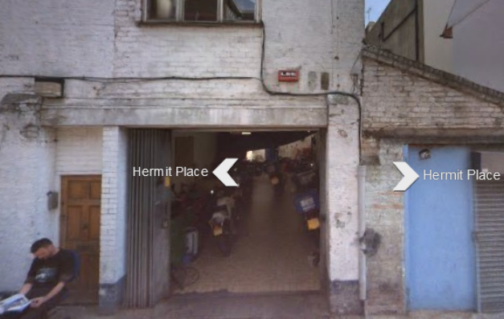

  - Bing Map screenshot, inside 2 Hermit Place

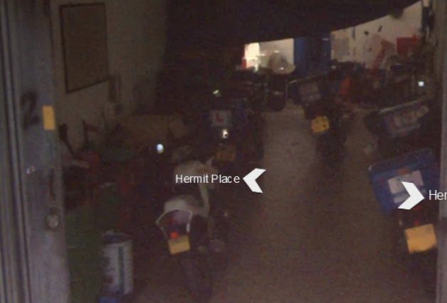

  - Property particulars from Rightmove, 2 Hermit Place

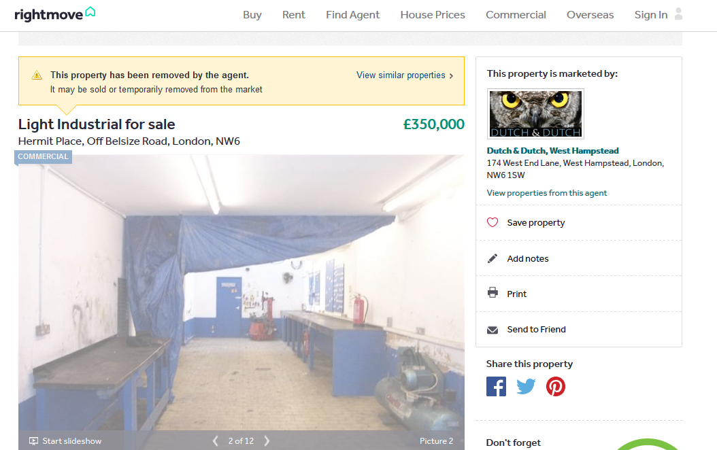

  - Property details from Rightmove, 2 Hermit Place

