10, REGENTS PARK ROAD

List Entry Summary
This building is listed under the Planning (Listed Buildings and Conservation Areas) Act 1990 as amended for its special architectural or historic interest.
Name: 10, REGENTS PARK ROAD
List entry Number: 1130375

Location
10, REGENTS PARK ROAD
The building may lie within the boundary of more than one authority.
County: Greater London Authority
District: Camden
District Type: London Borough
Parish:
National Park: Not applicable to this List entry.
Grade: II
Date first listed: 22-Dec-1998
Date of most recent amendment: Not applicable to this List entry.

Legacy System Information
The contents of this record have been generated from a legacy data system.
Legacy System: LBS
UID: 477844

Asset Groupings
This list entry does not comprise part of an Asset Grouping. Asset Groupings are not part of the official record but are added later for information.

List entry Description

Summary of Building
Legacy Record - This information may be included in the List Entry Details.

Reasons for Designation
Legacy Record - This information may be included in the List Entry Details.

History
Legacy Record - This information may be included in the List Entry Details.

Details
CAMDEN
TQ2883NW REGENT'S PARK ROAD 798-1/75/1904 (North side) 22/12/98 No.10
II
Block of flats and studios. 1954-6 by Erno Goldfinger, assisted by Miss BA James, for the Regent's Park Housing Society Ltd. Reinforced concrete construction with three parallel load-bearing walls (at the rear and to either side of the stairs) with a beam and column construction at the front. The columns exposed and board-marked. In-situ concrete slab floors, externally expressed and wire-brushed to expose aggregate. The deep cornice similarly treated. Red brick infill. Cantilevered concrete balconies with precast panel fronts; precast balustrade to roof terrace. EXTERIOR: 4 storeys and attic, each originally with two flats per floor; those to ground floor and attic are studios, set behind garages and roof terrace respectively. Flats C and D are now combined. Basement laundry, garden room and storage areas. The principal elevation is a symmetrical composition above the ground floor, which has entrance offset by double garage to left. These and garage to right have varnished timber doors. Door and surrounds glazed with Georgian wired glass. Flats have continuous metal casement windows. Balconies are angled, with metal balustrades to side contrasting with precast panels to front. The whole facade a careful composition of contrasting materials and finishes. Rear facade simple, but ground-floor studios with similar balconies to those on front. Ten letter boxes arranged in two rows. INTERIOR: is also of interest. Entrance hall with quarry tile floor leads to staircase set in central structural well. Cantilevered staircase without risers, the slender steel balustrades springing from the side of the treads in a manner comparable to that found in the spiral stair of Goldfinger's demolished Player House. The first floor with two 2-bedroom flats, the second and third floors each with one 1-bedroom and one 3-bedroom flat, all originally with folding screens between living room, dining area and kitchen with fitted cupboards, and with mahogany veneered fitted bedroom cupboards. Goldfinger originally provided tiled bathrooms, and specified bathroom fittings and suggested colour schemes. Living rooms and studios originally with thermoplastic acotiles tiled floors similar to those in Goldfinger's own Willow Road. These features may be of interest where they
survive. HISTORICAL NOTE: in 1952 a group of people formed themselves into a co-operative to build themselves homes under the 1936 Housing Act, which allowed Housing Societies or Associations to raise a loan or mortgage through local authorities. The flats were collectively owned by the Society, which elected officers to represent them in dealing with the architect, builder and St Pancras council, through whom they obtained the 90% mortgage. Few such societies were formed because of potential legal difficulties, though they were the most common way of building in eg. Scandanavia at the time, and the venture attracted considerable interest. The design and fittings, though simple, were of high quality at a time when building licences were still restricted for private building. The planning is compact but skillful. No.10 Regent's Park Road is a single gap caused by bomb damage set into a long mid-C19 terrace. Goldfinger linked his cornice through with those of the adjoining stuccoed houses. As these adjoining houses were parallel but not level with each other, the face of the new block was built to line up with the face of the house on the right, with the balconies projecting to line up with the house on the left. No.10 Regent's Park Road is one of Goldfinger's first post-war works. It marks the first stage of his progression from the restrained modern classicism of his Willow Road terrace (here as there brick is still the dominant material), towards the tougher, exposed grid - which is first seen here - and which was to go on to dominate his late, great projects. The bold expression of the balconies, with their mannered, pre-cast panels, is seen particularly as a foretaste both of Goldfinger's later works and the general development of a tougher architectural idiom in brick and concrete by younger architects from 1958 onwards. The contrast of red brick and concrete with the neighbouring stuccoed terraces is remarkable. The flats are also important in their own right as one of Goldfinger's most successful and least altered domestic works, and as a most interesting example of how ten flats could be provided on a tiny gap site. (Architectural Design: April 1954: 105; House and Garden: August 1956: 30-33; Architectural Design: September 1956: 280-282; Architectural Design: June 1961: 262; Dunnett J and Stamp G: Erno Goldfinger: Architectural Association: 1983-: 77, 93; Elwall R: Erno Goldfinger: London: 1996-: 72).
Listing NGR: TQ2839383761

Selected Sources
Books and journals
Dunnett, James, Stamp, Gavin, Erno Goldfinger, (1983), 77,93
Elwall, R, Erno Goldfinger, (1996), 72
'House and Garden' in August, (1956), 30-33
'Architectural Design' in June, (1961), 262
'Architectural Design' in April, (1954), 105
'Architectural Design' in September, (1956), 280-282
National Grid Reference: TQ 28393 83761

Map
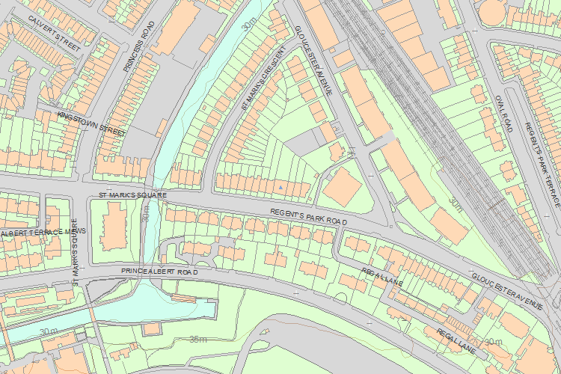© Crown Copyright and database right 2017. All rights reserved. Ordnance Survey Licence number 100024900.
© British Crown and SeaZone Solutions Limited 2017. All rights reserved. Licence number 102006.006.
Use of this data is subject to Terms and Conditions.
The above map is for quick reference purposes only and may not be to scale. For a copy of the full scale map, please see the attached PDF - 1130375 .pdf
The PDF will be generated from our live systems and may take a few minutes to download depending on how busy our servers are. We apologise for this delay.
This copy shows the entry on 15-Feb-2017 at 09:49:11.
End of official listing

