Barley Wood Planning Consultancy
39 Carne View Road, Probus,
Truro, Cornwall, TR2. 4HZ.

Telephone: 01726-882266 : Mobile: 07989-406538

Town and Country Planning Act 1990 (As Amended)
Section 174 appeal

84 Parkway
London
NW1 7AN

Appeal by
Leo Kaufman

GROUNDS OF APPEAL (D)

Re:

Serving of Enforcement Notice by London Borough of Camden Council regarding “Without planning permission: Installation of a water tank on roof of dwelling (Class C3)” at the above site.

Council Reference: EN16/0198
Planning Inspectorate Ref.:

Proprietor : D.G.Laverick, BTP. MRTPI. Chartered Town Planner

Contents

- Introduction.

- The Appeal site & its location.

- Background to the submission of the Appeal.

- Council’s Reasons for Enforcement Action.

- Statement to support Grounds of Appeal.

- Conclusion.

Appendices

Appendix 1: Copy of the Enforcement Notice.

Appendix 2: Ordnance Survey extract relating to premises, the subject of Enforcement Action.

Appendix 3: Documentary evidence to support contention that water tank has been extant for more than 4 years.

- INTRODUCTION

1.1 The Appellants’ grounds of appeal have been prepared with reference to the Borough Council’s reasons for instigating Enforcement Action.

2.0. THE APPEAL SITE & ITS LOCATION

2.1 The appeal site is located on the western side of Parkway, London, in the London borough of Camden. The location of the Appeal site is detailed in the small O.S. extract shown below.
The Appeal site
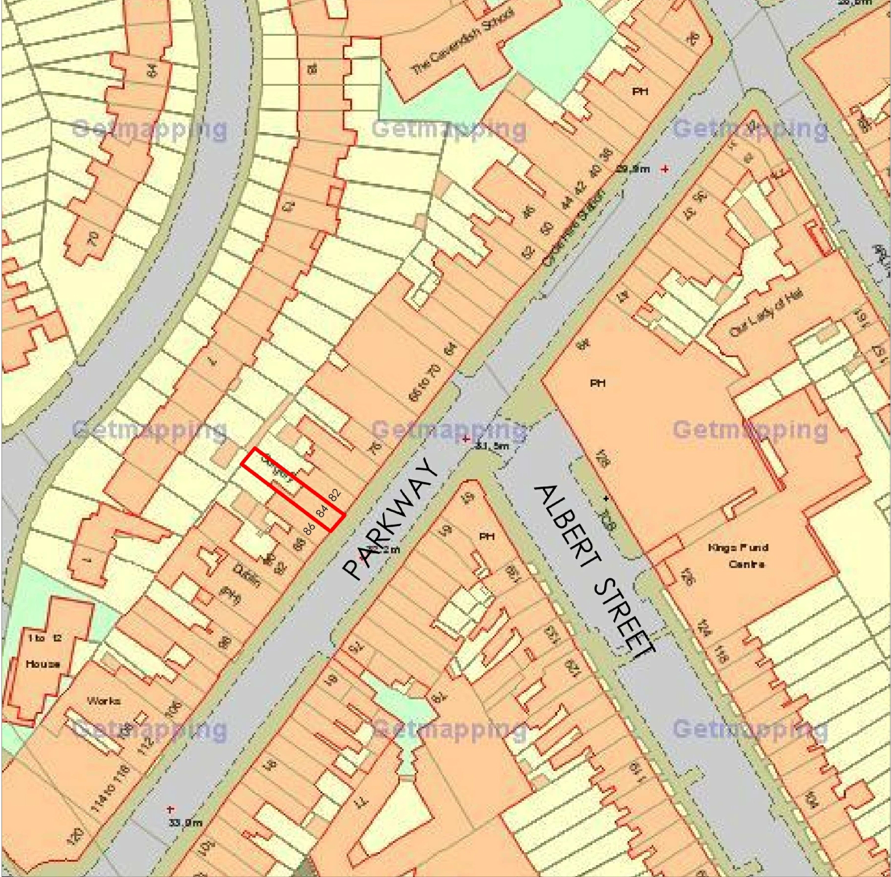
2.2 The appeal site does not comprise a listed building nor locally listed structure but is located within Camden Town Conservation Area.

- BACKGROUND TO THE SUBMISSION OF THE APPEAL

3.1 On 5th October 2016 Camden Council issued an Enforcement Notice, which would take effect on 16th November 2016 unless an appeal was submitted against the Council’s action beforehand.

3.2 This Enforcement Notice cited “Without planning permission: Installation of a water tank on roof of dwelling (Class C3)” as the subject of their action.

3.3 It is against this Enforcement Notice that this appeal has been lodged.

- COUNCIL’S REASONS FOR ENFORCEMENT ACTION

4.1 This appeal concerns the serving of an Enforcement Notice regarding the development described in paragraph 3.2 above. The Council stated that the reasons for issuing this Notice were:

  - It appears to the Council that the above breach of planning control has occurred within the last 4 years.

  - The unauthorised water tank located at the main roof level is considered to be a visually obtrusive addition due to its overly bulky appearance as well as materials and is detrimental to the character and appearance of the host property and the surrounding Camden Town Conservation Area. The development is therefore contrary to Policy CS14 (Promoting high quality places and conserving our heritage) of the Core Strategy and Policy DP24 (Securing high quality design) and DP25 (Heritage) of the Development Policies of the Camden Local Development Framework.

  - These ‘reasons for enforcement’ raise the following issues.

- Whether or not the subject of the appeal has resulted in a development that is visually obtrusive or is detrimental to the character or appearance of the host property or the surrounding Camden Town Conservation Area.

- Whether or not the development is contrary to stated Council policies.

- Whether or not there are any mitigating circumstances that may support the case for approval.

4.3 Notwithstanding any policy matters, whether or not they be national, regional or local, the Appellants submission for this Appeal, as well as being submitted on Ground ‘A’ is also being submitted on Ground ‘D,’ that it was too late for enforcement action to be taken. Thus policy issues are not relevant to the submission on Ground ‘D’.

5.0 STATEMENT TO SUPPORT GROUNDS OF APPEAL ON GROUND ‘D.’

5.1 The Appeal property is located on the north-western side of Parkway near the vehicular junction with Albert Street. The building is a mid-terraced property and comprises ground floor, first, second and third floor level accommodation within a mansard roof level.

5.2 The terrace of properties of which the Appeal property forms a part, are generally three-four storeys in height, with the upper level being located within mansard roofs.
5.3 The Appeal property is seen to the middle of the picture, the shop premises seen as “MooBoo.”
The north western side of Parkway and the Appeal premises
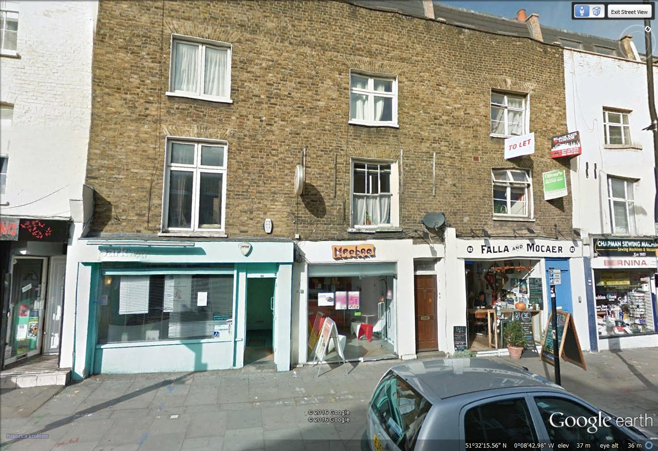
5.4 The water tank was installed on the roof before 5th October, 2012; therefore the water tank is immune from enforcement action. The Appellant encloses documentary evidence to support this strong contention in Appendix 3, attached to this Ground of Appeal.

6.0 CONCLUSION

6.1 The appeal proposal, for the reasons stated above, does not cause harm to any interest of acknowledged importance.

6.2 In the light of the comments contained in the above statement the Inspector is respectfully requested to allow this appeal.

