Barley Wood Planning Consultancy
39 Carne View Road, Probus,
Truro, Cornwall, TR2. 4HZ.

Telephone: 01726-882266 : Mobile: 07989-406538

Town and Country Planning Act 1990 (As Amended)
Section 174 appeal

84 Parkway
London
NW1 7AN

Appeal by
Leo Kaufman

GROUNDS OF APPEAL A,D,E,F & G

Re:

Serving of Enforcement Notice by London Borough of Camden Council regarding “Without planning permission: Installation of a water tank on roof of dwelling (Class C3)” at the above site.

Council Reference: EN16/0198
Planning Inspectorate Ref.:

Proprietor : D.G.Laverick, BTP. MRTPI. Chartered Town Planner

Contents

- Introduction.

- The Appeal site & its location.

- Background to the submission of the Appeal.

- Council’s Reasons for Enforcement Action.

- Statement to support Grounds of Appeal.

- Whether the proposal complies with Council policy.

- Whether or not there are any mitigating circumstances that may support the case for approval.

- Conclusion.

Appendices

Appendix 1: Copy of the Enforcement Notice.

Appendix 2: Ordnance Survey extract relating to premises, the subject of Enforcement Action.

Appendix 3: List of 26 properties within the immediately surrounding conservation area that possess tanks and other structures similar to that on the roof of the Appeal property.

Appendix 4: Extract of 50 page officer's report giving permission for "additional plant including condenser units, PV cells, AHUs duct drops and a new louvre grille" Greater London House, Hampstead Road, on a building described as.."an imposing white Art Deco building and a striking example of early 20th Century Egyptian Revival architecture".

Appendix 5: Email from Vivienne Caswill - Complaints Investigation Officer from the London Borough of Camden, whom the Appellant requested that the enforcement should be delayed until the outcome of the tanks that he had reported had been investigated and resolved. In response Ms Caswill stated 'My understanding is that they (the enforcement team) will contact you in the first instance to see if the matter can be resolved."

Appendix 6: Copy of Email from Enforcement Officer John Nichols confirming that a specific building identified by the Appellant was indeed a listed building that is owned by the Council which has a UPVC clad water tank on the roof and that they will not have any action taken about it as the property belongs to the Council.

Appendix 7: Enforcement Officer’s response to Appellant’s emails regarding the water tank on the roof of No.63 Parkway, opposite the appeal premises.

Appendix 8 Computer generated photographs showing types of screening that could be used.

- INTRODUCTION

1.1 The Appellants’ grounds of appeal have been prepared with reference to the Borough Council’s reasons for instigating Enforcement Action.

2.0. THE APPEAL SITE & ITS LOCATION

2.1 The appeal site is located on the western side of Parkway, London, in the London borough of Camden. The location of the Appeal site is detailed in the small O.S. extract shown below.
The Appeal site
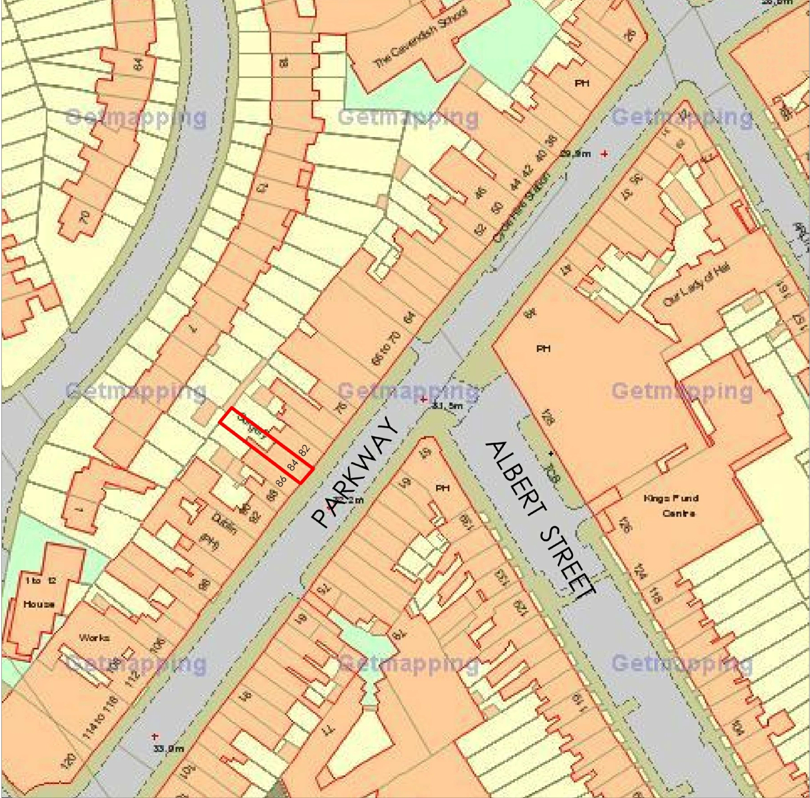
2.2 The appeal site does not comprise a listed building nor locally listed structure but is located within Camden Town Conservation Area.

- BACKGROUND TO THE SUBMISSION OF THE APPEAL

3.1 On 5th October 2016 Camden Council issued an Enforcement Notice, which would take effect on 16th November 2016 unless an appeal was submitted against the Council’s action beforehand.

3.2 This Enforcement Notice cited “Without planning permission: Installation of a water tank on roof of dwelling (Class C3)” as the subject of their action.

3.3 It is against this Enforcement Notice that this appeal has been lodged.

- COUNCIL’S REASONS FOR ENFORCEMENT ACTION

4.1 This appeal concerns the serving of an Enforcement Notice regarding the development described in paragraph 3.2 above. The Council stated that the reasons for issuing this Notice were:

  - It appears to the Council that the above breach of planning control has occurred within the last 4 years.

  - The unauthorised water tank located at the main roof level is considered to be a visually obtrusive addition due to its overly bulky appearance as well as materials and is detrimental to the character and appearance of the host property and the surrounding Camden Town Conservation Area. The development is therefore contrary to Policy CS14 (Promoting high quality places and conserving our heritage) of the Core Strategy and Policy DP24 (Securing high quality design) and DP25 (Heritage) of the Development Policies of the Camden Local Development Framework.

  - These ‘reasons for enforcement’ raise the following issues.

- Whether or not the subject of the appeal has resulted in a development that is visually obtrusive or is detrimental to the character or appearance of the host property or the surrounding Camden Town Conservation Area.
- Whether or not the development is contrary to stated Council policies.

- Whether or not there are any mitigating circumstances that may support the case for approval.

4.3 Notwithstanding any policy matters, whether or not they be national, regional or local, the Appellants submission for this Appeal, as well as being submitted on Ground ‘A’ is also being submitted on Ground ‘D,’ that it was too late for enforcement action to be taken. Thus policy issues are not relevant to the submission on Ground ‘D’.

5.0 STATEMENT TO SUPPORT GROUNDS OF APPEAL ON GROUND ‘A.’

5.1 The Appeal property is located on the north-western side of Parkway near the vehicular junction with Albert Street. The building is a mid-terraced property and comprises ground floor, first, second and third floor level accommodation within a mansard roof level.
5.2 The terrace of properties of which the Appeal property forms a part, are generally three-four storeys in height, with the upper level being located within mansard roofs.
5.3 The ground floors are all in retail/commercial use with the upper floors being used for residential accommodation.
5.4 The Appeal property is seen to the middle of the picture, the shop premises seen as “MooBoo.”
5.5 The Camden Town Conservation Area Appraisal and Management Strategy states that “Parkway is a tree-lined street leading up a gentle slope towards Regents Park. It was developed in the 1820s and 1830s with modest three-storey houses on both sides, with flat-fronted yellow stock brick façades adhering to classical proportions, devoid of elaborate decoration other than continuous eaves parapets and simple openings for painted timber sash windows. On the north side, a pair of houses in their original state survive at Nos 98 & 100, but the remainder of properties were converted to retail uses at ground level from the mid-19th century onwards. The street currently offers a mix of retail and restaurant uses with some small businesses providing specialist services.

The north western side of Parkway where the Appeal premises are located.
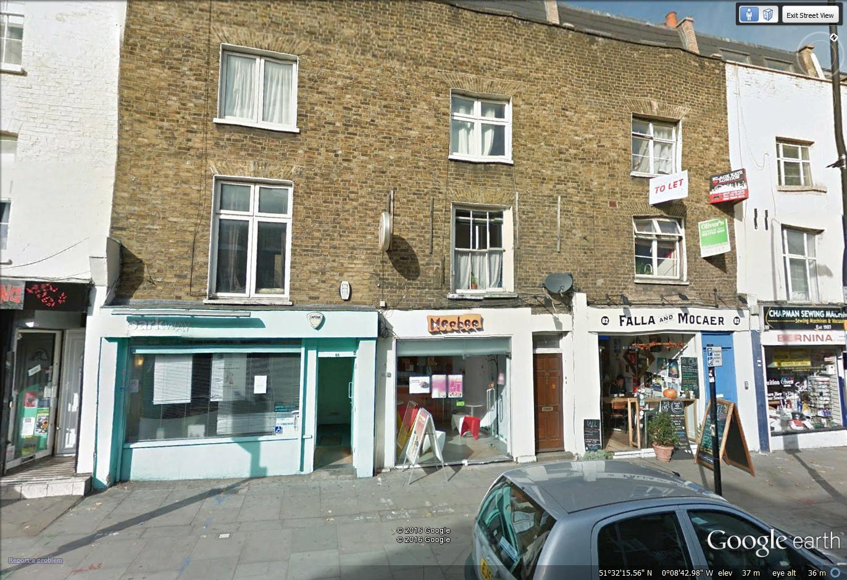

5.6 In all of the text relating to Parkway there doesn’t appear to be any mention whatsoever about the rear elevation of any property within the road.
5.7 It is strongly contended that the rear elevation of the Appeal property does not merit any special character or significance as there are many different and eclectic individual structural elevations within the rear of the terrace. It in no way provides an elevation that is homogeneous in nature.
5.8 The Camden Town Conservation Area Appraisal and Management Strategy identifies the Appeal premises as being a building that makes a positive contribution to the conservation area, (Parkway: 2-112, 1-13, Public House, 27, 31-33, 39-47, 61-75, 77-79, 81-101). However, there is no mention whether or not this includes the rear of the property as well as the street elevation.
5.9 With regard to Roof alterations and extensions, the Conservation Area Appraisal states: The Conservation Area retains many diverse historic rooflines which it is important to preserve. Fundamental changes to the roofline, insensitive alterations, poor materials, intrusive dormers, or inappropriate windows can harm the historic character of the roofscape and will not be acceptable.
5.10 The Local Planning Authority state that the unauthorised water tank at the main roof level is considered to be a visually obtrusive addition due to its overly bulky appearance as well as materials and is detrimental to the character and appearance of the host property and the surrounding Camden Town Conservation Area.
5.11 The Appellant would wish to respond with the comments that the water tank, although being able to be seen from the houses to the rear in Gloucester Crescent cannot be seen from the ground and first floor but only from the second and third floors. It is IMPOSSIBLE to be seen from the street elevation and is certainly not prominent within the street elevation within the conservation area.
5.12 The Inspector is respectfully advised that the Appellant has compiled a list of 26 properties within the immediately surrounding conservation area that possess tanks and other structures similar to that on the roof of the Appeal property. This list is attached as Appendix 3 to these Grounds of Appeal.
5.13 These have all been reported to Camden Council’s enforcement team. To date the Council has not found it expedient to take enforcement action or done anything to have these tank enclosures removed. However the enforcement notice states that the council finds it expedient to serve this enforcement notice.
A good explanation is required.
5.14 This list of tank enclosures can all be seen from the street whereas the tank enclosure on the subject property cannot be seen from the street at all.
5.15 It is extremely interesting to note that some of these properties are actually owned by the Council themselves, some are Listed Buildings whilst others are actually Listed Buildings owned by the Council. Dual standards seem to exist in the Borough of Camden.
5.16 The Appellant would respectfully wish to advise the Inspector that with regard to the Tank Enclosure:-
The Appellant would be happy to accept a condition to adapt the tank enclosure so that either:
1. the enclosure looks like a chimney stack by placing in front of it a brickwork panel or brick wall, or
2. to place one or two air conditioning units in front of the tank enclosure so that it conceals the actual tank. This is common in hundreds of properties in the Borough of Camden.
Please see photo images attached as Appendix 8 to this Statement.

- WHETHER THE PROPOSAL COMPLIES WITH COUNCIL POLICY.

Core Strategy

6.1 Policy CS14 (Promoting high quality places and conserving our heritage) states:

The Council will ensure that Camden’s places and buildings are attractive, safe and easy to use by:
a) requiring development of the highest standard of design that respects local context and character;
b) preserving and enhancing Camden’s rich and diverse heritage assets and their settings, including conservation areas, listed buildings, archaeological remains, scheduled ancient monuments and historic parks and gardens;
c) promoting high quality landscaping and works to streets and public spaces;
d) seeking the highest standards of access in all buildings and places and requiring schemes to be designed to be inclusive and accessible;
e) protecting important views of St Paul’s Cathedral and the Palace of Westminster from sites inside and outside the borough and protecting important local views.
Response: The Appellant strongly contends that the appeal development complies with all of the relevant sections of the above policy.

Development Policies of the Camden Local Development Framework.

6.2 Policy DP24 (Securing high quality design) states:

The Council will require all developments, including alterations and extensions to existing buildings, to be of the highest standard of design and will expect developments to consider:
a) character, setting, context and the form and scale of neighbouring buildings;
b) the character and proportions of the existing building, where alterations and extensions are proposed;
c) the quality of materials to be used;
d) the provision of visually interesting frontages at street level;
e) the appropriate location for building services equipment;
f) existing natural features, such as topography and trees;
g) the provision of appropriate hard and soft landscaping including boundary treatments;
h) the provision of appropriate amenity space; and
i) accessibility.
Response: It is strongly contended that the appeal development does consider the character, setting, context and the form and scale of neighbouring buildings.
6.3 Policy DP25 (Heritage) states:

Conservation areas

In order to maintain the character of Camden’s conservation areas, the Council will:
a) take account of conservation area statements, appraisals and management plans when assessing applications within conservation areas;
Response: This part of the policy is solely the responsibility of the Local Planning Authority.
b) only permit development within conservation areas that preserves and enhances the character and appearance of the area;
Response: It is strongly contended that the appeal development does preserve the character and appearance of the conservation area.
c) prevent the total or substantial demolition of an unlisted building that makes a positive contribution to the character or appearance of a conservation area where this harms the character or appearance of the conservation area, unless exceptional circumstances are shown that outweigh the case for retention;
d) not permit development outside of a conservation area that causes harm to the character and appearance of that conservation area; and
e) preserve trees and garden spaces which contribute to the character of a conservation area and which provide a setting for Camden’s architectural heritage.
Listed buildings
To preserve or enhance the borough’s listed buildings, the Council will:
e) prevent the total or substantial demolition of a listed building unless exceptional circumstances are shown that outweigh the case for retention;
f) only grant consent for a change of use or alterations and extensions to a listed building where it considers this would not cause harm to the special interest of the building; and
g) not permit development that it considers would cause harm to the setting of a listed building.
Response: Parts c, d, e, f, and g are not considered relevant to this appeal submission.
Archaeology
The Council will protect remains of archaeological importance by ensuring acceptable measures are taken to preserve them and their setting, including physical preservation, where appropriate.
Other heritage assets
The Council will seek to protect other heritage assets including Parks and Gardens of Special Historic Interest and London Squares.
Response. This part of the policy is not considered relevant to this appeal submission.

7.0 WHETHER OR NOT THERE ARE ANY MITIGATING CIRCUMSTANCES THAT MAY SUPPORT THE CASE FOR APPROVAL.

7.1 As previously stated in paragraph 5.12 above, the Inspector is respectfully advised that the Appellant has compiled a list of 26 properties within the immediately surrounding conservation area that possess tanks and other structures similar to that on the roof of the Appeal property. This list is attached as Appendix 3 to these Grounds of Appeal.

7.2 These have all been reported to Camden Council’s enforcement team. To date the Council has not done anything to have these tank enclosures removed.

7.3 This list of tank enclosures can all be seen from the street whereas the tank enclosure on the subject property cannot be seen from the street at all.

7.4 It is extremely interesting to note that some of these properties are actually owned by the Council themselves; some are Listed Buildings whilst others are actually Listed Buildings owned by the Council. Dual standards seem to exist in the Borough of Camden.

7.5 An extract of a 50 page officer's report (case number 2016/4208/P) is attached as Appendix 4 to this Statement. This report recommends approval for "additional plant including condenser units, PV cells, AHUs duct drops and a new louvre grille" on the roof of a building described as.."an imposing white Art Deco building and a striking example of early 20th Century Egyptian Revival architecture". This building is a famous Art Deco Landmark building.

The report goes to length describing what nice people the applicants are, so it is obvious that when the Council likes you they give you permission for anything. However in my case it is obvious that the Council has a personal vendetta, or racial dislike for me, and is going out of it’s way to refuse permission without good reason.

7.6 Email from Vivienne Caswill - Complaints Investigation Officer from the London Borough of Camden is attached as Appendix 5 to this Statement. The Appellant had requested that the enforcement should be delayed until the outcome of the tanks that he had reported had been investigated and resolved. In response Ms Caswill stated 'My understanding is that they (the enforcement team) will contact you in the first instance to see if the matter can be resolved."

7.7 Unfortunately this was never done and the Councils enforcement section, just merely took SWIFT Action to serve this enforcement notice without any attempt at an alternative resolution or discussion with the Enforcement Section, as has been promised.

7.8 The Appellant has had discussions with some Enforcement Officers within Camden Council and attaches as Appendix 6 Copy of an Email from Enforcement Officer John Nichols confirming that a specific building identified by the Appellant was indeed a listed building that is owned by the Council which has a UPVC clad water tank on the roof and that they will not have any action taken about it as the property belongs to the Council.

7.9 Another Enforcement Officer, Hardev Singh has responded today with regard to another property with a tank on the roof at No.63 Parkway, opposite the appeal premises. The email response received today is attached as Appendix 7 to this Statement. It states that as the tank cannot be seen from the street view, it is unlikely that any enforcement action will be taken.

GROUND F

7.10 The Appellant would respectfully wish to advise the Inspector that with regard to the Tank Enclosure on his property:-

The Council could have requested lesser steps instead of removing the tank. The notice could have requested

1. the enclosure looks like a chimney stack by placing in front of it a brickwork panel or brick wall,
or

2. to place one or two air conditioning units in front of the tank enclosure so that it conceals the actual tank. This is common in hundreds of properties in the Borough of Camden.

7.11 It should be noted that the enforcement notice simply asks for the tank to be removed, but not the tank enclosure covering it!

7.12 The Inspector is respectfully advised that computer generated photographs showing the possible structures, described above, are contained within Appendix 8, attached to this Statement.

GROUND E

7.13 This property is owned by both Leo Kaufman and Pauline Kaufman, yet the notice was only served on Leo Kaufman. Furthermore the notice was not served on anybody at the property itself, although the notice says that this was done.

7.14 As a result there has not been proper service, and the notice is invalid.

GROUND G

7.15 This tank provides vital water pressure to all the flats and residents in this building therefore if the tank was required to be removed, all the flats in the building would have to be extensively remodelled and re-plumbed. As a result at least one year would be required to get this completed, as the flats are let on annual tenancies, and the works could not be carried out whilst the tenants are in occupation.

GROUND D

7.16 Please see separate sheet for Ground D.

8.0 CONCLUSION

8.1 The appeal proposal, for the reasons stated above, does not cause harm to any interest of acknowledged importance.

8.2 In the light of the comments contained in the above statement the Inspector is respectfully requested to allow this appeal.

