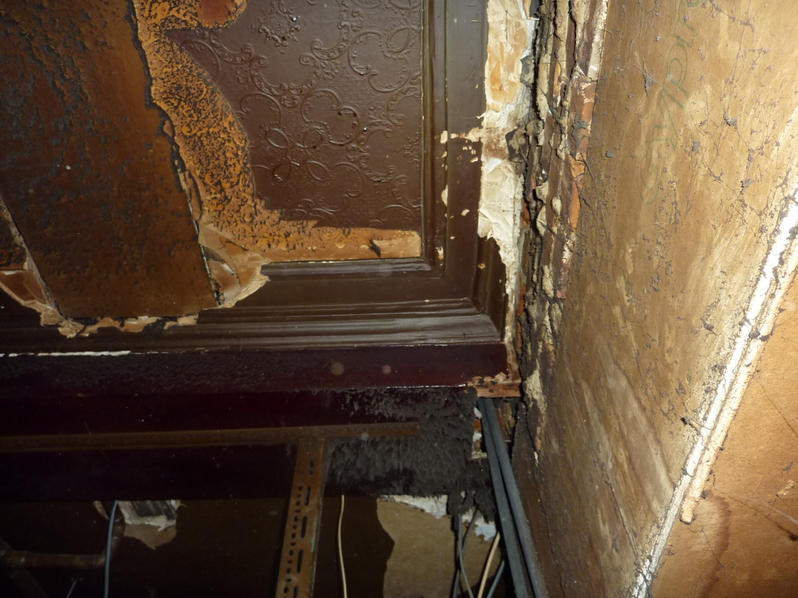Photo 1

Taken directly below hoist location with rear wall of building on the right hand side. Section of missing ceiling to left has been replaced with board, also observed from floor opening up works above.

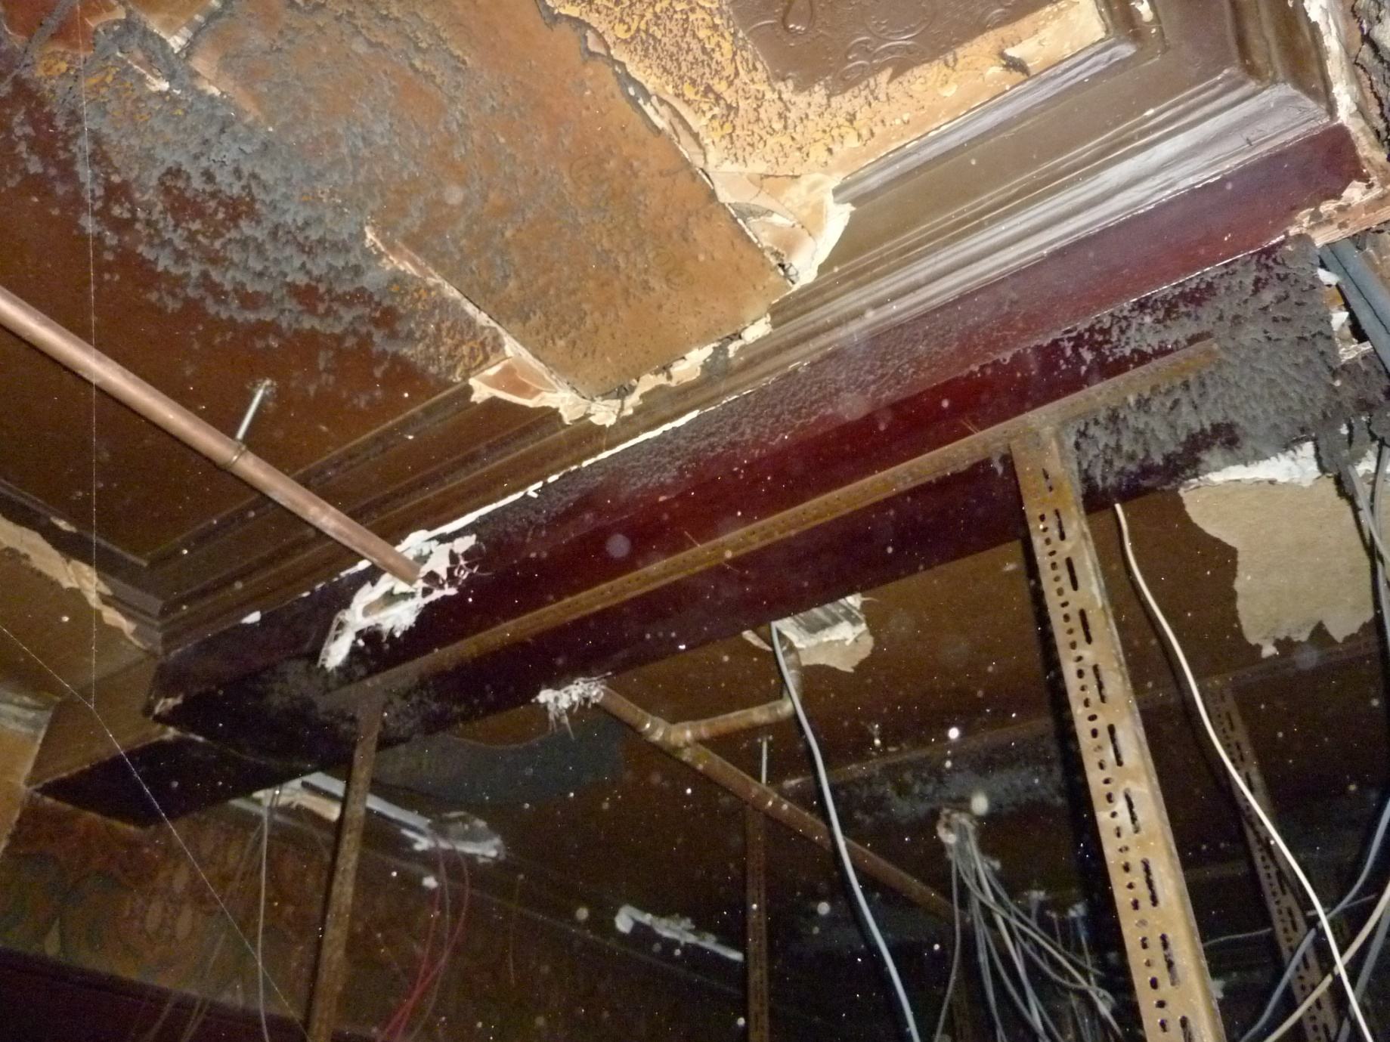Photo 2

View of existing beam in location of new hoists.

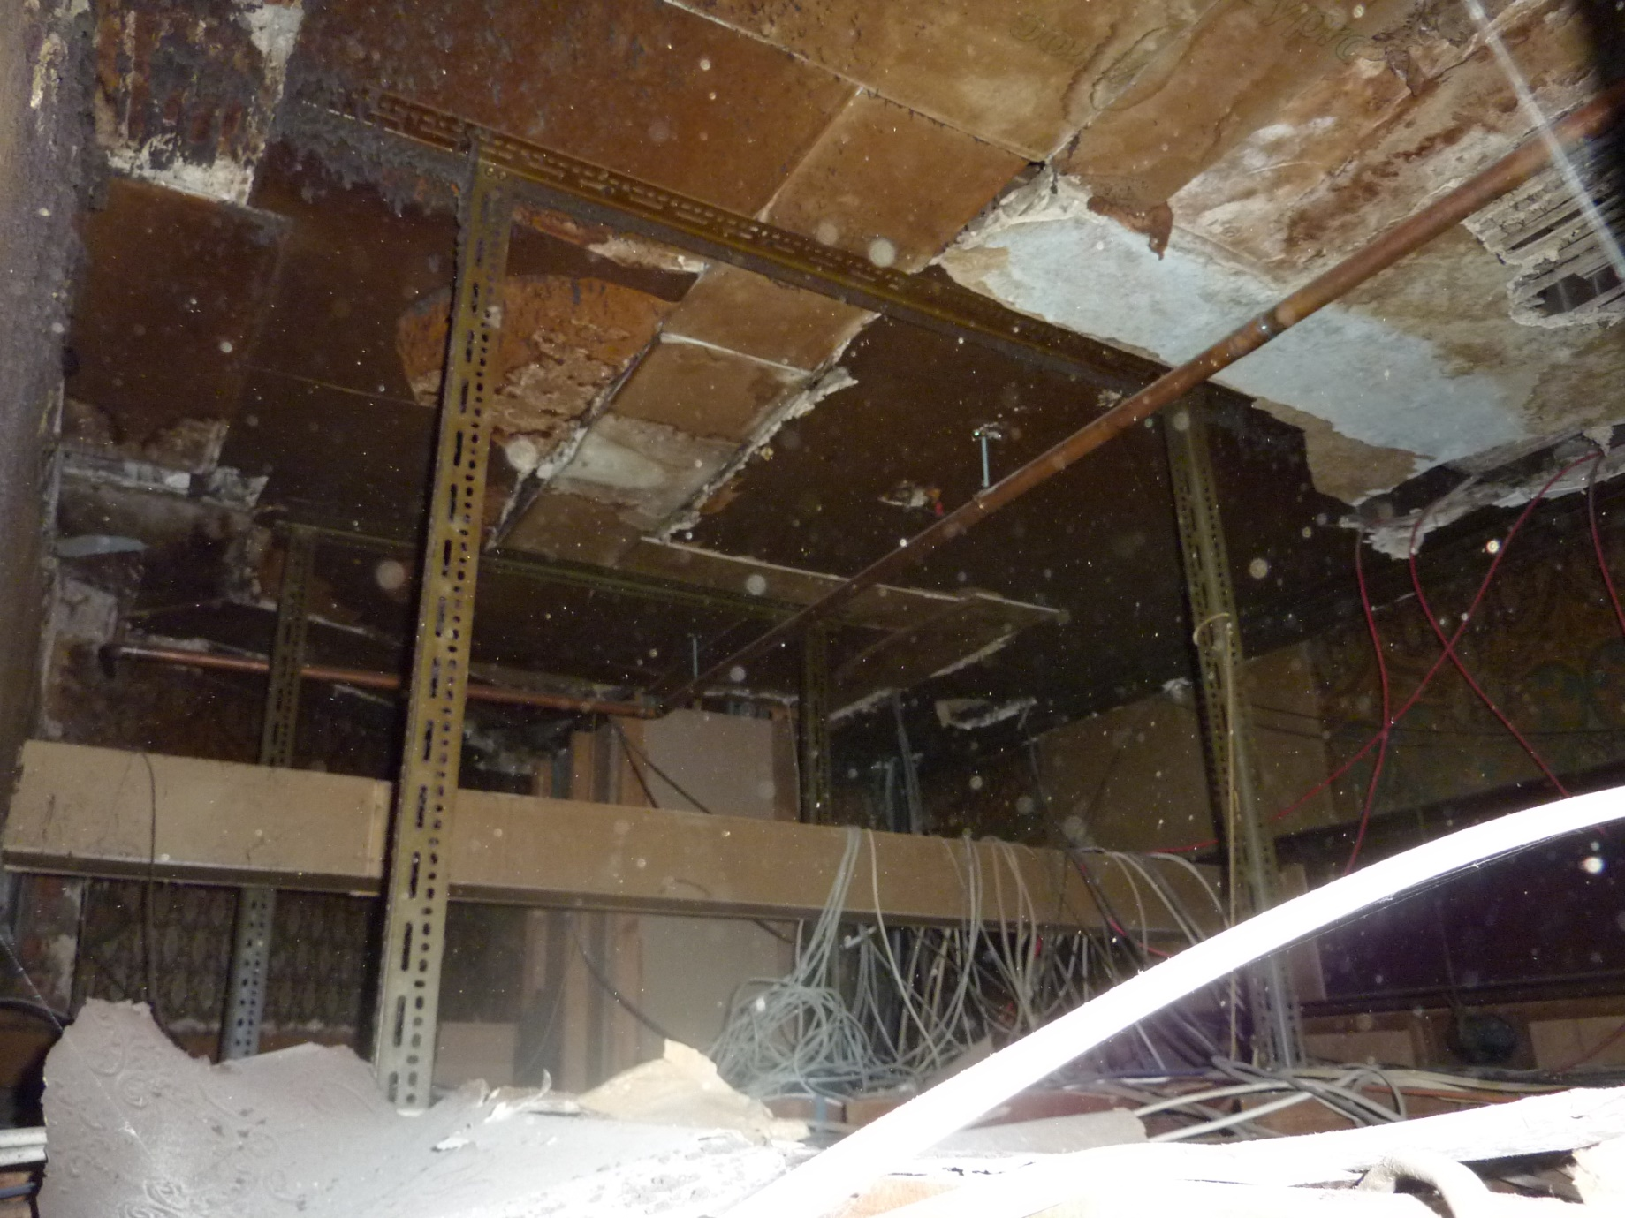Photo 3

View of ceiling (towards bar counter)

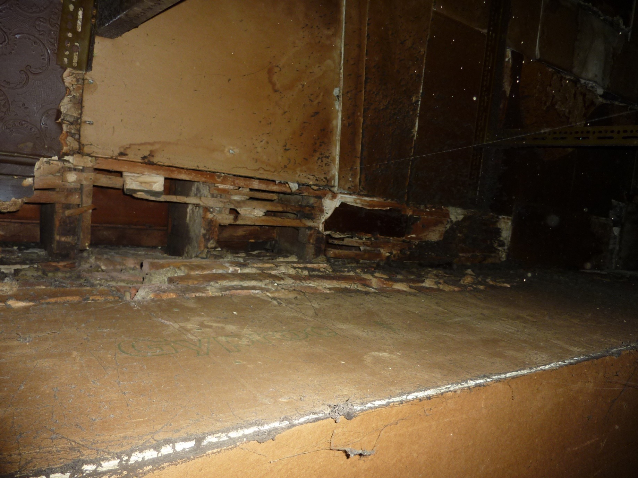Photo 4

View of rear wall with hoist location to the left.

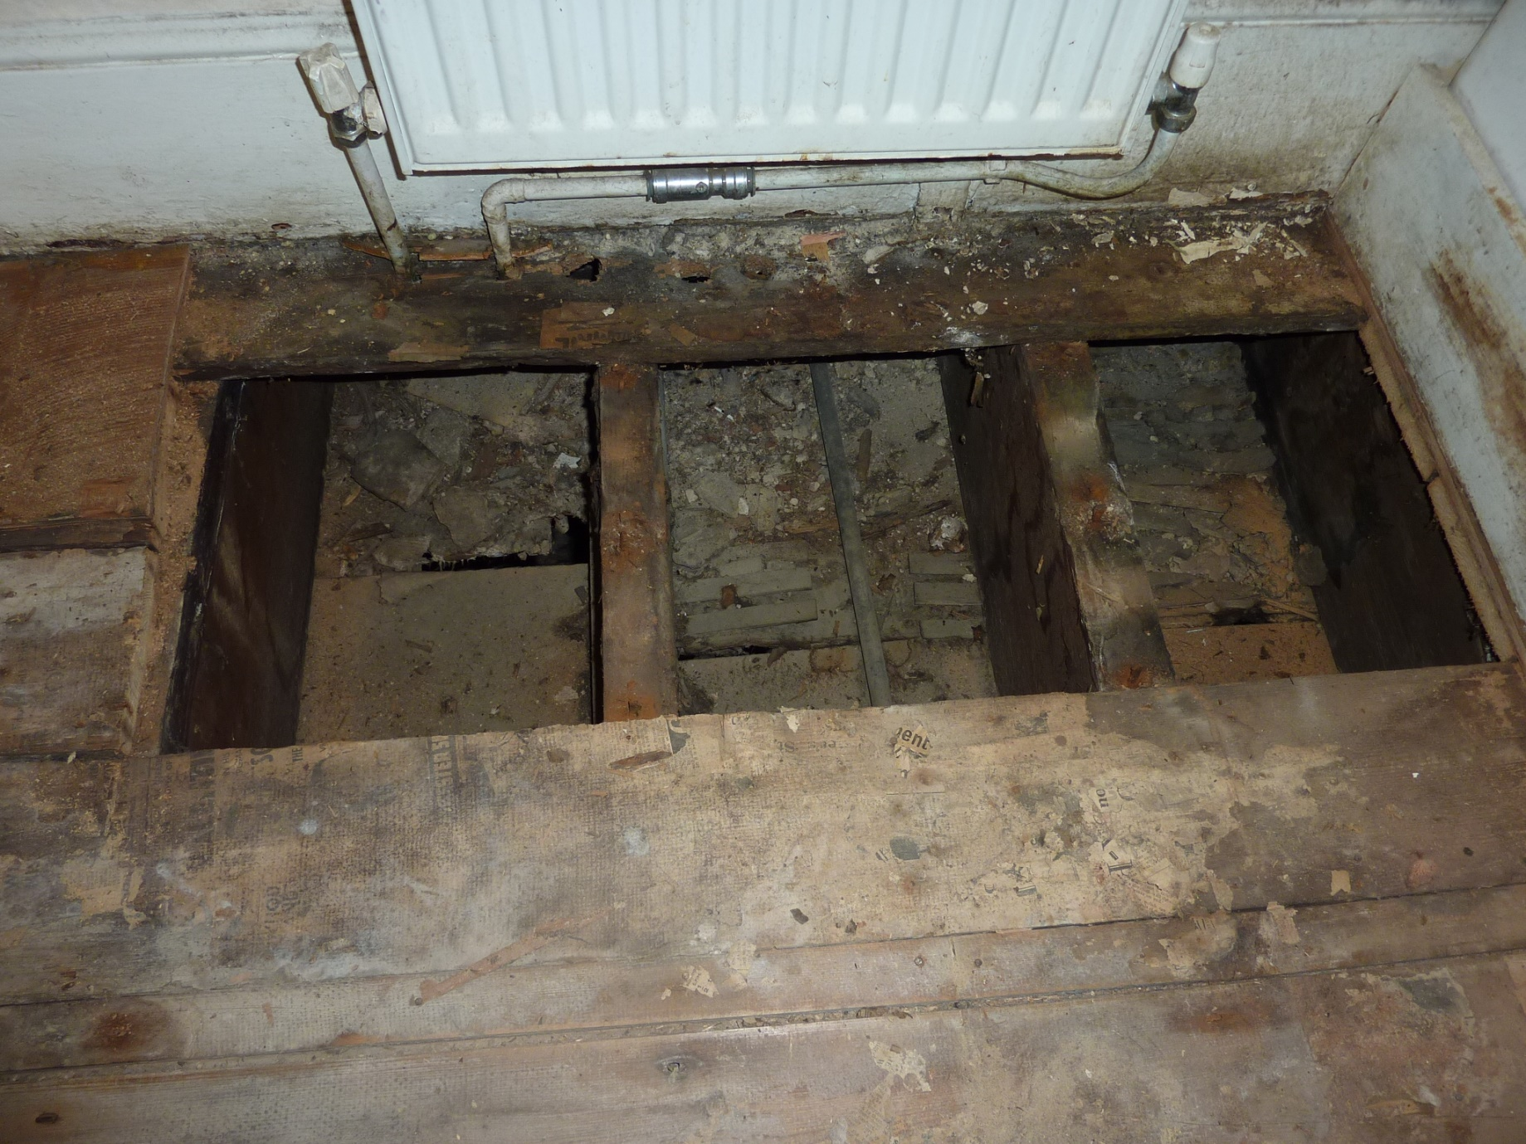Photo 5

View of opened floor section to hoist position.