
- Menu
- Search

What are you looking for?

Click anywhere to close (ESC)

- Listing
  - Search the List
  - Enrich the List
  - Apply for Listing
  - What is Listing?
  - Listing Guidance
- Advice
  - Your Home
  - Planning
  - Latest Advice & Guidance
  - Caring for Heritage
  - Technical Guidance
  - Heritage at Risk
  - Constructive Conservation
  - Heritage Protection Guide
- Research
  - Our Research Strategy and Agenda
  - Research Methods
  - Current Research
  - Research Results
  - Support & Collaboration
  - Inclusive Heritage
  - Heritage Counts
- Images & Books
  - Find Photos
  - Search All Publications
  - Buy Books
  - The Historic England Archive
  - Be an Archive Detective
- Services & Skills
  - Education
  - Grants
  - Our Planning Services
  - Training & Skills
  - Archive Services
  - Heritage Action Zones
- Get Involved
  - Be a Volunteer
  - Protect Your Heritage
  - Help Write History
  - Visit Your Heritage
- What's New
  - News
  - In Your Area
  - Latest Listings
  - Latest Research
  - Heritage Online Debate
  - Statements
  - Stay Up To Date
  - Black British History
  - Open All Hours
  - Angel Awards
  - FWW Centenary

  - What We Do
  - Who We Are
  - Jobs
  - Contact Us
  - Volunteer with Historic England

  - Website Terms and Conditions
  - Data Protection
  - Privacy and Cookies
  - Links Policy
  - Historic England Blog: House Rules
  - Listed Property Owner Survey Competition Terms and Conditions
This browser is not fully supported by Historic England. Please update your browser to the latest version so that you get the best from our website.
We use cookies to give you the best possible experience online. By using this website, you consent to cookies being used in accordance with our Cookie Policy.
- Home
- ...
- Listing
- Search the List
- List Entry
- Section Navigation
  - Map Search
  - Minor Amendments
  - Download Listing Data
  - Non-Listed Sites
  - About The List
  - Enrich the List
  - Understanding List Entries

NUMBER 15 TO 24 AND AREA RAILINGS

List Entry Summary
This building is listed under the Planning (Listed Buildings and Conservation Areas) Act 1990 as amended for its special architectural or historic interest.
Name: NUMBER 15 TO 24 AND AREA RAILINGS
List entry Number: 1378736

Location
NUMBER 15 TO 24 AND AREA RAILINGS, 15-24, HARRINGTON SQUARE
The building may lie within the boundary of more than one authority.
County: Greater London Authority
District: Camden
District Type: London Borough
Parish:
National Park: Not applicable to this List entry.
Grade: II
Date first listed: 11-Jan-1999
Date of most recent amendment: Not applicable to this List entry.

Legacy System Information
The contents of this record have been generated from a legacy data system.
Legacy System: LBS
UID: 478070

Asset Groupings
This list entry does not comprise part of an Asset Grouping. Asset Groupings are not part of the official record but are added later for information.

List entry Description

Summary of Building
Legacy Record - This information may be included in the List Entry Details.

Reasons for Designation
Legacy Record - This information may be included in the List Entry Details.

History
Legacy Record - This information may be included in the List Entry Details.

Details
CAMDEN
TQ2983SW HARRINGTON SQUARE 798-1/83/1863 (East side) Nos.15-24 (Consecutive) and area railings
II
Terrace of 10 houses, forming east side of former square. 1842-48. Grey brick, No.19 reddened, No.21 painted, over stuccoed ground floor. Slate roofs. 4 storeys and basements, No.15 with attics, all 2 windows wide. No.15 terminates terrace, projects forward with wider main bay and entrance with Doric door surround in narrower bay to side. The other houses with projecting porches. No.17 now with window, the others with panelled doors, that to No.19 with raised and fielded panelling. Upper windows with small paned sashes, those to Nos 21 (wholly) and 16 (partly) replaced; first floor with casements opening on to projecting balconies with cast-iron railings of crossed spear pattern set in round-arched rendered surrounds, all save Nos 19 and 22 with rosettes in spandrels. Ground floor with 4-light sashes under cambered heads. Heavy stuccoed cornice over second floor. Rendered parapet to Nos 15-21 and No.24; that to Nos 23 and 24 renewed in machicolated brick. INTERIORS not inspected. SUBSIDIARY FEATURES: railings with spearhead finials to all areas.
Listing NGR: TQ2923783230

Selected Sources
Legacy Record - This information may be included in the List Entry Details
National Grid Reference: TQ 29237 83230

Map
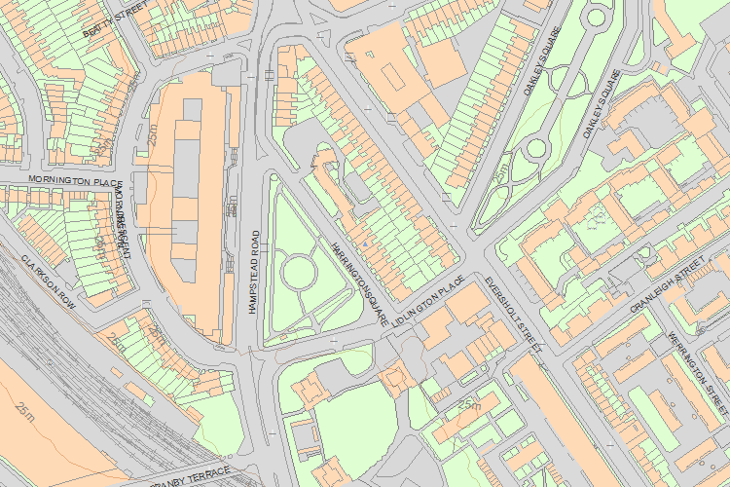© Crown Copyright and database right 2017. All rights reserved. Ordnance Survey Licence number 100024900.
© British Crown and SeaZone Solutions Limited 2017. All rights reserved. Licence number 102006.006.
Use of this data is subject to Terms and Conditions.
The above map is for quick reference purposes only and may not be to scale. For a copy of the full scale map, please see the attached PDF - 1378736 .pdf
The PDF will be generated from our live systems and may take a few minutes to download depending on how busy our servers are. We apologise for this delay.
This copy shows the entry on 31-Jan-2017 at 02:19:17.
End of official listing

Your Contributions

