Montagu Evans LLP
5 Bolton Street
London
W1J 8BA
5 Bolton Street  London  W1J 8BA |  | Application Ref: 2016/1776/L
 |  | Please ask for: Kate Phillips
 |  | Telephone: 020 7974 2521
 |  | 14 September 2016

Dear Sir/Madam

DECISION

Planning (Listed Building and Conservation Areas) Act 1990

Listed Building Consent Refused

Address:
Land at Chester Gate adjacent to Nos. 6-10 Cambridge Terrace
London
NW1 4JL

Proposal:
Various works relating to reinstatement of historic garden on Chester Gate, including repositioning of railings and lamp posts, and associated works
Drawing Nos: Chester Gate Landscape Report: Garden Works (dated 02/03/2016); Transport Statement (dated March 2016); Heritage Statement (dated March 2016); Design & Access Statement (dated March 2016); 639 - 1.002; 622.01 (PP) 001; 622.01 (PP) 002; 622.01 (CD) 001; 622.01 (MP) 001; 622.01 (SC) 001 Rev RJH; 6932 - 4.901; 6932 - 4.903; 622.02 (SC) 001 Rev P2; 622.02 (SC) 002 Rev P2; 622.02(SC) 003 Rev P2.

The Council has considered your application and decided to refuse listed building consent for the following reason(s):

Reason(s) for Refusal

1 | The proposed development, by reason of the design, the lack of historical evidence to support the proposed creation of a private garden and the loss of historic curtilage fabric, would cause harm to the listed building and its setting and there is no public benefit to outweigh the less than substantial harm caused to the heritage asset. The proposal is contrary to Policy CS14 (Promoting high quality places and conserving our heritage) of the London Borough of Camden Local Development Framework Core Strategy and Policy DP25 (Conserving Camden's heritage) of the London Borough of Camden Local Development Framework Development Policies.

Informative(s):

You can find advice about your rights of appeal at:

http://www.planningportal.gov.uk/planning/appeals/guidance/guidancecontent

Yours faithfully
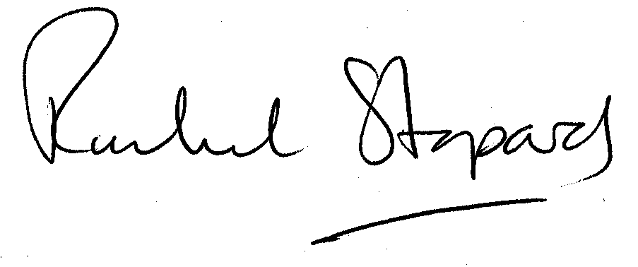
Rachel Stopard
Executive Director Supporting Communities

