
- Menu
- Search

What are you looking for?

Click anywhere to close (ESC)

- Listing
  - Search the List
  - Enrich the List
  - Apply for Listing
  - What is Listing?
  - Listing Guidance
- Advice
  - Your Home
  - Planning
  - Latest Advice & Guidance
  - Caring for Heritage
  - Technical Guidance
  - Heritage at Risk
  - Constructive Conservation
  - Heritage Protection Guide
- Research
  - Our Research Strategy and Agenda
  - Research Methods
  - Current Research
  - Research Results
  - Support & Collaboration
  - Inclusive Heritage
  - Heritage Counts
- Images & Books
  - Find Photos
  - Search All Publications
  - Buy Books
  - The Historic England Archive
  - Be an Archive Detective
- Services & Skills
  - Education
  - Grants
  - Our Planning Services
  - Training & Skills
  - Archive Services
  - Heritage Action Zones
- Get Involved
  - Be a Volunteer
  - Protect Your Heritage
  - Help Write History
  - Visit Your Heritage
- What's New
  - News
  - In Your Area
  - Latest Listings
  - Latest Research
  - Heritage Online Debate
  - Statements
  - Stay Up To Date
  - Black British History
  - Open All Hours
  - Angel Awards
  - FWW Centenary

  - What We Do
  - Who We Are
  - Jobs
  - Contact Us
  - Volunteer with Historic England

  - Website Terms and Conditions
  - Data Protection
  - Privacy and Cookies
  - Links Policy
  - Historic England Blog: House Rules
  - Listed Property Owner Survey Competition Terms and Conditions
This browser is not fully supported by Historic England. Please update your browser to the latest version so that you get the best from our website.
We use cookies to give you the best possible experience online. By using this website, you consent to cookies being used in accordance with our Cookie Policy.
- Home
- ...
- Listing
- Search the List
- List Entry
- Section Navigation
  - Map Search
  - Minor Amendments
  - Download Listing Data
  - Non-Listed Sites
  - About The List
  - Enrich the List
  - Understanding List Entries

NUMBERS 1-10 AND ATTACHED RAILINGS

List Entry Summary
This building is listed under the Planning (Listed Buildings and Conservation Areas) Act 1990 as amended for its special architectural or historic interest.
Name: NUMBERS 1-10 AND ATTACHED RAILINGS
List entry Number: 1244296

Location
NUMBERS 1-10 AND ATTACHED RAILINGS, 1-10, CAMBRIDGE TERRACE
The building may lie within the boundary of more than one authority.
County: Greater London Authority
District: Camden
District Type: London Borough
Parish:
National Park: Not applicable to this List entry.
Grade: I
Date first listed: 14-May-1974
Date of most recent amendment: Not applicable to this List entry.

Legacy System Information
The contents of this record have been generated from a legacy data system.
Legacy System: LBS
UID: 476795

Asset Groupings
This list entry does not comprise part of an Asset Grouping. Asset Groupings are not part of the official record but are added later for information.

List entry Description

Summary of Building
Legacy Record - This information may be included in the List Entry Details.

Reasons for Designation
Legacy Record - This information may be included in the List Entry Details.

History
Legacy Record - This information may be included in the List Entry Details.

Details
CAMDEN
TQ2882NE CAMBRIDGE TERRACE 798-1/87/145 (East side) 14/05/74 Nos.1-10 (Consecutive) and attached railings
GV I
Terrace of 10 houses. 1825. By John Nash. Northern half, Nos 7-10 rebuilt in facsimile 1986 (war damage), restoring exact external details and symmetry of terrace. Stucco with rusticated ground floor. Slated mansard roof with dormers. EXTERIOR: 4 storeys, attics and basements. 26 window range. Slightly projecting end and original centre bay (with recessed centre). Square-headed ground floor openings; panelled doors with overlights. Recessed sashes. Projecting bays with paired Doric columns, having rusticated blocks at intervals, supporting an entablature and balustrade at 1st floor level. Beneath, square-headed tripartite sashes with segmental arches. Upper floors with architraved sashes and continuous cast-iron balcony to 1st floor windows. Projecting bays with enriched pilaster strips through 1st and 2nd floors and at 3rd floor; 1st floor windows round-arched with radial patterned top and tripartite sash lower portion. Main dentil cornice at 3rd floor level. Cornice and blocking course above 3rd floor. Right hand return with projecting bowed bay rising the height of the building. Left hand return of 4 windows and with double Doric portico. INTERIORS: not inspected. SUBSIDIARY FEATURES: attached cast-iron railings to areas. Nos 7-10 were listed on 08/02/88. (Survey of London: Vol. XIX, Old St Pancras and Kentish Town (St Pancras II): London: -1938: 122).
Listing NGR: TQ2875882534

Selected Sources
Books and journals
'Survey of London' in Old St Pancras and Kentish Town The Parish of St Pancras Part 2: Volume 19 , (1938), 122
National Grid Reference: TQ 28757 82557

Map
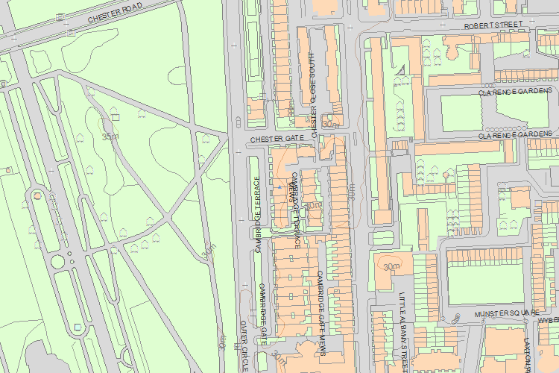© Crown Copyright and database right 2017. All rights reserved. Ordnance Survey Licence number 100024900.
© British Crown and SeaZone Solutions Limited 2017. All rights reserved. Licence number 102006.006.
Use of this data is subject to Terms and Conditions.
The above map is for quick reference purposes only and may not be to scale. For a copy of the full scale map, please see the attached PDF - 1244296 .pdf
The PDF will be generated from our live systems and may take a few minutes to download depending on how busy our servers are. We apologise for this delay.
This copy shows the entry on 31-Jan-2017 at 11:17:03.
End of official listing

Your

