77A BELSIZE PARK GARDENS, LONDON NW3 4JP; PROPOSED FLANK WINDOW at LGFL PHOTOS for PLANNING APPLICATION

Richard Kay Architect Ltd. 11.01.2017

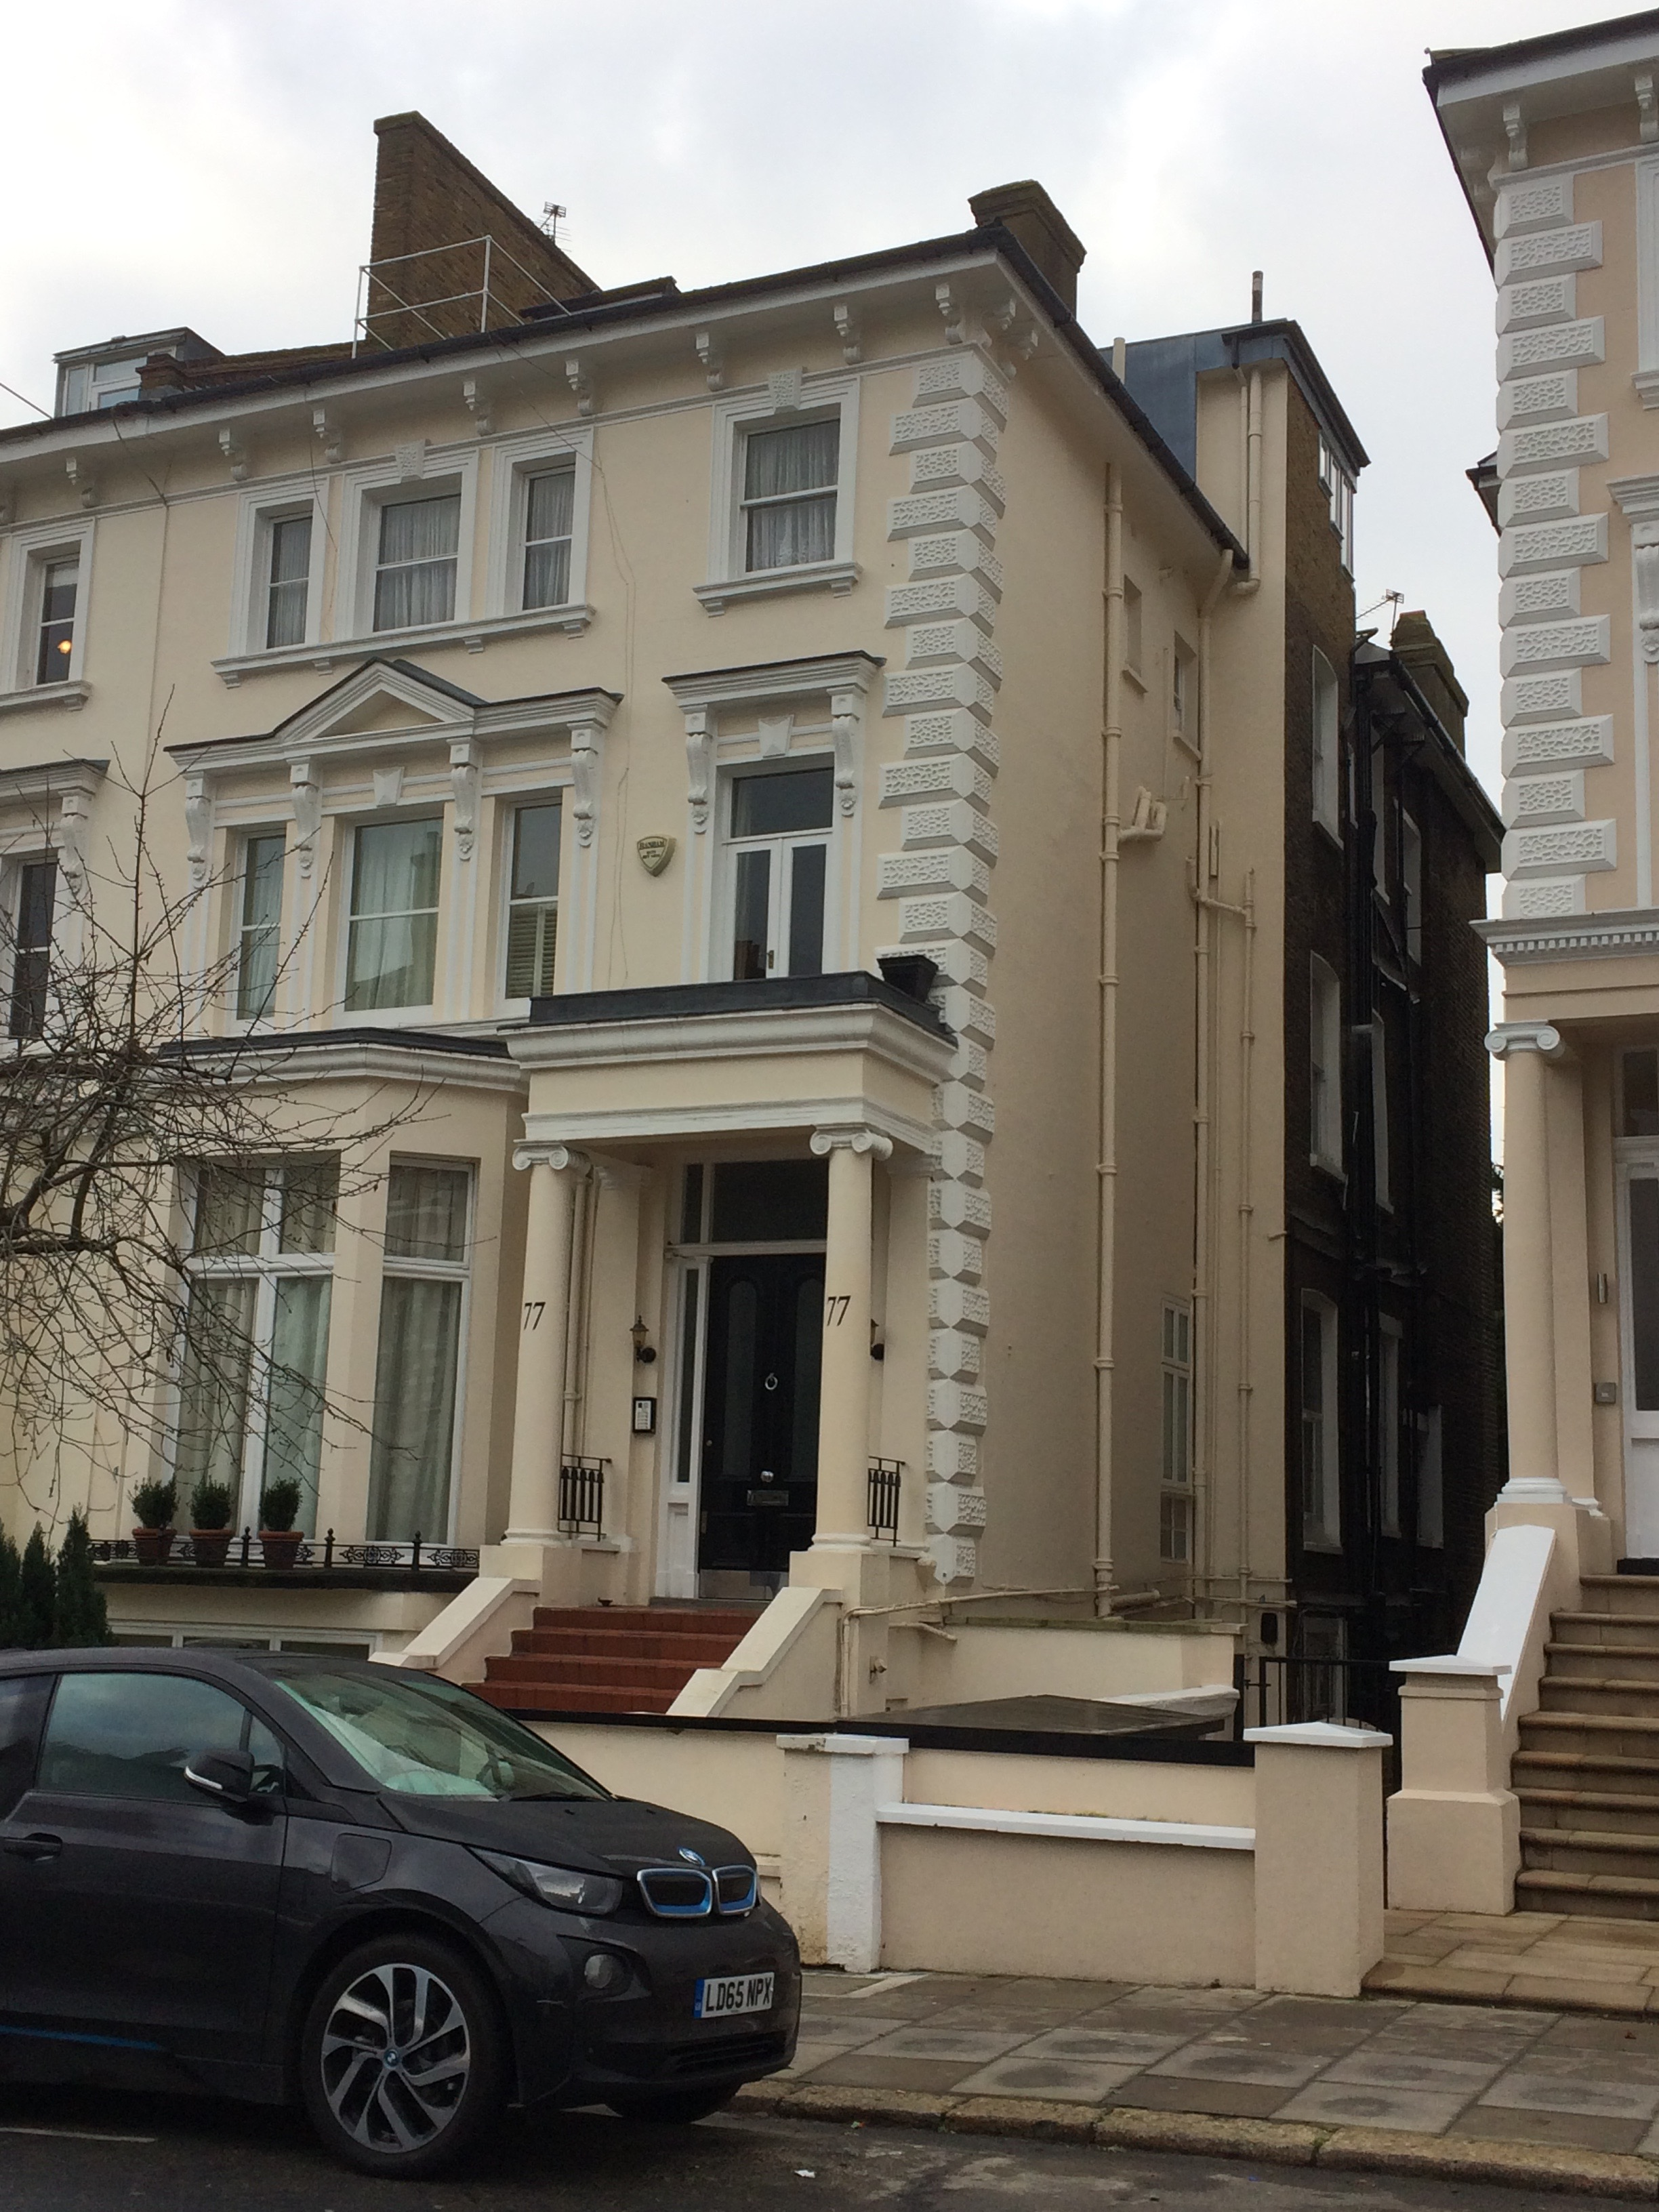

Front elevation

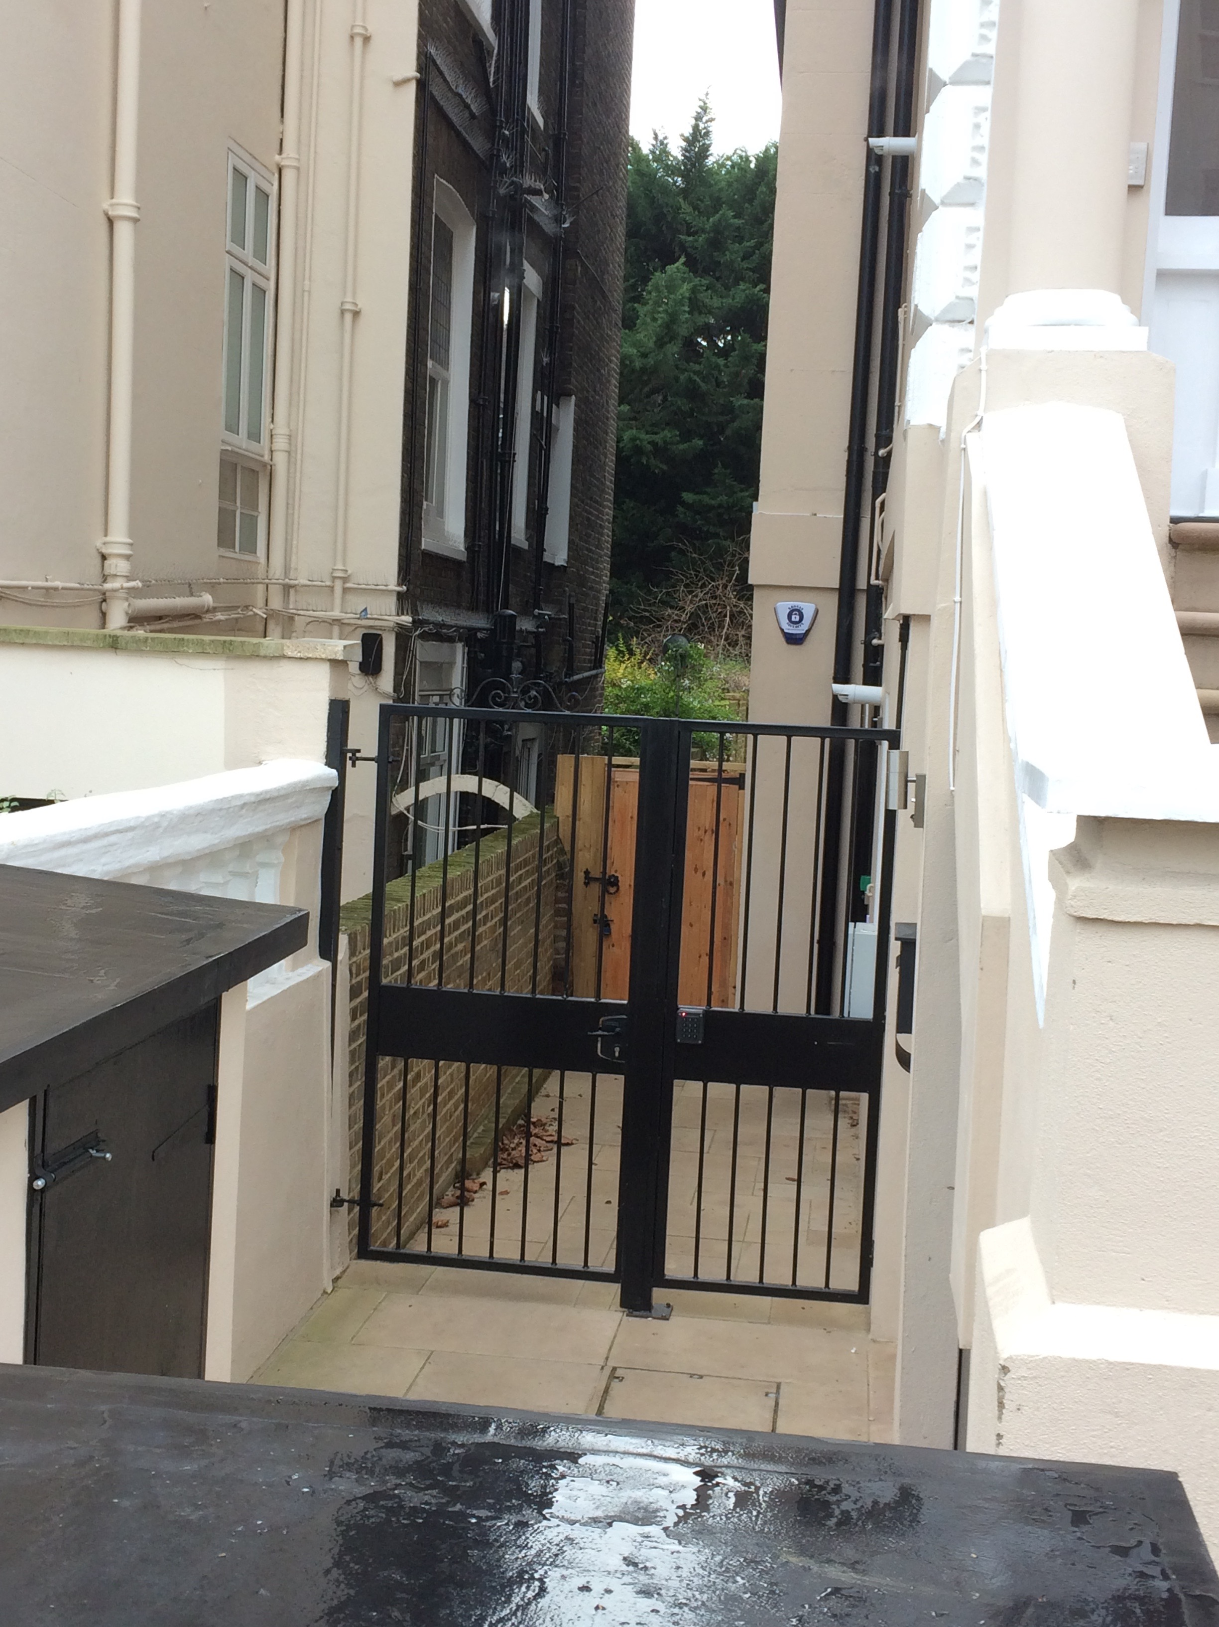

Flank viewed from front of 75 Belsize Park Gardens
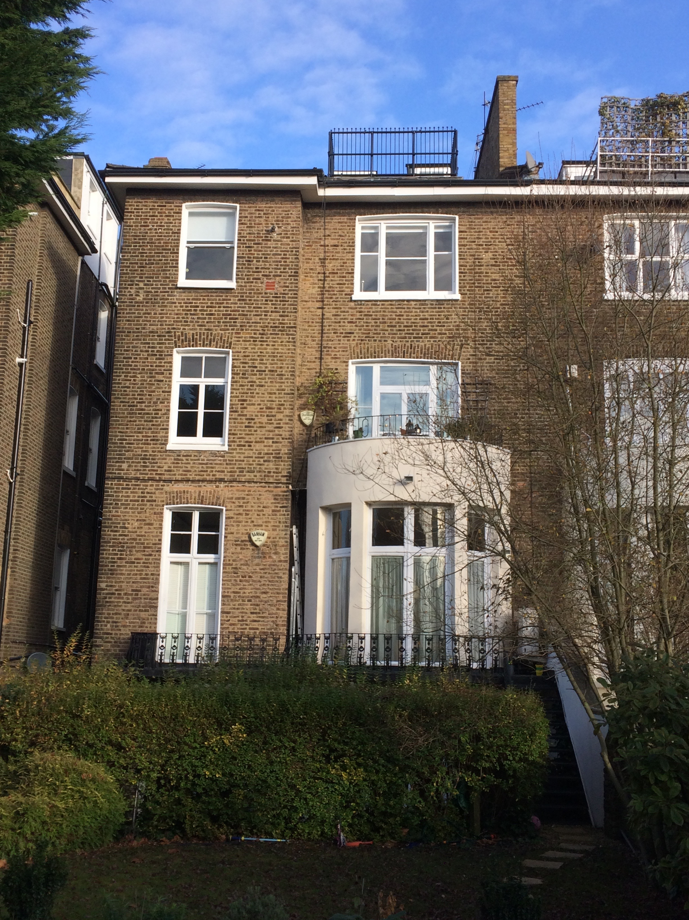

Rear Elevation

Circulation: Camden Council Planning Department/Planning Portal ) with planning application
Applicants: Mr. & Mrs. Alpay )

