
- Menu
- Search

What are you looking for?

Click anywhere to close (ESC)

- Listing
  - Search the List
  - Enrich the List
  - Apply for Listing
  - What is Listing?
  - Listing Guidance
  - Showcasing Designation
- Advice
  - Your Home
  - Planning
  - Latest Advice & Guidance
  - Caring for Heritage
  - Technical Guidance
  - Heritage at Risk
  - Constructive Conservation
  - Heritage Protection Guide
- Research
  - Research Approaches
  - Current Research
  - Research Results
  - Support & Collaboration
  - Inclusive Heritage
- Images & Books
  - Search All Publications
  - Buy Images
  - Books
  - The Historic England Archive
  - Aerial Photos
  - Magazines
  - Picturing England
- Services & Skills
  - Grants
  - Our Planning Services
  - Education
  - Training & Skills
  - Archive Services
  - Heritage Action Zones
- Get Involved
  - Be a Volunteer
  - Protect Your Heritage
  - Help Write History
  - Visit Your Heritage
- News & Features
  - News
  - Statements
  - Newsletter
  - First World War
  - The Second World War and the Blitz
  - Angel Awards
  - Exhibitions

  - What We Do
  - How We Are Run
  - Jobs
  - Contact Us
  - Volunteer with Historic England

  - Website Terms and Conditions
  - Data Protection
  - Privacy and Cookies
  - Links Policy
  - Historic England Blog: House Rules
  - Gormley’s ROOM Competition Terms and Conditions
This browser is not fully supported by Historic England.
We use cookies to give you the best possible experience online. By using this website, you consent to cookies being used in accordance with our Cookie Policy.
- Home
- ...
- Listing
- Search the List
- List Entry
- Section Navigation
  - Minor Amendments
  - Download Designation Data
  - Non-Listed Sites

GREAT NORTHERN HOTEL AND ATTACHED RAILINGS

List Entry Summary
This building is listed under the Planning (Listed Buildings and Conservation Areas) Act 1990 as amended for its special architectural or historic interest.
Name: GREAT NORTHERN HOTEL AND ATTACHED RAILINGS
List entry Number: 1113244

Location
GREAT NORTHERN HOTEL AND ATTACHED RAILINGS, PANCRAS ROAD
The building may lie within the boundary of more than one authority.
County: Greater London Authority
District: Camden
District Type: London Borough
Parish:
National Park: Not applicable to this List entry.
Grade: II
Date first listed: 06-Jul-1984
Date of most recent amendment: Not applicable to this List entry.

Legacy System Information
The contents of this record have been generated from a legacy data system.
Legacy System: LBS
UID: 477694

Asset Groupings
This list entry does not comprise part of an Asset Grouping. Asset Groupings are not part of the official record but are added later for information.

List entry Description

Summary of Building
Legacy Record - This information may be included in the List Entry Details.

Reasons for Designation
Legacy Record - This information may be included in the List Entry Details.

History
Legacy Record - This information may be included in the List Entry Details.

Details
CAMDEN
TQ3083SW PANCRAS ROAD 798-1/85/1266 (East side) 06/07/84 Great Northern Hotel and attached railings
GV II
Hotel. 1854, by Lewis Cubitt. Yellow stock brick with stucco dressings. Slate roof with pedimented dormers. Crescent shaped building. Concave main facade towards King's Cross Station, Euston Road (qv). EXTERIOR: 5 storeys, attic and basement. 18 windows wide; southern return 5 windows with slightly advanced central bay. Sixth and thirteenth bays slightly advanced with tripartite windows and stucco dressings; 1st and 2nd floors, triangular pediments and segmental pediments respectively. Below that to left hand side, the main entrance with cast-iron and wood portico; round-arched glazing. Round-arched ground floor openings with stucco keystones and impost bands. Plain stucco bands at 1st, 2nd, and 3rd floor levels. Other windows square-headed, 1st to 3rd floor with stucco architraves. Modillion cornice. Prominent slab chimney-stacks. Road facade similar. INTERIOR: not inspected. SUBSIDIARY FEATURES: attached cast-iron railings of geometric design to areas. HISTORICAL NOTE: curved plan reflects the original alignment of Pancras Place, now Pancras Road. The hotel was one of the first to include rooms on the "continental system" with bedrooms en suite with sitting rooms. The company prided itself on the fireproof construction of the hotel, with thick walls dividing every room and with the corridors constructed of brick arches supported by iron girders. (Hunter M and Thorne R (eds.): Change at King's Cross: London: -1990: 77-79).
Listing NGR: TQ3017883017

Selected Sources
Books and journals
Hunter, M, Thorne, R, Change at Kings Cross, (1990), 77,78,79
National Grid Reference: TQ 30178 83017

Map
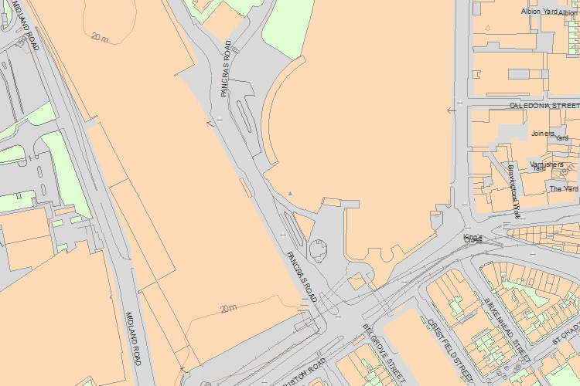© Crown Copyright and database right 2016. All rights reserved. Ordnance Survey Licence number 100024900.
© British Crown and SeaZone Solutions Limited 2016. All rights reserved. Licence number 102006.006.
Use of this data is subject to Terms and Conditions.
The above map is for quick reference purposes only and may not be to scale. For a copy of the full scale map, please see the attached PDF - 1113244 .pdf
The PDF will be generated from our live systems and may take a few minutes to download depending on how busy our servers are. We apologise for this delay.
This copy shows the entry on 21-Apr-2016 at 11:21:41.
End of official listing

