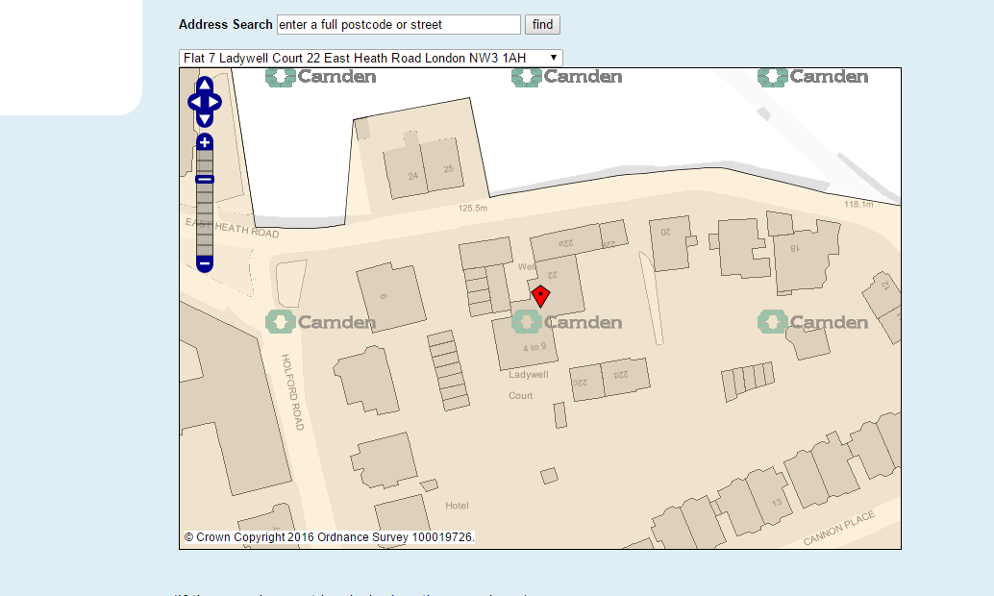
T1 Sycamore T2 Sycamore

