**Design Statement**

Site Detail:

82 Heath Street

Ref No.

2016/6383/NEW

As the client requested us (agents) to apply for Display and Advertisement application for renewal of the new facial sign.

The main reason of the change is, the property is under new management and they will be using the property as Florist, the existing sign and the proposed sign will be identical the only change will be the name, the project sign will be only renewed. Apart from them there weren’t be any changes.

THE EXISTING SIGN AND PROPOSED SIGN IS IDENTICAL ONLY THE PANLES WILL BE CHANGED. AND THE EXISTING PANAL AND PROPOSED PANEL IS ALUMINIUM COMPOSITE LOOK AT PAGE 2 SHOWS IN DETAIL THE MATERIAL THAT WILL BE USED. IF THE DRAWINGS CAN BE REVIEWED AGAIN IN DETAIL THERE IS ALL THE MESAURNMENTS.

This statement will be support with all our drawings. If you have any questions please do not hesitate to contact me from, [memet](mailto:memet@tm-london.uk)_g@hotmail.co.uk or 07712113991.

Thank you

Memet Gumus

Kind Regards

**Existing sign**

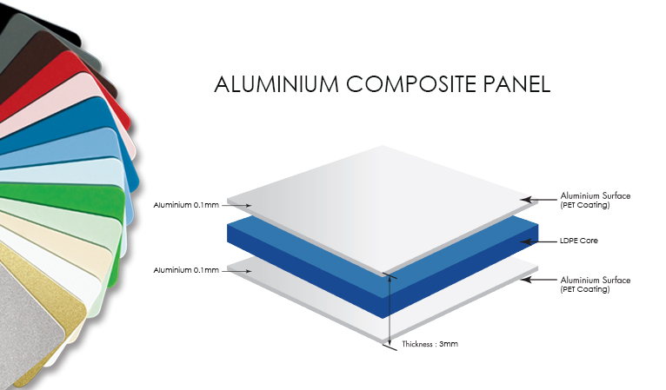

**sign material**

