**Application for Full Planning Permission**

The following statement has been prepared to accompany the Householders Planning Application for the proposed alterations at: 80a College Place, London, NW1 0DJ

Proposal: Removal of section of rear external wall and formation of aluminum sliding doors.

Applicant: Mike McKinlay

Date: 28 November 201

**Introduction**

The application relates to a ground floor period flat located in Camden Town. The property was purchased 12 years ago by the Applicant who wishes to refurbish, and improve the natural light and thermal efficiency in the kitchen by installing high performance glazed doors.

**Use**

Dwellinghouse

**Layout**

The layout will remain unchanged

**Access**

As existing

**External existing**

The external wall to be removed looks out to the applicant’s small walled patio garden and therefore does not overlook any neighbouring properties.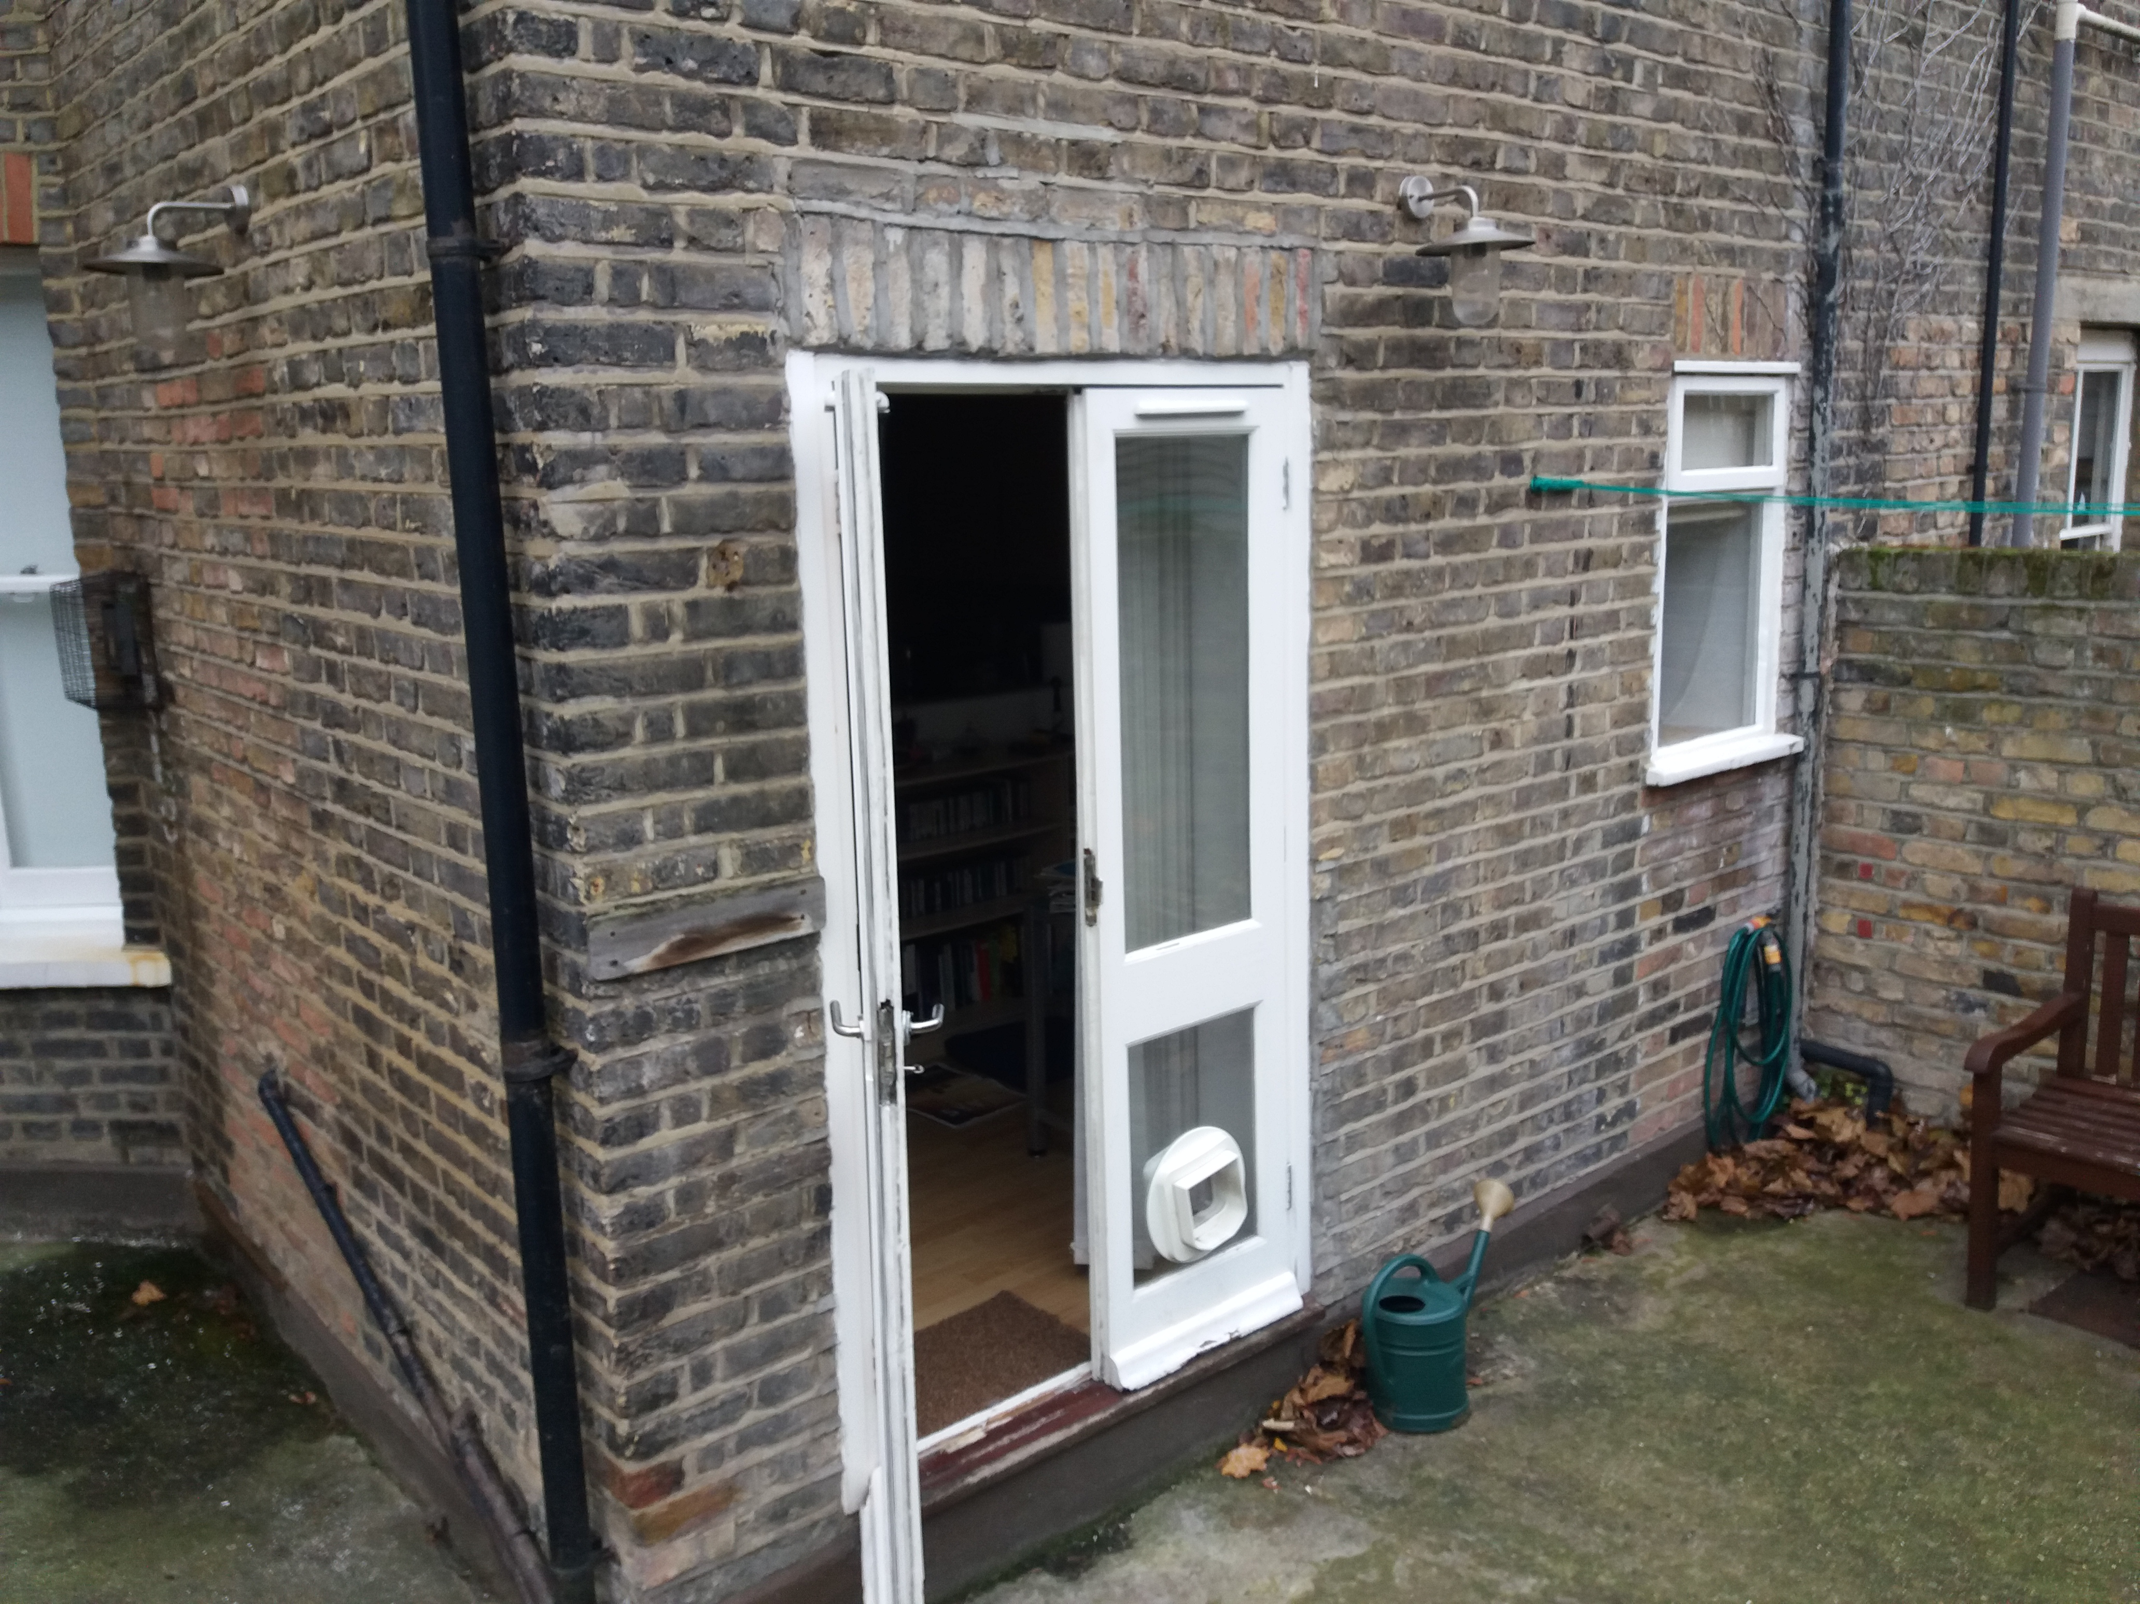

Internal existing:

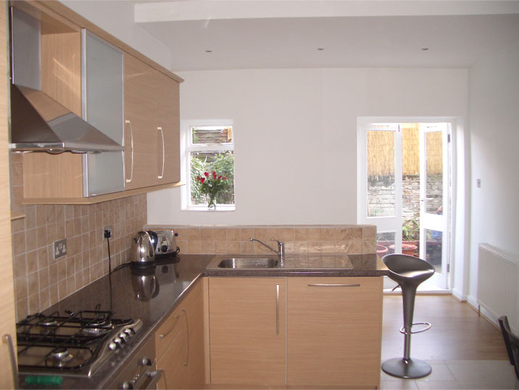

**Proposed sliding door specification**

Lift and slide door to be manufactured in the Schuco ASS70Hi aluminum system powder coated to standard RAL colour (slate grey). Door to be in 2 panes with both panes sliding alternatively. Glazing to be fully toughened safety glass with 6mm clear tough Low E soft coat as inner pane, 16mm argon gas filled cavity with warm edge spacer and 6mm clear toughened outer pane. Ironmongery to be in standard Silver Aluminium Anodised finish.

The setback of the doors to match the existing setback of the French doors and window which are currently in place.

**Design of doors**

The photograph below shows an example of the proposed doors design externally

