**Construction Management**

**Plan**

**pro forma** v2.1

30 Camden St, NW1 0LG

Quinn London Ltd

**Contents**

**Revisions 3**

**Introduction 4**

**Timeframe 6**

**Contact 7**

**Site 9**

**Community liaison 12**

**Transport 15**

**Environment 25**

**Agreement 30**

**Appendices**

**A – Programmes**

**B – Site Plans**

**C – CLOCS and FORS**

**D – Logistics Plans**

**E – Monitoring Locations**

**F – Construction Working Group minutes and correspondence**

**G – Delivery Schedule Template**

**Revisions & additional material**

Please list all iterations here:

|  |  |  |
| --- | --- | --- |
| **16.12.16** | **B** | **M. Mullen** |
| **19.12.16** | **C** | **W. Bragg** |

**Additional sheets**

Please note – the review process will be quicker if these are submitted as Word documents or searchable PDFs.

|  |  |  |
| --- | --- | --- |
| **Date** | **Version** | **Produced by** |
|  |  |  |

**Introduction**

The purpose of the **Construction Management Plan (CMP)** is to help developers to minimise construction impacts, and relates to both on site activity and the transport arrangements for vehicles servicing the site.

It is intended to be a live document whereby different stages will be completed and submitted for application as the development progresses.

The completed and signed CMP must address the way in which any impacts associated with the proposed works, and any **cumulative impacts of other nearby construction sites**, will be mitigated and managed. The level of detail required in a CMP will depend on the scale and kind of development. Further policy guidance is set out in Camden Planning Guidance [**(CPG)** 6: Amenity](http://www.camden.gov.uk/ccm/content/environment/planning-and-built-environment/two/planning-policy/supplementary-planning-documents/camden-planning-guidance.en) and [**(CPG)** 8: Planning Obligations](http://www.camden.gov.uk/ccm/content/environment/planning-and-built-environment/two/planning-policy/supplementary-planning-documents/camden-planning-guidance.en).

This CMP follows the best practice guidelines as described in [Transport for London’s](https://www.tfl.gov.uk/info-for/freight/safety-and-the-environment/improving-construction-safety) (TfL’s Standard for [Construction Logistics and Cyclist Safety](http://www.clocs.org.uk/standard-for-clocs/) (**CLOCS**) scheme) and [Camden’s Minimum Requirements for Building Construction](http://www.camden.gov.uk/ccm/cms-service/download/asset?asset_id=3257318) **(CMRBC)**.

The approved contents of this CMP must be complied with unless otherwise agreed with the Council in writing. The project manager shall work with the Council to review this CMP if problems arise in relation to the construction of the development. Any future revised plan must also be approved by the Council and complied with thereafter.

It should be noted that any agreed CMPdoes not prejudice or override the need to obtain any separate consents or approvals such as for road closures or hoarding licences.

If your scheme involves any demolition, you need to make an application to the Council’s Building Control Service. Please complete the “[**Demolition Notice**](http://www.camden.gov.uk/ccm/content/environment/building-control/file-storage-items/demolition-notice---the-building-act-1984-section-80-notice-bc104-.en)**.**”

Please complete the questions below with additional sheets, drawings and plans as required. The boxes will expand to accommodate the information provided, so please provide as much information as is necessary. **It is preferable if this document, and all additional documents, are completed electronically and submitted as Word files to allow comments to be easily documented. These should be clearly referenced/linked to from the CMP.**

Please notify that council when you intend to start work on site. Please also notify the council when works are approximately **3 months from completion.**

(Note the term 'vehicles' used in this document refers to all vehicles associated with the implementation of the development, e.g. demolition, site clearance, delivery of plant & materials, construction, etc.)

Revisions to this document may take place periodically. **Timeframe**

**DEVELOPER ACTIONS**

**COUNCIL ACTIONS**

**Post app submission**

**0ommunity liaison**

**Appoint principal contractor**

**Requirement to submit CMP**

**Begin community liaison**

**Work can commence if draft CMP is approved**

**Council response to second draft**

**Resubmission of CMP if first draft refused**

**2ommunity liaison**

**3ommunity liaison**

**1ommunity liaison**

INDICATIVE TIMEFRAME (MONTHS)

**4ommunity liaison**

**Council response to draft**

**Submit draft CMP**

**Contact**

1. Please provide the full postal address of the site and the planning reference relating to the construction works.

Address: 30 Camden St

Planning ref: 2013/1969/P

Type of CMP - Section 106 planning obligation/Major sites framework:

2. Please provide contact details for the person responsible for submitting the CMP.

Name: Michael Mullen

Address: Quinn Ldn Ltd, Dome House, 8 Hartley Ave, NW7 2HX

Email: Michael.mullen@quinnlondon.co.uk

Phone: 077 1507 6733

3. Please provide full contact details of the site project manager responsible for day-to-day management of the works and dealing with any complaints from local residents and businesses.

Name: Warren Bragg

Address: Quinn Ldn Ltd, Dome House, 8 Hartley Ave, NW7 2HX

Email: [warren.bragg@quinnlondon.co.uk](mailto:warren.bragg@quinnlondon.co.uk)

Phone: 078 8953 7134

4. Please provide full contact details of the person responsible for community liaison and dealing with any complaints from local residents and businesses if different from question 3. In the case of [**Community Investment Programme (CIP)**](http://www.camden.gov.uk/ccm/content/environment/planning-and-built-environment/two/placeshaping/twocolumn/the-community-investment-programme.en), please provide contact details of the Camden officer responsible.

Name: Rebecca Ellis

Address: Consultation and Engagement officer, Camden Council

Email:Rebecca.ellis@camden.gov.uk

Phone: 0207 974 3878

5. Please provide full contact details including the address where the main contractor accepts receipt of legal documents for the person responsible for the implementation of the CMP.

Name: Henry Kiviorg

Address: Quinn Ldn Ltd, Dome House, 8 Hartley Ave, NW7 2HX

Email: henry.kiviorg@quinnlondon.co.uk

Phone: 075 1557 9267

**Site**

6. Please provide a site location plan and a brief description of the site, surrounding area and development proposals for which the CMP applies.

The site is located on the ground of St Pancreas community center on Camden St. Plender St runs perpendicular to the North with Crowndale St to the South. The site lies to the east of the 1 way A400 and and the Cobden primary school opposite. All areas to the North, west and South are residential.

The old St Pancreas Community center occupies the West of the site and Camden Studies occupy the East. The development will see the old community center being demolished to make way for the conatruction of 14 new apartments housed in 1 block. Further details of the works are detailed belater.

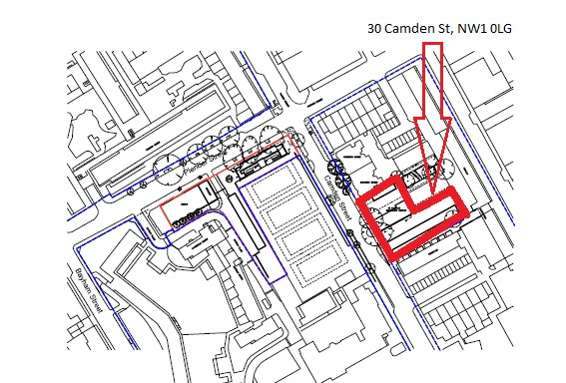

7. Please provide a very brief description of the construction works including the size and nature of the development and details of the main issues and challenges (e.g. narrow streets, close proximity to residential dwellings etc).

The overall scope of the project is to demolish the existing community center and build 14 No. new apartments, there is also a requirement to re-weather the existing roof to the studios at the rear of the property.

The existing community center is approx. 400 sq/m in footprint, it consists of a basement that has an area of 150 sq/m. The buildings super structure consists of a concrete foundations and slab, masonry brickwork makes up the external envelope, the structural roof consists of timber and is weathered in zinc.

Having served as a community center for decades, it is evident that the building is past its sell by date. A new purpose built center has been built in Pender street to serve the community.

The new apartment block will be constructed once the community center has been completed. The block will consist of 14 Units, 5 No. 2 beds, 5 No. 1 beds and 4 No. 3 beds.The existing basement will be filled in as part of the groundworks. The foundation will consist of a raft foundation supported on concrete piles. The main elevelope will be masonry brickwork to match the new community center at Plender st, The main frame will be RC construction. A green roof will complete the superstructure. There will be 1 No. passenger lift, a plant room, bin store and also bicycle.

Running parallel to the main development is the requirement to re-weather the studios at the rear of the community center. There are 10 No. studio Units, 9 of which are occupied. The construction of these are as per the existing community center. The scope of work to these units is to replace the existing zinc roof membrane and replacing it with a similar approved finish. Rainwater good will also be replaced where required.

Prior to the main building works detailed above, QLL will have taken possession of the site to carry out enabling works such as trial pits, surveys, hoarding erection etc.

A step by step overview of the main works is detailed below:

**Re-weathering of Studios:**

* Removal of highlighted asbestos as per the report.
* The erection of scaffolding around the perimeter of existing studio buildings. This will be to gain access to roof section only.
* Replacing the existing roof panels with new panels which will match the existing.
* Replacing rainwater goods to existing studio.
* Commence soft strip of community centre.
* Demolition of existing garages.

**Demolition of community center and new build apartments:**

* Demolition of existing community centre.
* New build inclusive of foundations, the superstructure of the building will consist of: -
* Concrete piled foundation supports.
* RC Concrete raft foundation.
* RC Concrete frame.
* Masonry brickwork to external walls.
* Traditional drywall internal walls and warm deck roofing system.

The footprint will increase from the existing of 420 sq/m to 590 sq/m.

8. Please identify the nearest potential receptors (dwellings, business, etc.) likely to be affected by the activities on site (i.e. noise, vibration, dust, fumes, lighting etc.). 

9. Please provide a scaled plan detailing the local highway network layout in the vicinity of the site. This should include details of on-street parking bay locations, cycle lanes, footway extents and proposed site access locations.

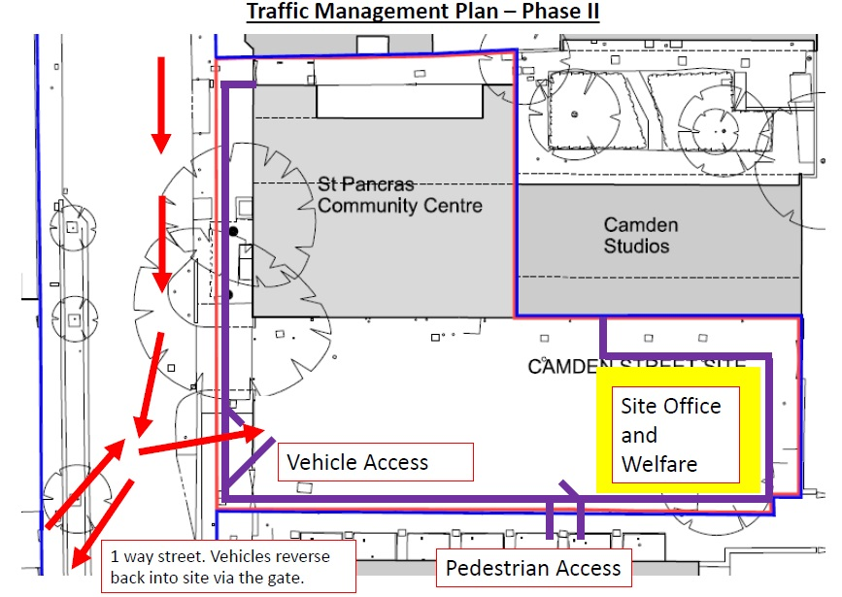

10. Please provide the proposed start and end dates for each phase of construction as well as an overall programme timescale. (A Gantt chart with key tasks, durations and milestones would be ideal).

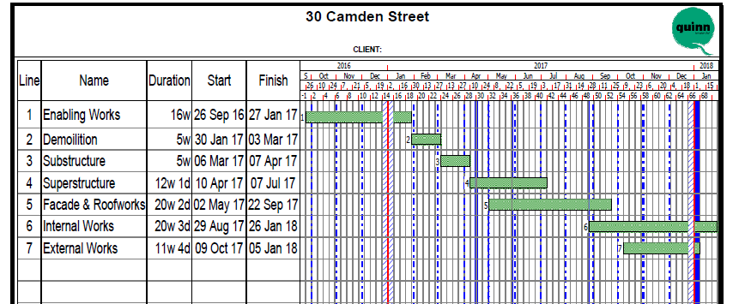

11. Please confirm the standard working hours for the site, noting that the standard working hours for construction sites in Camden are as follows:

* 8.00am to 6pm on Monday to Friday
* 8.00am to 1.00pm on Saturdays
* No working on Sundays or Public Holidays

Site hours will be as noted above.

12. Please indicate if any changes to services are proposed to be carried out that would be linked to the site during the works (i.e. connections to public utilities and/or statutory undertakers’ plant). Larger developments may require new utility services. If so, a strategy and programme for coordinating the connection of services will be required. If new utility services are required, please confirm which utility companies have been contacted (e.g. Thames Water, National Grid, EDF Energy, BT etc.) You must explore options for the utility companies to share the same excavations and traffic management proposals. Please supply details of your discussions.

The site will require new utility connections for gas, water and electricity, as this is a design and build schemes, applications will be made at a later date upon design completion that will determine requirements. Application will be made by the relevant utility provider to meet their needs.

All

**Community Liaison**

**A neighbourhood consultation process must have been undertaken prior to submission of the CMP first draft. This consultation must relate to construction impacts, and should take place following the grant of planning permission in the lead up to the submission of the CMP. A consultation process specifically relating to construction impacts must take place regardless of any prior consultations relating to planning matters. This consultation must include all of those individuals that stand to be affected by the proposed construction works. These individuals should be provided with a copy of the draft CMP, or a link to an online document. They should be given adequate time with which to respond to the draft CMP, and any subsequent amended drafts. Contact details which include a phone number and email address of the site manager should also be provided.**

Significant time savings can be made by running an effective neighbourhood consultation process. This must be undertaken in the spirit of cooperation rather than one that is dictatorial and unsympathetic to the wellbeing of local residents and businesses.

These are most effective when initiated as early as possible and conducted in a manner that involves the local community. Involving locals in the discussion and decision making process helps with their understanding of what is being proposed in terms of the development process. **The consultation and discussion process should have already started, with the results incorporated into the CMP first draft submitted to the Council for discussion and sign off.**This communication should then be ongoing during the works, with neighbours and any community liaison groups being regularly updated with programmed works and any changes that may occur due to unforeseen circumstances through newsletters, emails and meetings.

Please note that for larger sites, details of a construction working group may be required as a separate S106 obligation. If this is necessary, it will be set out in the S106 Agreement as a separate requirement on the developer.

**Cumulative impact**

Sites located within high concentrations of construction activity that will attract large numbers of vehicle movements should consider establishing contact with other sites in the vicinity in order to manage traffic routeing and volumes. Developers in the Tottenham Court Road area have done this to great effect.

**Quinn Statement on cumulative impact and effect:**

Quinn recognise that Camdne council have a requirement for us to consider the above in relation to our site and the surrounding areas. We have set out what we believe to be our ‘local area’ as per our drawing showing the potential receptors.

There are no major construction sites within our vicinity, as this is a relative small build compared to the larger developments in London, we will not require the larger plant or machinery typcal of the large build projects i.e, tower cranes etc.

We will manage traffic so that deliveries are co-ordinated in a manner that will not cause multiple deliveries at the same time. The entrance is on a one way stree that which also aids planning of deliveries and our supply chain in that there is only one route to site.

A traffic marshall will be able to see from an organisation chart of what deliveries are expected within each time frame, we plan to aloow 4 time slots per day.

**13. Consultation**

The Council expects meaningful consultation. For large sites, this may mean two or more meetings with local residents **prior to submission of the first draft CMP**.

Evidence of who was consulted, how the consultation was conducted and a summary of the comments received in response to the consultation. Details of meetings including minutes, lists of attendees etc. must be included.

In response to the comments received, the CMP should then be amended where appropriate and, where not appropriate, a reason should be given. The revised CMP should also include a list of all the comments received. Developers are advised to check proposed approaches to consultation with the Council before carrying them out. If your site is on the boundary between boroughs then we would recommend contacting the relevant neighbouring planning authority.

Please provide details of consultation of draft CMP with local residents, businesses, local groups (e.g. residents/tenants and business associations) and Ward Councillors.

As Principal Contractor, we will manage public relations proactively through liaison with neighbours via attendance at regular residents meetings, through newsletters and letters. Residents will be notified a minimum of 7 days in advance of noisy or dusty work activities.

Through our relationship with ‘Developing projects’, we will: -

Meet local residents group on the last Monday of every month as part of our Construction Working Group..

Write a monthly letter to local residents group, in terms of major works, we will write to them 1 week in advance

Have a ‘meet the contractor’ event for the wider community to visit and ask questions on the development.

Have a A3 notice board on the front of the site hoarding with updates, site contacts etc.

Our site manager will be the 1st point of contact and all correspondence will be logged.

Further to the first point, the monthly meeting with the residents will be considered as our working group, attendees will include: -

Site team

Residents committee and residents

Local councillor.

A no. of meetings and the meet the contractor event has already taken place.

Evidence of correspondence is in the Appendice’s.

**14. Construction Working Group**

Please provide details of community liaison proposals including any Construction Working Group that will be set up, addressing the concerns of the community affected by the works, the way in which the contact details of the person responsible for community liaison will be advertised to the local community, and how the community will be updated on the upcoming works i.e. in the form of a newsletter/letter drop, or weekly drop in sessions for residents.

Since possession of the site, we have been in regular consultation with Rebecca Ellis, local engagement officer of Camden council. In association with Simon Wooden of Developing projects we have met the local residents association on the following dates: -

26th September

24th October

21st November

These meetings will continue for the duration of the project.

We held a ‘meet the contractor’ on the 16th November.

**15. Schemes**

Please provide details of any schemes such as the ‘Considerate Constructors Scheme’, such details should form part of the consultation and be notified to the Council. Contractors will also be required to follow the “[Guide for Contractors Working in Camden](http://www.camden.gov.uk/ccm/cms-service/download/asset?asset_id=799001)” also referred to as “[Camden’s Considerate Contractors Manual](http://www.camden.gov.uk/ccm/cms-service/download/asset?asset_id=799001)”.

The site has been registered ith considerate constructors, site ID: 99460



Quinin will be pro-active in contributing to the local environment by:

Actively controlling works to minimise dust, noise, waste from neighbours.

Apply good practice in minimising noise.

Housekeeping to boundarys through daily upkeep.

Wheel washing vehicles.

Road claning as needed.

Friendly approach to neighbors/pedestrians alike.

Approcah King cross training college to provide training.

Regular contact with neighbors as noted earlier.

**16. Neighbouring sites**

Please provide a plan of existing or anticipated construction sites in the local area and please state how your CMP takes into consideration and mitigates the cumulative impacts of construction in the vicinity of the site. The council can advise on this if necessary.

There are no new build developents in close proximity that will impinge on our development in regard to deliveries/logistics.

**Transport**

**This section must be completed in conjunction with your principal contractor. If one is not yet assigned, please leave the relevant sections blank until such time when one has been appointed.**

Camden is a CLOCS Champion, and is committed to maximising road safety for Vulnerable Road Users (VRUs) as well as minimising negative environmental impacts created by motorised road traffic. As such, all vehicles and their drivers servicing construction sites within the borough are bound by the conditions laid out in the [CLOCS Standard.](http://www.clocs.org.uk/wp-content/uploads/2014/09/CLOCS-Standard-v1.2.pdf)

This section requires details of the way in which you intend to manage traffic servicing your site, including your road safety obligations with regard to VRU safety. It is your responsibility to ensure that your principal contractor is fully compliant with the terms laid out in the CLOCS Standard. It is your principal contractor’s responsibility to ensure that all contractors and sub-contractors attending site are compliant with the terms laid out in the CLOCS Standard.

Checks of the proposed measures will be carried out by the council to ensure compliance. Please refer to the CLOCS Standard when completing this section. Guidance material which details CLOCS requirements can be accessed [here](http://www.camden.gov.uk/ccm/cms-service/stream/asset?asset_id=3489660&), details of the monitoring process are available [here](http://www.camden.gov.uk/ccm/cms-service/stream/asset/?asset_id=3345820&).

Please contact [CLOCS@camden.gov.uk](mailto:CLOCS@camden.gov.uk) for further advice or guidance on any aspect of this section.

**CLOCS Considerations**

17. Name of Principal contractor:

Quinn Lonodn Ltd

18. Please submit the proposed method for checking operational, vehicle and driver compliance with the CLOCS Standard throughout the duration of the contract (please refer to our [CLOCS Overview document](http://www.camden.gov.uk/ccm/cms-service/stream/asset?asset_id=3489660&) and [Q18 example response](http://www.camden.gov.uk/ccm/cms-service/stream/asset?asset_id=3489661&)).

**Contracts**

FORS Bronze accreditation as a minimum will be a contractual requirement, FORS Silver or Gold operators will be appointed where possible. Where FORS Bronze operators are appointed, written assurance will be sought from contractors that all vehicles over 3.5t are equipped with additional safety equipment, and that all drivers servicing the site will have undertaken approved additional training (eg. SUD, elearning, Van Smart, on-cycle training etc). CLOCS Compliance will be included as a contractual requirement.

**Desktop checks**

Desktop checks will be made against the FORS database of trained drivers and accredited companies as outlined in the CLOCS Standard Managing Supplier Compliance guide. These will be carried out as per a risk scale based on that outlined in the CLOCS Managing Supplier Compliance guide.

**Site checks**

Checks of FORS ID numbers will form part of the periodic checks and will be carried out as per an appropriate risk scale.

Random spot checks will be carried out by site staff on vehicles and drivers servicing the site at a frequency based on the aforementioned risk scale. Results from these checks will be logged and retained, and enforced upon accordingly. Where the contractors own vehicles and drivers are used the above approach will be modified accordingly.

Collision reporting data will be requested from operators and acted upon when necessary.

19. Please confirm that you as the client/developer and your principal contractor have read and understood the [CLOCS Standard](http://www.clocs.org.uk/wp-content/uploads/2015/05/CLOCS-Standard-v1.2-APRIL_15.pdf) and included it in your contracts. Please sign-up to join the [CLOCS Community](http://www.clocs.org.uk/links-to-partners/) to receive up to date information on the standard by expressing an interest online.

I confirm that I have included the requirement to abide by the CLOCS Standard in my contracts to my contractors and suppliers:

I Michael Mullen, of Quinn London and our site team, have read and are taking a pro active approach to CLOCs and will abode by them for the project duration.

Please contact [CLOCS@camden.gov.uk](mailto:CLOCS@camden.gov.uk) for further advice or guidance on any aspect of this section.

**Site Traffic**

**Sections below shown in blue directly reference the CLOCS Standard requirements. The CLOCS Standard should be read in conjunction with this section.**

**20. Traffic routing**: *“Clients shall ensure that a suitable, risk assessed vehicle route to the site is specified and that the route is communicated to all contractors and drivers. Clients shall make contractors and any other service suppliers aware that they are to use these routes at all times unless unavoidable diversions occur.”* (P19, 3.4.5)

Routes should be carefully considered and risk assessed, taking into account the need to avoid where possible any major cycle routes and trip generators such as schools, offices, public buildings,museums etc. Where appropriate, on routes that use high risk junctions (i.e. those that attract high volumes of cycling traffic) installing Trixi mirrors to aid driver visibility should be considered.

Consideration should also be given to weight restrictions, low bridges and cumulative impacts of construction (including neighbouring construction sites) on the public highway network. The route(s) to and from the site should be suitable for the size of vehicles that are to be used.

1. Please indicate routes on a drawing or diagram showing the public highway network in the vicinity of the site including details of links to the [Transport for London Road Network](http://www.lscp.org.uk/lrsu/engineering_tlrn.html) (TLRN).

The site is situated on the A400 which is is a one way street running from North to South. All our supply chain will be required to enter the A400 via the A503 to minimise traffic on minor neighbourhood routes.

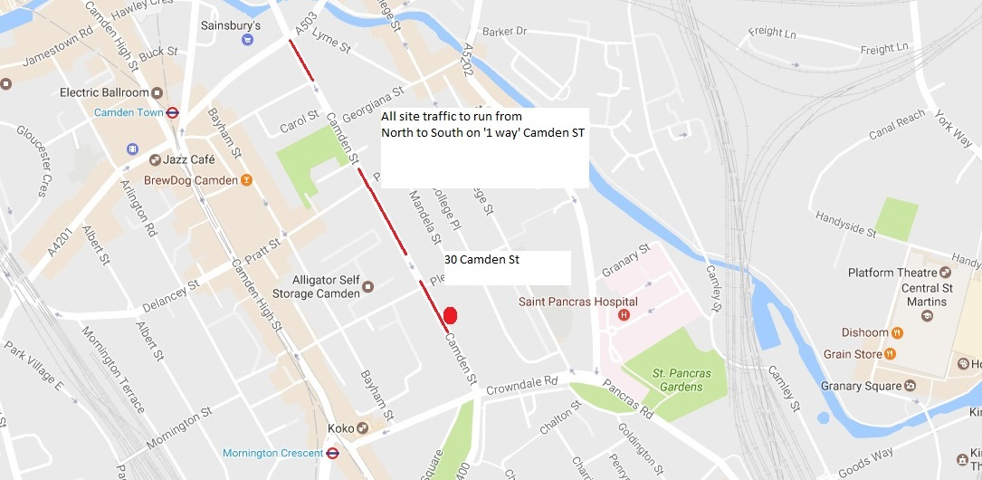

1. Please confirm how contractors, delivery companies and visitors will be made aware of the route (to and from the site) and of any on-site restrictions, prior to undertaking journeys.

Upon awarding of a contract, Quinn will conduct a ‘pre award’ meeting to discuss the contract requirements, one of which will be logistics as mentioned in this document. The meetings will be minuted and form part of the contract document which will need to be adhered to.

It will be a requirement for our supply chain to: -

Hold a minimum bronze level certification

Have necessary protection apparatus installed on vehicle

Have a class VI mirror fitted

Display prominent signage on vehicles to warn pedestrians and cyclists alike

**21. Control of site traffic, particularly at peak hours**: “*Clients shall consider other options to plan and control vehicles and reduce peak hour deliveries”* (P20, 3.4.6)

Construction vehicle movements are generally acceptable between 9.30am to 4.30pm on weekdays and between 8.00am and 1.00pm on Saturdays). If there is a school in the vicinity of the site or on the proposed access and/or egress routes, then deliveries must be restricted to between 9.30am and 3pm on weekdays during term time. (Refer to the [*Guide for Contractors Working in Camden*](http://www.camden.gov.uk/ccm/cms-service/download/asset?asset_id=799001)).

A delivery plan should ensure that deliveries arrive at the correct part of site at the correct time. Instructions explaining such a plan should be sent to all suppliers and contractors**.** Consideration should be given to the location of any necessary holding areas for large sites with high volumes of traffic. Vehicles must not wait or circulate on the public highway. Whilst deliveries should be given set times to arrive, dwell and depart, no undue time pressures should be placed upon the driver at any time.

1. Please provide details of the typical sizes of all vehicles and the approximate frequency and times of day when they will need access to the site, for each phase of construction.You should estimate the average daily number of vehicles during each major phase of the work, including their dwell time at the site. High numbers of vehicles per day and/or long dwell times may require vehicle holding procedures.

The site team will adopt the principles set out in the CLOCS guide for managing work-related road risk for the duration of this project. Direct suppliers & sub-contractors suppliers will be FORS accredited & this will be monitored during the project.

Articulated lorries will not be permitted to undertake deliveries onto site as the space is not sufficient. Standard ‘rigi – back’ lorries will only be permitted. The type of lorry invisaged will be a dump truck type lorry for groundworks, standard type concrete lorry and a ridgi back lorry for deliveries, all on single chassis.

Deliveries will be delivered on a ‘just in time’ basis & storage kept to a minimum. They will be pre-arranged and co-ordinated to minimise disruption and prevent congestion on public roads, with school pick-up & drop-of times avoided where possible. A Daily Schedule will identify 4 delivery slots per day. This will take into account that there will be no permitted deliveries between 8.30 and 9.30am and 3.30 and 4.30pm during school opening and closing hrs. See Appendices. No articulated lorries will be permitted to enter site.

All delivery vehicles will be directed via the gate man, who will supervise access for pedestrians & vehicles, as well as manoeuvring vehicles & loading / unloading activities. There is a school across the road from the site, the entrance along with the pick up and drop off points are all ‘beyond’ the site entrance which reduces our impact on them. Our delivery schedule will reflect the need to minimise traffic outside our site during school open and close times. Both diagram and school pick up/drop off points are shown in the appendices.

During the enabling works, loading/unloading of materials will be within the site compound and for loading skips on the side road next to the community centre. During main works, unloading/loading materials and skip loading will be done via the street outside of site.

The gate man will be responsible for ensuring that vehicles wheels are washed when leaving site, pavements and roads are kept free of dirt & accessible for pedestrians etc.

The Logistics Plans identify safe routes, segregation of plant equipment site vehicles etc. & will be provided as necessary, put on the site noticeboard and a copy retained in the site safety file.

As design is incomplete at this stage, the level of groundworks at this stage is still unknown, upon completion of design and appointing of a contractor, a meeting will be held to determine the requirments for taking away materials, the sub contractor will adhere to a plan that will be in line with the above, i.e, pre planned arrivals of vehicals to remove materials, an ad hoc method will not be accepted by us as a main contractor.

Upon appointing a groundworks specialist, Quinn will work with that contractor in planning works specific to taking materials away, deliver machinery etc.

b. Please provide details of other developments in the local area or on the route.

There are no other developments that will affect this project in the vicinity.

c. Please outline the system that is to be used to ensure that the correct vehicle attends the correct part of site at the correct time.

All deliveries to be pre booked.

4 allocated slots per day, slots booked onto delivery board.

Weekly co-ordination meetings will determine extent of supply chain requirements.

d. Please identify the locations of any off-site holding areas (an appropriate location outside the borough may need to be identified, particularly if a large number of delivery vehicles are expected) and any measures that will be taken to ensure the prompt admission of vehicles to site in light of time required for any vehicle/driver compliance checks. Please refer to question 24 if any parking bay suspensions will be required for the holding area.

There is sufficient space on site given the size of this project and there will be no requirement for ‘off site’ holding areas. The delivery schedule will allow us to track deliveries and allows ample time for loading/unloading. During this time checks will be carried out for compliance checks.

e. Please provide details of any other measures designed to reduce the impact of associated traffic (such as the use of [construction material consolidation centres](http://content.tfl.gov.uk/directory-of-london-consolidation-centres.pdf)).

All visits will have to be booked in via our schedule, this schedule allows for the road to be kept free from Quinn site traffic during school opening and closing times.

**22. Site access and egress:** “*Clients shall ensure that access to and egress from the site is appropriately managed, clearly marked, understood and clear of obstacles.”* (P18, 3.4.3)

Vehicles entering and leaving the site should be carefully managed, using gates that are clearly marked and free from obstacles. Traffic Marshalls must ensure the safe passage of pedestrians, cyclists and other traffic when vehicles are entering and leaving site, particularly if reversing.

a. Please detail the proposed access and egress routes to and from the site

b. Please describe how the access and egress arrangements for construction vehicles will be managed.

Traffic must be managed efficiently on site to avoid causing nuisance to local residents in terms of noise, dust, congestion and road closures. Most of the best practices that must be followed to minimise these impacts have been already covered in the previous sections, however there are some actions that are directly related to traffic management such as:

* Schedule site deliveries, limited to 4 per day, in pre allocated time slots.
* Ensuring that deliveries are co-ordinated to arrive on a ‘just in time’ basis & drivers keep to their allocated time slots.
* No parking in residential streets surrounding the site.
* While on site, the drivers will be asked to remain in their cabs at all times, unless operating vehicle mechanisms for loading / off-loading or using welfare facilities.
* All loaded vehicles leaving site must be sheeted.
* Ensure that there are designated walkways on and around site.
* The site delivery access route will be via gated access from Camden Street, where vehicles will reverse onto site by banksman/gateman in order to off-load of load, ensuring that public footpaths are maintained & gates closed to ensure site security.

1. Please provide swept path drawings for any tight manoeuvres on vehicle routes to and from the site including proposed access and egress arrangements at the site boundary (if necessary). As per layout in Section A

The road sweep arrangement below was made for the provision of a visit of a fire engine post construction. A typical rigi-back construction lorry will be of the same size or smaller than a fire engine. A lorry will either drive in and be loaded/unloaded and then reverse out if required assisted by a banksman.

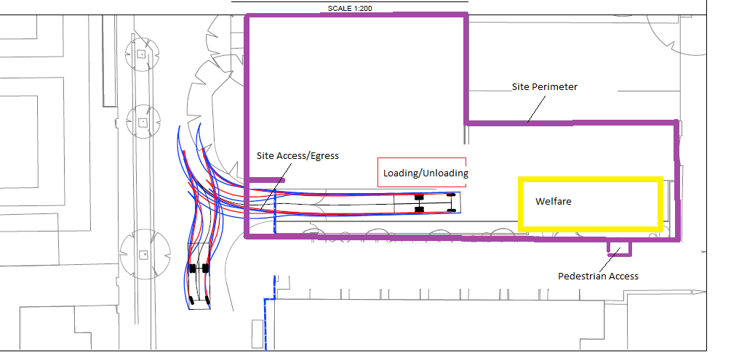

d. Provision of wheel washing facilities should be considered if necessary. If so, please provide details of how this will be managed and any run-off controlled.

Upon exiting the gate, drivers will be required to wait as our gateman washes all wheels, once driver leaves the gateman will clean any excess debris from footpaths.

**23. Vehicle loading and unloading:** *“Clients shall ensure that vehicles are loaded and unloaded on-site as far as is practicable.”* (P19, 3.4.4)

If this is not possible, Traffic Marshalls must ensure the safe passage of pedestrians, cyclists and motor traffic in the street when vehicles are being loaded or unloaded.

Please provide details of the parking and loading arrangements for construction vehicles with regard to servicing and deliveries associated with the site (e.g. delivery of materials and plant, removal of excavated material). This is required as a scaled site plan, showing all points of access and where materials, skips and plant will be stored, and how vehicles will access and egress the site. If loading is to take place off site, please identify where this is due to take place and outline the measures you will take to ensure that loading/unloading is carried out safely. Please outline in question 24 if any parking bay suspensions will be required.



Drivers will approach site southbound on Camden St.

They wil be directed in the site by banksman.

Banksmen will control loading/unloading withing the confined vehicle access area.

All skips will be stored with the vehicle access area.

There will be no loading/unload outside the vehicle access area. If needed the banksman will assist in helping the lorry to reverse out of site.

**Highway interventions**

**Please note that Temporary Traffic Orders (TTOs) and hoarding/scaffolding licenses may be applied for prior to CMP submission but won’t be granted until the CMP is signed-off.**

**24. Parking bay suspensions and temporary traffic orders**

Please note, parking bay suspensions should only be requested where absolutely necessary. Parking bay suspensions are permitted for a maximum of 6 months, requirement of exclusive access to a bay for longer than 6 months you will be required to obtain [Temporary Traffic Order (TTO)](http://camden.gov.uk/ccm/content/transport-and-streets/traffic-management/temporary-road-restrictions/) for which there is a separate cost.

Please provide details of any proposed parking bay suspensions and TTO’s which would be required to facilitate construction. **Building materials and equipment must not cause obstructions on the highway as per your Considerate Contractors obligations unless the requisite permissions are secured.**

Information regarding parking suspensions can be found [here.](http://www.camden.gov.uk/ccm/navigation/transport-and-streets/parking/parking-bay-suspensions/)

Quinn London will not be making any application for parking suspensions as part of our works. We will be making application to utility companes for services and they will make applications if needed.

**25. Scaled drawings of highway works**

Please note that use of the public highway for storage, site accommodation or welfare facilities is at the discretion of the Council and is generally not permitted. If you propose such use you must supply full justification, setting out why it is impossible to allocate space on-site. You must submit a detailed (to-scale) plan showing the impact on the public highway that includes the extent of any hoarding, pedestrian routes, parking bay suspensions and remaining road width for vehicle movements. We prefer not to close footways but if this is unavoidable, you should submit a scaled plan of the proposed diversion route showing key dimensions.

a. Please provide accurate scaled drawings of any highway works necessary to enable construction to take place (e.g. construction of temporary vehicular accesses).

There is no adjustments to the highways for enabling works or for construction works to take place.

b.Please provide details of all safety signage, barriers and accessibility measures such as ramps and lighting etc.

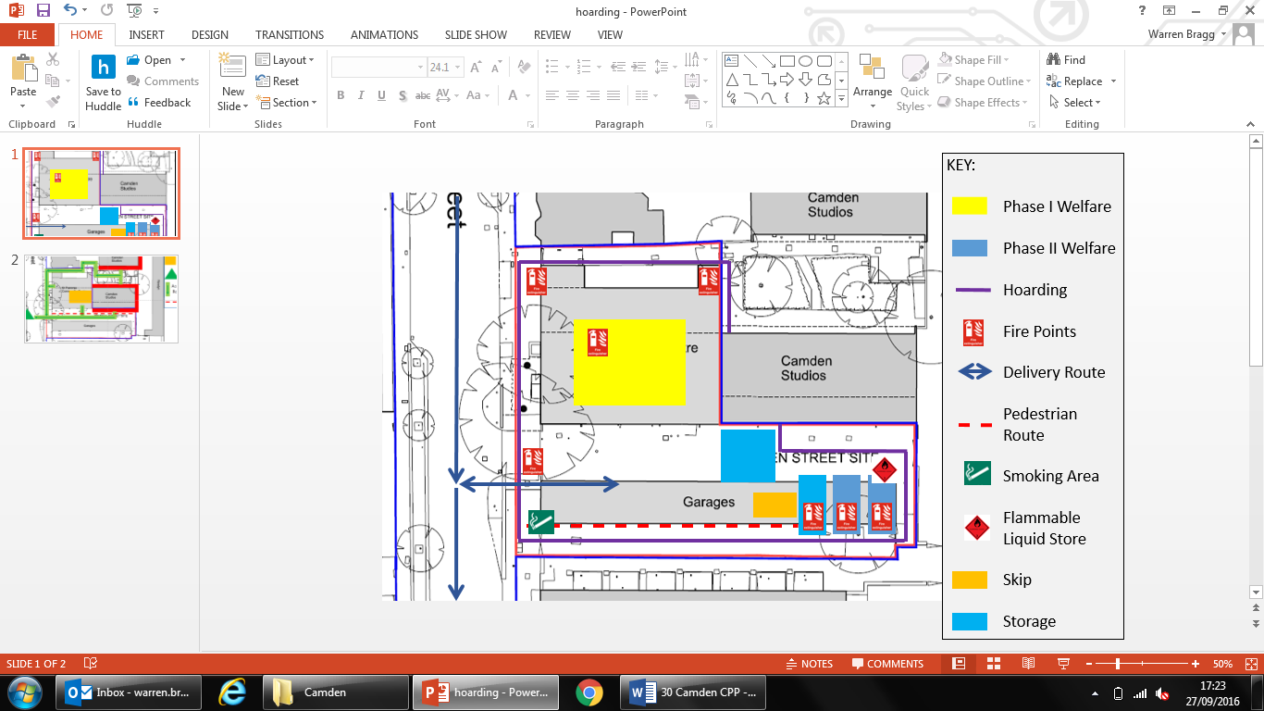

The hoardling will be erected as labelled above in purple.

All mandatory safety and CSCS signage will be prominently displayed.

An A3 info board for residents will also be displayed.

Hoarding to have lighting.

**26. Diversions**

Where applicable, please supply details of any diversion, disruption or other anticipated use of the public highway during the construction period (alternatively a plan may be submitted).

There will be no diversions necessary.

**27. VRU and pedestrian diversions, scaffolding and hoarding**

Pedestrians and/or cyclist safety must be maintained if diversions are put in place. Vulnerable footway users should also be considered. These include wheelchair users, the elderly, those with walking difficulties, young children, those with prams, the blind and partially sighted. Appropriate ramping must be used if cables, hoses, etc. are run across the footway.

Any work above ground floor level may require a covered walkway adjacent to the site. A licence must be obtained for scaffolding and gantries. The adjoining public highway must be kept clean and free from obstructions. Lighting and signage should be used on temporary structures/skips/hoardings etc.

A secure hoarding will generally be required at the site boundary with a lockable access.

1. Please provide details describing how pedestrian and cyclist safety will be maintained, including any proposed alternative routes (if necessary), and any Traffic Marshall arrangements.

A traffic marshall will ensure public safety during access and egress.

All vehicles will be loaded/unloaded within boundary.

All vehicle visits will be planned to control the entrance and minimise risks to public.

1. Please provide details of any temporary structures which would overhang the public highway (e.g. scaffolding, gantries, cranes etc.) and details of hoarding requirements or any other occupation of the public highway.

Theres is a requirement for a scaffold within the site boundary.

A scaffold and hoarding licence has been applied for.

There will be no overhanging elements over the pavment or beyond boundary.

The hoarding is highlighted in **Purple** below.

SYMBOL IS FOR INTERNAL USE



**Environment**

To answer these sections please refer to the relevant sections of **Camden’s Minimum Requirements for Building Construction (**[**CMRBC**](http://www.camden.gov.uk/ccm/cms-service/download/asset?asset_id=3257318)**).**

28. Please list all [noisy operations](http://www.camden.gov.uk/ccm/content/environment/environmental-health--consumer-protection/noise/reducing-noise/noise-from-construction-sites.en?page=2)  and the construction method used, and provide details of the times that each of these are due to be carried out.

As detailed in the scope of works, this project has a requirement for demolition, groundworks and a new build envelope. All of which can be noisey by nature. There will be ‘under no circumstance’ noisey works outside working hours inclusive of turm=ning on machinery. When possible, we will endeavour to cease noisy works between 12 and 2pm. Noisey operations will include: -

Engines

Drilling

Excavating

29. Please confirm when the most recent noise survey was carried out (before any works were carried out) and provide a copy. If a noise survey has not taken place please indicate the date (before any works are being carried out) that the noise survey will be taking place, and agree to provide a copy.

Essentailly, the site is empty with no activity since possession.

Prior to works commencing, Quinn will survey on Monday 19th December and continue to monitor on a weekly basis every Monday and Wednesday at 8.30am, 12pm and 3pm.

30. Please provide predictions for [noise](http://www.camden.gov.uk/ccm/content/environment/environmental-health--consumer-protection/noise/reducing-noise/noise-from-construction-sites.en?page=2) and vibration levels throughout the proposed works.

As detailed above, continuous monitoring will be undertaken on a weekly basis, where possibly risk will be reduced in design.

All results from monitoring will be compared from baseline survey results and the trigger levels will be as follows: -

Green – if 3dB or less above baseline – no further action

Amber – if between 3dB and 8dB above baseline – works can continue but works assessment needed and measures installed

Red – if above baseline 8dB or more – work to cease, methodology to change to bring level within safe limitations

All measurements will be recorded and maintained as per Quinn London CEP plan. Measurement location shown in appendices.

31. Please provide details describing mitigation measures to be incorporated during the construction/[demolition](http://www.camden.gov.uk/ccm/navigation/environment/building-control/demolition/) works to prevent noise and vibration disturbances from the activities on the site, including the actions to be taken in cases where these exceed the predicted levels.

The following measures will be adhered to in order to keep noise to a minimum: -

Design to be sympathetic to noise and vibration

Co ordinated delivery times as mentioned previously

Ensuring plant has sound reduction apparatus fitted, i.e. mufflers etc

Strict adherence to site working hours

When possible, to have a ‘quiet time’ between 12 and 2pm

Carry out noise survey and monitoring as noted earlier

Impletement action plan when Green, Amber and Red level are triggered.

32. Please provide evidence that staff have been trained on BS 5228:2009

It is a requirement that all Quinn staff are trained to a minmun of the Site Managers Safety Training Scheme run by the CITB.

Noise awareness training will be passed down via tool box talks.

33. Please provide details on how dust nuisance arising from dusty activities, on site, will be prevented.

Dust and emissions arising from site may annoy our neighbours and can cause air pollution. Dust blowing onto watercourses can also damage the ecology, affecting plant growth and light levels.

Predictions of dust generation are very unreliable but a qualitative evaluation has been undertaken of the likelihood that emissions may give rise to some perceptible nuisance & the assessment of risk posed by the works indicated a ‘low risk’ of dust impacts (Appendix IV). Suitable mitigation measures appropriate to this level of risk will be:

* Identify sensitive receptors and inform the authorities of any likely nuisance that could occur (refer to Appendix IV).
* Damp down work areas / materials / equipment with water to suppress the dust, ensuring that the application does not create excessive mud that could runoff into watercourses. Use non-potable water where possible.
* Ensure stockpiles of materials do not exceed height of boundary hoarding.
* Plan machinery & dust causing activities to be located away from receptors as far as possible.
* Use dust screening when dust-generating activities can not be avoided and other measures do not guarantee the reduction of dust in the air.
* Avoid the use of diesel powered generators& use mains electricity or battery powered equipment where practical.
* Carry out daily pre-use inspections to mechanical plant on site to ensure that they are in good working order.
* Minimise cutting and grinding on site where possible.
* Use equipment and techniques such as dust extractors to minimise dust when using cutters and saws.
* Maintain vehicles in good repair and conform to the manufacturers or legislative/British Standard emission standards.
* Ensure that engines are switched off when they are not in use.
* Take account of the wind conditions when arranging activities that are likely to emit aerosols, fumes, odours and smoke & frequently review work activities.
* Regular inspection and cleaning of local highways and site boundaries for dust deposits, including keeping the hoarding clean.
* Sheeting of trucks & skips leaving site carrying loose demolition debris.
* Consideration will be given by QLL to TfL’s Construction Logistics Programme & in particular the use of the Construction Consolidation Centres, which may assist with reducing the number of deliveries to site. The closest being at Avondale Construction, NW1 8NS, less than 1 mile away.
* As a major development site within Greater London, all non-road mobile machinery (NRMM) will be required to meet Stage IIIA of the NRMM EU Directive 97/68/EC.

34. Please provide details describing how any significant amounts of dirt or dust that may be spread onto the public highway will be prevented and/or cleaned.

As detailed earlier, A traffic marshall will be employed, as well as managing vehicle access/egress, he/she will maintain the site entrance and adjacent highway in relation to dust, debris etc.

35. Please provide details describing arrangements for monitoring of [noise](http://www.camden.gov.uk/ccm/content/environment/environmental-health--consumer-protection/noise/reducing-noise/noise-from-construction-sites.en?page=2), vibration and dust levels.

As described in statements 31 and 33 above.

36. Please confirm that a Risk Assessment has been undertaken at planning application stage in line with the GLA policy. [The Control of Dust and Emissions During Demolition and Construction 2104 (SPG)](https://www.london.gov.uk/file/18750/download?token=zV3ZKTpP), that the risk level that has been identified, and that the appropriate measures within the GLA mitigation measures checklist have been applied. Please attach the risk assessment and mitigation checklist as an appendix.

Quinn not appointed during planning stage.

37. Please confirm that all of the GLA’s ‘highly recommended’ measures from the [SPG](https://www.london.gov.uk/file/18750/download?token=zV3ZKTpP) document relative to the level of risk identified in question 36 have been addressed by completing the [GLA mitigation measures checklist.](https://www.london.gov.uk/what-we-do/planning/implementing-london-plan/supplementary-planning-guidance/control-dust-and)

38. If the site is a ‘High Risk Site’, 4 real time dust monitors will be required. If the site is a ‘Medium Risk Site’, 2 real time dust monitors will be required. The risk assessment must take account of proximity to sensitive receptors (e.g. schools, care homes etc), as detailed in the [SPG](https://www.london.gov.uk/file/18750/download?token=zV3ZKTpP). Please confirm the location, number and specification of the monitors in line with the SPG and confirm that these will be installed 3 months prior to the commencement of works, and that real time data and quarterly reports will be provided to the Council detailing any exceedances of the threshold and measures that were implemented to address these.

This site is not considered ‘high risk’.

39. Please provide details about how rodents, including [rats](http://www.camden.gov.uk/ccm/content/environment/environmental-health--consumer-protection/pest-control/about-the-pest-control-service.en), will be prevented from spreading out from the site. You are required to provide information about site inspections carried out and present copies of receipts (if work undertaken).

A contractor has been appointed to deal with rodents, as the site is essentially static of activity at present traps have been set and a survey has been carried out by the pest control contractor. Just prior to commencement of works, the contractor will set traps and install measures which will be monitored monthly and upgraded as necessary.

The contractor is: -

Competant in HSE procedures for laying bait (as per info sheet MISC515)

Compliant with control of pesticides reg’s 1986, incl. 1997 ammendmends

Compliant in biocidal products regs 2001 incl 2003 ammendmants

Quinn can provide details of contractor and of works carried out as necessary.

40. Please confirm when an asbestos survey was carried out at the site and include the key findings.

An asbestos surve has been carried out, details will be sent with this CMP.

41. Complaints often arise from the conduct of builders in an area. Please confirm steps being taken to minimise this e.g. provision of a suitable smoking area, tackling bad language and unnecessary shouting.

Quoinn will champion the behavieral ethos set out in the Considerate Constructor best practice, as standard company procedure Quinn will: -

Allocate designated smoking areas.

Not allow PPE to be worn outside site boundarys

Allow congregation of workforce around hoarding externally

Include in induction behavieral standards toward shouting, swearing etc.

Operate yellow/red card warning system in relation to anti social behavior

42. If you will be using non-road mobile machinery (NRMM) on site with net power between 37kW and 560kW it will be required to meet the standards set out below. The standards are applicable to both variable and constant speed engines and apply for both PM and NOx emissions.

**From 1st September 2015**

**(i) Major Development Sites** – NRMM used on the site of any major development will be required to meet Stage IIIA of EU Directive 97/68/EC

**(ii) Any development site within the Central Activity Zone -** NRMM used on any site within the Central Activity Zone will be required to meet Stage IIIB of EU Directive 97/68/EC

**From 1st September 2020**

**(iii) Any development site -** NRMM used on any site within Greater London will be required to meet Stage IIIB of EU Directive 97/68/EC

**(iv) Any development site within the Central Activity Zone -** NRMM used on any site within the Central Activity Zone will be required to meet Stage IV of EU Directive 97/68/EC

Please provide evidence demonstrating the above requirements will be met by answering the following questions:

1. Construction time period (mm/yy - mm/yy ):
2. Is the development within the CAZ? (Y/N):
3. Will the NRMM with net power between 37kW and 560kW meet the standards outlined above? (Y/N):
4. Please provide evidence to demonstrate that all relevant machinery will be registered on the NRMM Register, including the site name under which it has been registered:
5. Please confirm that an inventory of all NRMM will be kept on site and that all machinery will be regularly serviced and service logs kept on site for inspection:
6. Please confirm that records will be kept on site which details proof of emission limits, including legible photographs of individual engine plates for all equipment, and that this documentation will be made available to local authority officers as required:

SYMBOL IS FOR INTERNAL USE

**Agreement**

The agreed contents of this Construction Management Plan must be complied with unless otherwise agreed in writing by the Council. This may require the CMP to be revised by the Developer and reapproved by the Council. The project manager shall work with the Council to review this Construction Management Plan if problems arise in relation to the construction of the development. Any future revised plan must be approved by the Council in writing and complied with thereafter.

It should be noted that any agreed Construction Management Plan does not prejudice further agreements that may be required such as road closures or hoarding licences.

**Please notify that council when you intend to start work on site. Please also notify the council when works are approximately 3 months from completion.**

**Signed:** …………………………………………

**Date:** …16.12.16…………………………………………..

**Print Name:** ……M. Mullen………………………………………………..….

**Position: Site Manager**…………………………………………

Please submit to: [planningobligations@camden.gov.uk](mailto:planningobligations@camden.gov.uk)

End of form.

**Appendix A – programme**

**Appendix B – Existing Plans**

**Appendix C – CLOCS/FORS certs**

**D – Site Logistics plans**

**E – Noise monitoring locations**

**F – Construction Working Group minutes and correspondence**

**G – Delivery Schedule Template**