**Heritage Statement**

For

**The Roebuck PH, 15 Pond Street, London NW3 2PN**

The Roebuck is a Grade II Listed Building with the following listing description.

*TQ2785SW POND STREET 798-1/39/1325 (North side) 14/05/74 No.15 Roebuck Public House*

*Public house & hotel. Late 1860s. Stucco with channelled stucco ground floor. 3 storeys and cellars. Symmetrical facade of 5 windows plus 1-window extension over left hand carriage entrance. Public house openings round-arched with keystones and linked by impost bands; doorways, in outer bays, with fanlights and panelled doors. Upper floor sashes in round-arched openings with architraved heads, 1st floor with keystones, linked by impost bands; pilasters articulate bays, 1st floor with rusticated bands supporting an entablature with projecting modillion cornice, 2nd floor plain pilasters with enriched heads supporting entablature (inscribed Roebuck Hotel) and dentil and modillion pediment having a painted sculpture roebuck in the tympanum. Extension has architraved tripartite sashes; 1st floor with console bracketed cornice, 2nd floor with mask keystone. Entablature with dentil and modillion cornice. INTERIOR: now converted to a single bar, retains massively overscaled cornices with modillion decoration.*

*Listing NGR: TQ2713885475*

The property is currently used a public house with bars and customer toilets on the ground floor and basement level with further beer cellars to the basement. The trade kitchen is located on the first floor with the managers accommodation with the second floor previously used a staff accommodation now mostly used.

The application seeks approval for

* New food hoist.
* Wall removal to commercial kitchen.
* Over boarding of ground floor boards.
* Separation screens.
* Over bar structure removal.
* External painting.

**New Food Hoist**

The new food hoist will be installed between the commercial kitchen on the first floor and down into the ground floor bar area below. The food hoist will be constructed of stud partitioning around the hoist structure and clad in two layers of plasterboard for fire protection. The ground floor section of the hoist will be clad in painted V notched boarding to match the existing ceiling and column cladding.

A new opening will need to be formed in the kitchen through to the existing staff shower room. The wall is constructed of lathe and plaster and will need to be carefully cut open with new timbers bolted to existing to existing to form hatch.

A section of floor will need to be removed and existing joists trimmed to form new opening through the floor structure. The bar area below has an existing V notched boarded suspended ceiling which will also need an opening trimmed into it for the hoist to pass. The ceiling may also need additional supporting back to the floor structure At present the is very little access to the ceiling void to check its construction but this will be carried once approved and prior to full works commencing to ensure its suitable location. The positioning of the hoist has been chosen to best serve the kitchen and bar and also to avoid any possible collision with any hidden cornice below concealed within the ceiling void.

The lift motor will be installed within at the top of the hoist within the shaft.

The photograph below shows the location of the hoist in the bar area. (taken facing away from bar servery, front of bar to the left)

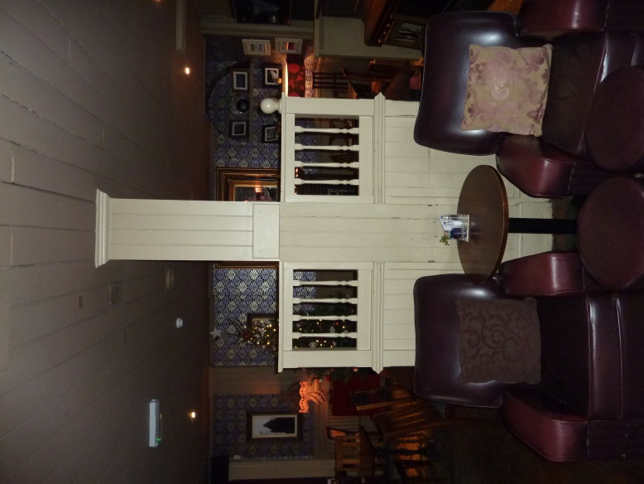The timber screen to the left of the column will be removed to enable the hoist to be installed and the hoist will be clad in similar boarding.

**Kitchen Wall Removal**.

The wall to the commercial kitchen is proposed to be partially removed to provide better access and circulation within the kitchen and to utilise the corridor space more efficiently. The existing door to the kitchen will be removed and reused to form a fire lobby further up the corridor. The wall is a loadbearing stub partition and a new beam and support posts will be installed to transfer the load to the floor below.

A new partition with existing door will be installed in the corridor to form a fire lobby from the main stairs and remaining parts of the first floor. This will be constructed in studwork with 2 layers of plasterboard. Architraves and skirtings will be installed to match existing and where the wall abuts the existing the partition and skirting will be cut around the existing features.

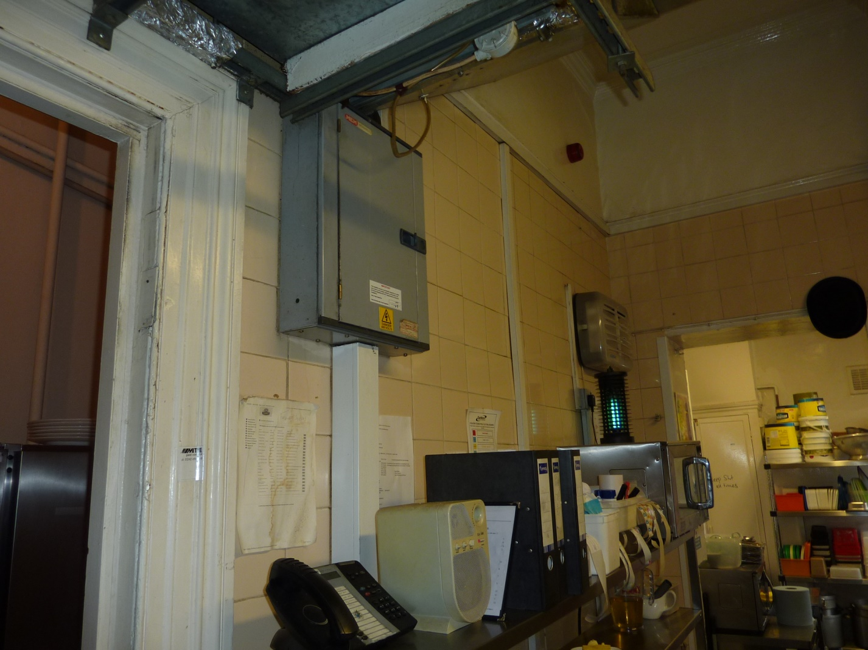

Photograph of wall section to be opened up. Existing opening to the left of photograph to remain as existing.

**Bar Floor**

The current ground floor has the original exposed floor through the bar area. These are in a poor condition and some sections badly damaged and some which have been replaced over the years.

The proposal would be to install new solid oak flooring laid on top of the existing floor board in order to preserve the floor boards below.

Photograph of existing flooring.

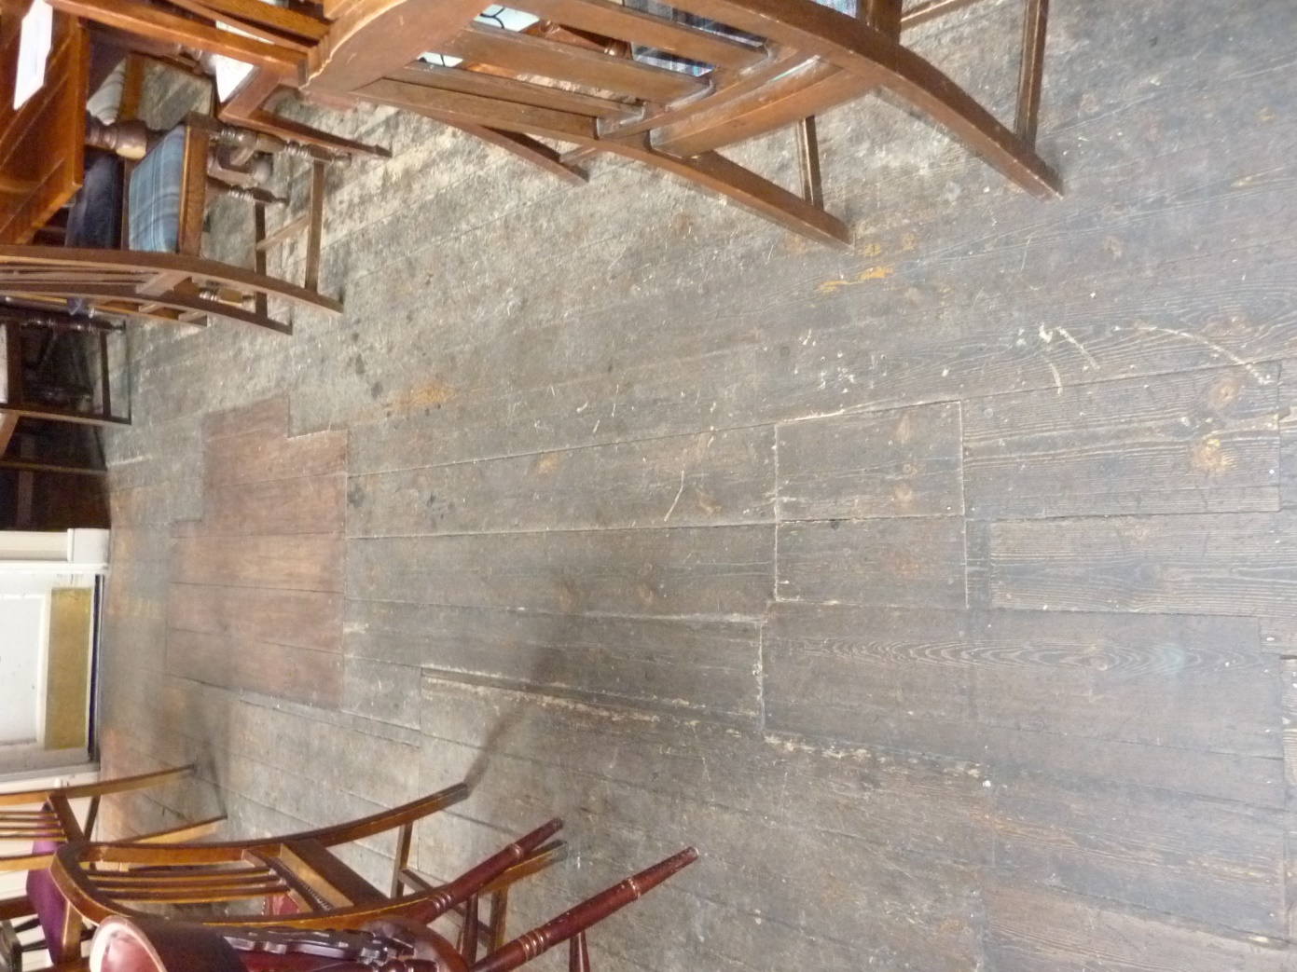

**Separation Screens**

Two screen will be installed as dividers in the bar area to provide separate spaces. The screen will be low level and constructed of stud partitions with V notched boarding to match the existing together with a chunky timber top rail to the screen.

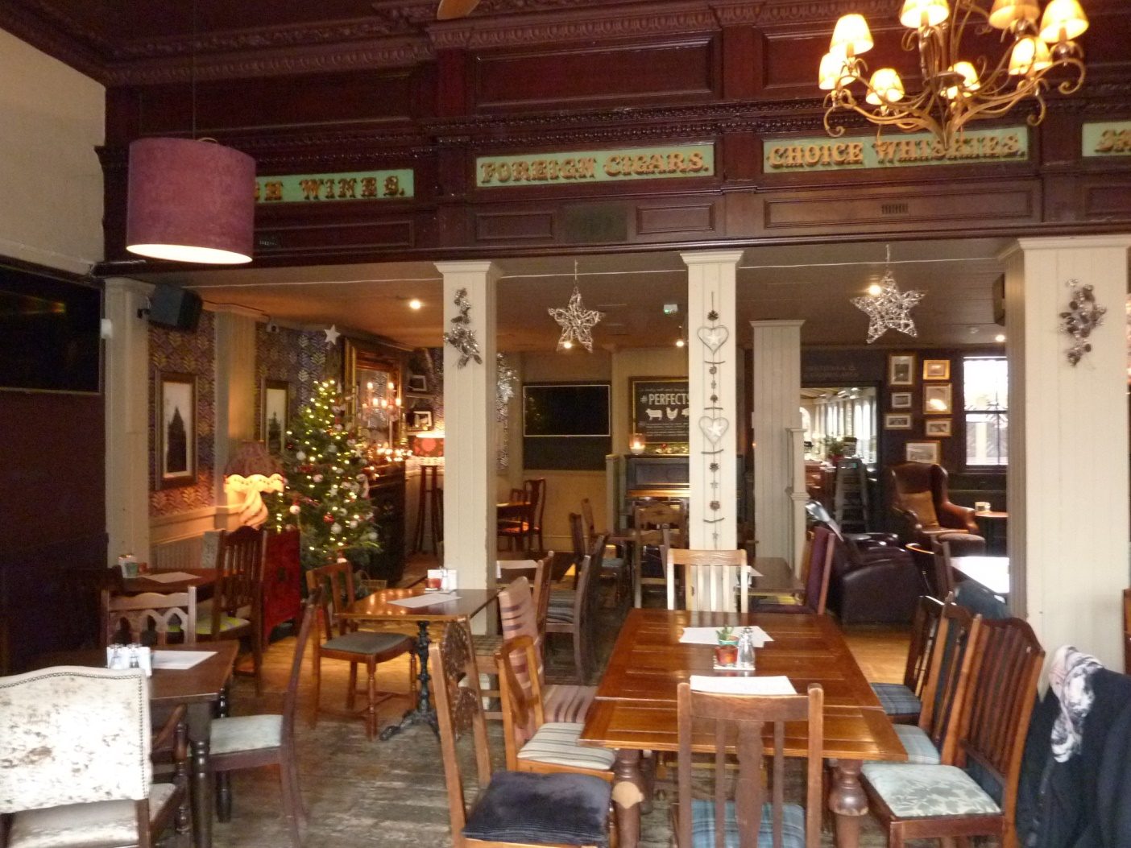

Photograph showing columns between which new screens will be installed

**Over Bar Structure Removal**

The proposal is to remove the existing over bar structure which is constructed of a plywood deck, timber cornice and turned timber posts. The structure is a decorative feature and serves no purpose as it is too high to be used as a glass storage rack. It’s positioning also detaches and obscures the view of the decorative cornice and signage above which is installed on the drop section formed by the false ceiling to the rear of the bar.

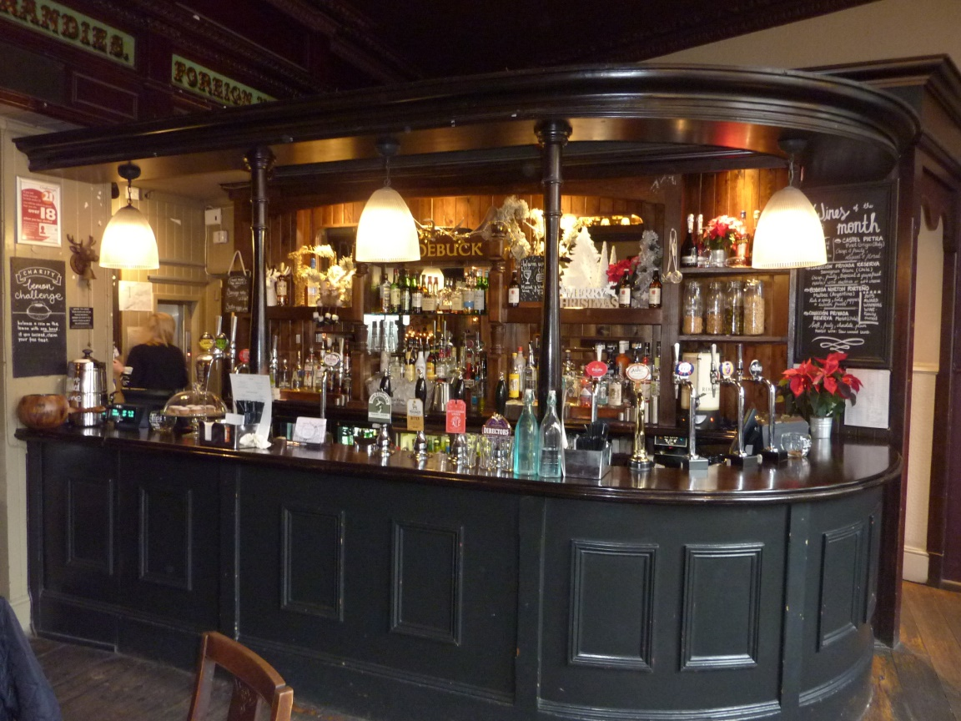

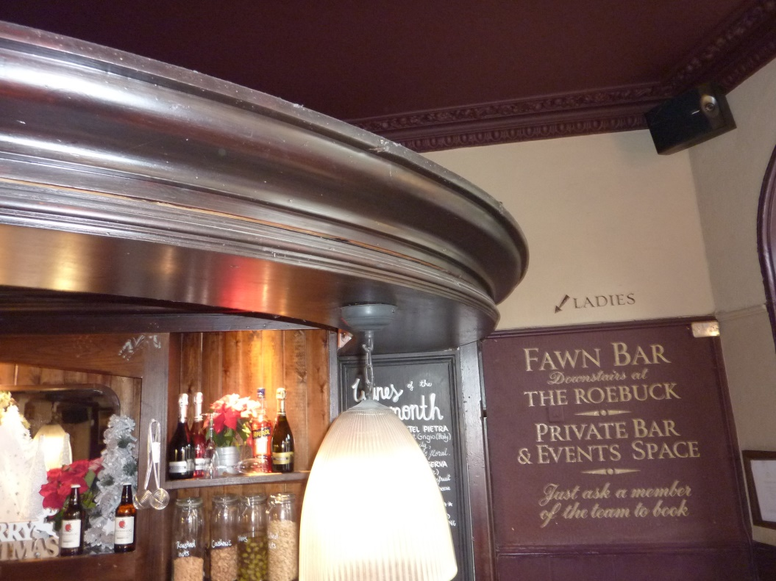

**External Front elevation painting**

The proposal is to repaint the lower level ground floor front elevation from its current Aubergine to a natural stone colour (reference to be confirmed). The remaining levels above will remain white.



We believe therefore that the works proposed will have little detrimental effect on the fabric of the existing Listed Building.