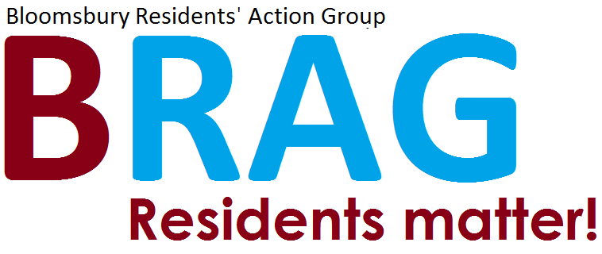

19 December 2016

Dear Laura Hazelton

# Re: Planning Application: 2016/6356/P, Rear of 1-3 Britannia Street London WC1X 9BN

BRAG (Bloomsbury Residents Action Group) was formed in June 2016 to be a Voice for residents who live in WC1, a corner of central London which has become a focus for developers who seem to have no interest in the wellbeing of the permanent residents who live there. This planning application is a case in point.

BRAG strongly objects to the application to permit an existing low-rise warehouse to be replaced by a much larger three-storey office block in the courtyard of Derby Lodge, the residential building that completely wraps around the land-locked application site.

Historic significance

Derby Lodge (formerly Derby Buildings) dates from 1865, one of the earliest examples of flatted residential accommodation built by Sydney Waterlow’s Improved Industrial Dwellings Company. The buildings have been listed as Grade II listed since 1994. They are an important part of the historic streetscape in this part of London. They are also first and foremost – as per Historic England’s Listing description - “philanthropic housing”.

Both the original residential purpose of the flats and their heritage significance underline how utterly inappropriate it is to allow the development of an over-scaled new office block with basement public gallery (which has absolutely no connection with the host building) within the curtilage of this historic residential block of flats.

The courtyard is an integral part of the listed buildings. It is an area of land that is attached to the residential structure, a curtilage space that creates a single urban entity – as designed by Sydney Waterlow in the 19th century.

Change of character

The existing warehouse (used as a mirror workshop with very few employees) has been a quiet and unobtrusive neighbour to the large number of residents who live near by. Its two-storey presence has not impinged unduly on residential amenity. Its use has not dominated or changed in any way the original residential nature of the surrounding dwellings.

In contrast, the scale of the application building will fundamentally alter the character of the space and impact negatively on the residential amenity of all tenants and owner-occupiers that live in the adjacent flats, and in buildings close to the site along Kings Cross Road and Britannia Street.

Impact on residential amenity

Global enterprise and activity means that the office building could be in use 24 hours a day. Terraces are proposed which will overlook people’s homes. Office workers could access spaces that are connected to the application building. They could talk and smoke outside at all hours of the day and evening. Light pollution from offices after twilight will impact on residents who currently experience darkness to the rear of their properties. Air conditioning units will add to increased noise at night. All this is an unacceptable intrusion on residential amenity.

As well as taking away light from existing residential homes, the courtyard acts as an echo chamber so ambient noise could increase substantially, simply due to the inappropriate imposition of an office block on a site for which use it was not intended. Excavation of the basement level to provide a gallery will impact negatively on residential amenity in terms of considerable noise and daily disturbance.

A Section 106 covenant on restricted use of terraces etc is hard to enforce, especially with cuts to local government spending leading to shortage of staff to do so. As any potential wrongdoing will take place within the courtyard space, it will be hidden from wider public view and be extremely hard to monitor from the streets bordering the site. A patrolling policeman would not be able to see someone misusing the office terrace facilities from the street.

Objections

1. BRAG objects to the demolition of the existing building and excavation of a new basement floor to create a new building which is unsuited to its location in relation to access, character and proximity of residential buildings which will have a loss of privacy due to the overlooking of neighbouring habitable rooms.

2. BRAG objects to change of use from Class B1c (light industrial business use) to class B1a (office use) and D1 (non residential institution use). Although the wider neighbourhood includes a mix of uses, and the warehouse has had commercial use within the courtyard, this has been extremely low-key and unobtrusive. The principal use of the host building is residential and Class B1a and D1 are inappropriate in context.

3. The application should be refused as it causes harm to residential amenity under Camden’s Policy DP26, which aims to protect the quality of life of neighbours and occupiers.

4. The proposals will cause harm to the setting of a listed building and should be rejected under Policy DP25. The land-locked site, which is the location for the application proposal, is part of the curtilage of listed 19th century Industrial dwellings. The scale and massing of the proposed office block will cause harm, as it will change the character of the courtyard space and conflict with the residential use and character of the surrounding dwellings. In relation to the NPPF, there are no public benefits to the large number of residents who surround the site who will, on the contrary, be harmed by increase noise, loss of light and loss of privacy.

I enclose an aerial view of the site, which shows how close the proposed development is to neighbouring residential homes

Yours sincerely,

Debbie Radcliffe

Secretary

Bloomsbury Residents Action Group (BRAG)

91 Judd Street

London WC1H 9NE

*Aerial view of the site, which shows residential dwellings in very close proximity to the proposed development. This clearly demonstrates how the proposed office block will add to the density of the urban block and be unacceptably close to the flats that surround the courtyard of Derby Lodge, and those in Britannia Street and Kings Cross Road.*

