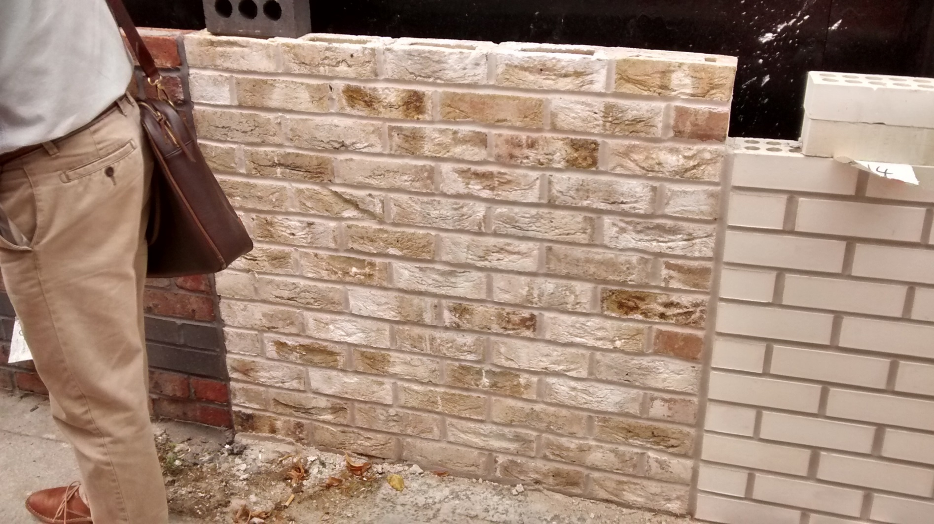
Con Mosso with white mortar (pointing to be flush)
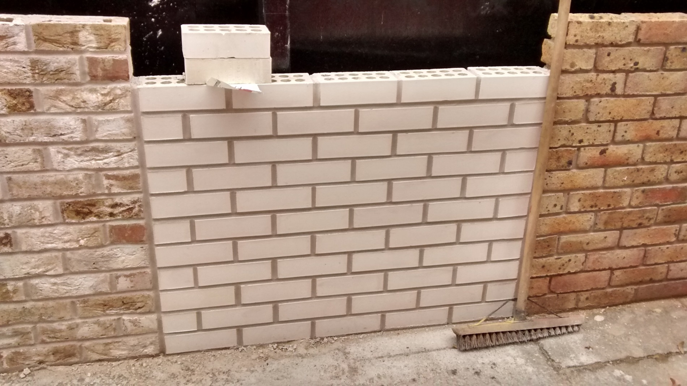
Centre: Englobe brick with white mortar (pointing to be flush) / Right Hand Side: Lindfield Yellow Multi (pointing to be raked)
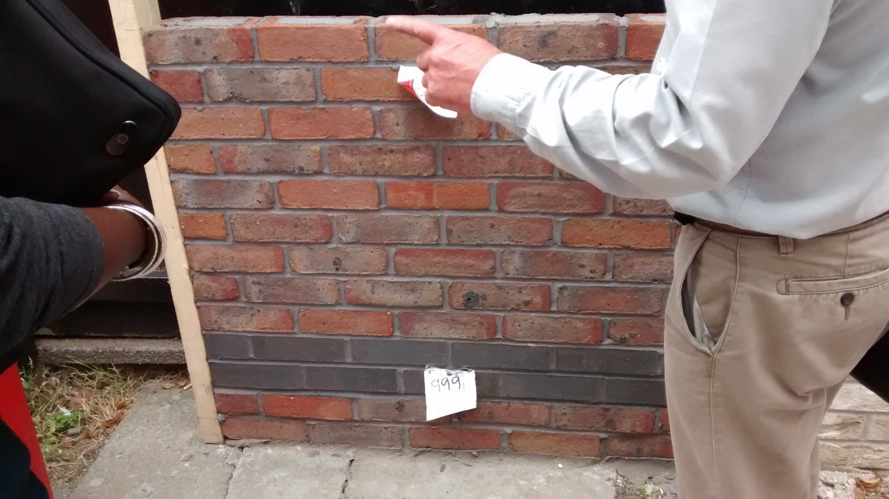
SBM and DCH: First Quality Facings by Freshfield Lane / Staffordshire Blue low level detail/band

