Fulcrum Building Design Ltd

9 Heneage Street

London

E1 5LJ
9 Heneage Street  London  E1 5LJ |  | Application Ref: 2016/3989/P
 |  | Please ask for: Robert Lester
 |  | Telephone: 020 7974 2188
 |  | 16 September 2016

Dear Sir/Madam

DECISION

Town and Country Planning Act 1990 (as amended)

Full Planning Permission Refused

Address:
1st Floor Flat
107 Bartholomew Road
London
NW5 2AR

Proposal:
Roof terrace on the roof of the side porch with black painted metal railings and the reinstatement of an existing bricked up opening as painted timber French doors at first floor level to provide access.

Drawing Nos: 248/16-PL- 01, 248/16-PL- 02, 248/16-PL- 03, 248/16-PL- 04 & 248/16-PL- 05.

The Council has considered your application and decided to refuse planning permission for the following reason(s):

Reason(s) for Refusal

1 | The proposed development, by reason of its siting, design and materials, would be detrimental to the character of the host building and the surrounding streetscene, failing to preserve or enhance the character and appearance of the surrounding conservation area, contrary to policy CS14 (Promoting high quality places and conserving our heritage) of the London Borough of Camden Local Development Framework Core Strategy and policies DP24 (Securing high quality design) and DP25 (Conserving Camden's heritage) of the London Borough of Camden Local Development Framework Development Policies.

In dealing with the application, the Council has sought to work with the applicant in a positive and proactive way in accordance with paragraphs 186 and 187 of the National Planning Policy Framework.

You can find advice about your rights of appeal at:

http://www.planningportal.gov.uk/planning/appeals/guidance/guidancecontent

Yours faithfully
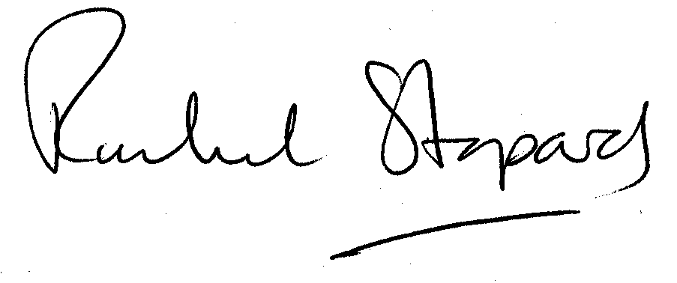
Rachel Stopard
Executive Director Supporting Communities

