Mr Tom Borowiecki
Studio-BAM
81a Grove Park
London
SE5 8LE
81a Grove Park  London  SE5 8LE |  | Application Ref: 2016/4965/P
 |  | Please ask for: Anna Roe
 |  | Telephone: 020 7974 1226
 |  | 2 November 2016

Dear Sir/Madam

DECISION

Town and Country Planning Act 1990 (as amended)

Full Planning Permission Granted

Address:
Flat 1st Floor
19 St Cuthbert's Road
London
NW2 3QJ

Proposal: Installation of metal balcony at rear first floor level and replacement of window with a door

Drawing Nos: OS Extract; Design and Access Statement; 002 A; 003 A; 004 B.

The Council has considered your application and decided to grant permission subject to the following conditions:

Conditions and Reasons:

1 | The development hereby permitted must be begun not later than the end of three years from the date of this permission.  Reason: In order to comply with the provisions of Section 91 of the Town and Country Planning Act 1990 (as amended).
2 | All new external work shall be carried out in materials that resemble, as closely as possible, in colour and texture those of the existing building, unless otherwise specified in the approved application.  Reason: To safeguard the appearance of the premises and the character of the immediate area in accordance with the requirements of policy CS14 of the London Borough of Camden Local Development Framework Core Strategy and policy DP24 of the London Borough of Camden Local Development Framework Development Policies.
3 | The development hereby permitted shall be carried out in accordance with the following approved plans: OS Extract; Design and Access Statement; 002 A; 003 A; 004 B.  Reason: For the avoidance of doubt and in the interest of proper planning.

Informatives:

Your proposals may be subject to control under the Building Regulations and/or the London Buildings Acts which cover aspects including fire and emergency escape, access and facilities for people with disabilities and sound insulation between dwellings. You are advised to consult the Council's Building Control Service, Camden Town Hall, Argyle Street WC1H 8EQ, (tel: 020-7974 6941).

Noise from demolition and construction works is subject to control under the Control of Pollution Act 1974. You must carry out any building works that can be heard at the boundary of the site only between 08.00 and 18.00 hours Monday to Friday and 08.00 to 13.00 on Saturday and not at all on Sundays and Public Holidays. You are advised to consult the Council's Compliance and Enforcement team [Regulatory Services], Camden Town Hall, Argyle Street, WC1H 8EQ (Tel. No. 020 7974 4444 or on the website http://www.camden.gov.uk/ccm/content/contacts/council-contacts/environment/contact-the-environmental-health-team.en or seek prior approval under Section 61 of the Act if you anticipate any difficulty in carrying out construction other than within the hours stated above.

Reasons for granting permission.

The proposal would introduce a balcony at rear first floor level, consisting of a sympathetic and consistent material when compared to existing development already in situ on the host building. Therefore the powder coated metal would represent a lightweight addition, whilst referencing the existing balcony directly above.

The alteration of the window would provide a door within the same opening and therefore be of limited impact. As such the proposed balcony and window alteration is considered an established form of development which is appropriate in terms of design and size.

The proposal is not judged to be harmful to neighbouring amenity and would provide valuable amenity space for the first floor flat. It would not extend beyond the existing single storey rear projection and so would not overshadow the ground floor flat. Similarly, given its modest size the impact in terms of noise and nuisance would be limited. Finally, given the existing rear windows and balcony it is not considered that the proposal would materially increase opportunities to overlook adjoining occupiers or result in a significant loss of privacy.

No objections have been received. The sites planning history and relevant appeal decisions were taken into account when coming to this decision.

As such, the proposed development is in general accordance with policies CS5 and CS14 of the London Borough of Camden Local Development Framework Core Strategy, and policies DP24 and DP26 of the London Borough of Camden Local Development Framework Development Policies. The proposed development also accords with policies of the Fortune Green & West Hampstead neighbourhood plan 2016, the London Plan 2016; and the National Planning Policy Framework.

In dealing with the application, the Council has sought to work with the applicant in a positive and proactive way in accordance with paragraphs 186 and 187 of the National Planning Policy Framework.

Yours faithfully
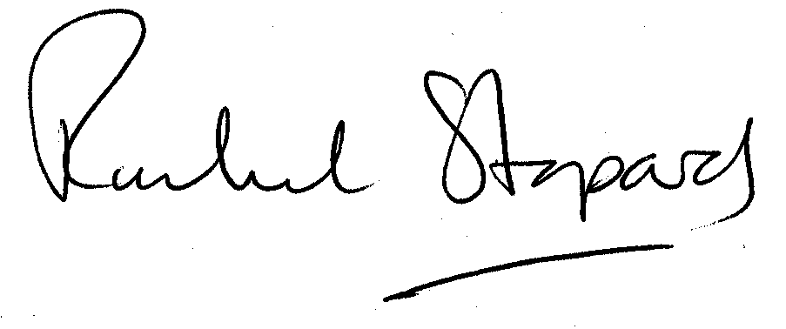
Rachel Stopard
Executive Director Supporting Communities

