**Lead Local Flood Authority comments**

|  |  |
| --- | --- |
| Scheme Address | Former 5-6 Eton Garages  London  NW3 4PE |
| Planning Reference | 2016/3872/P |
| Date | 22/09/2016 |



This site does not fall within one of our Local Flood Risk Zones as defined within figure 6 of the SFRA (below).

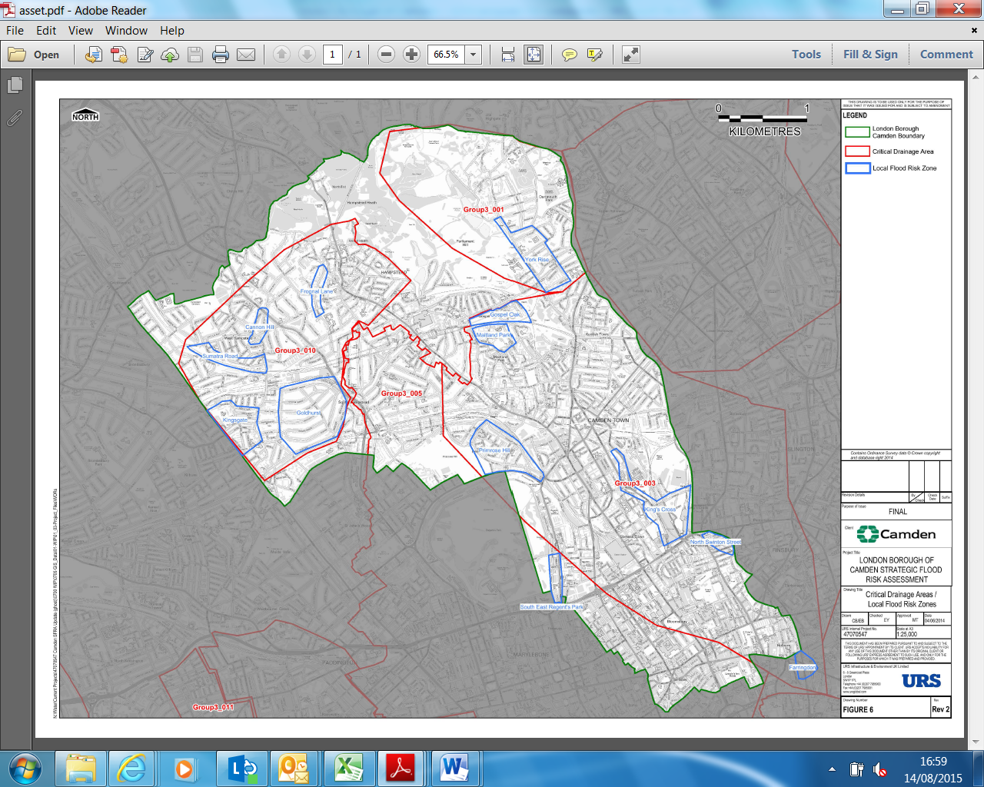

The site is not in an area identified in Camden’s Strategic Flood Risk Assessment as being at risk of surface water flooding, but it is adjacent to site which have previously experience surface water flooding.



DP23 requires that where a site is known to have a particular drainage issue, development should not place additional strain on adjoining sites or the existing drainage infrastructure. It also requires that the development is designed to cope with being flooded.

The policy requires developments to reduce their water consumption, the pressure on the combined sewer network and the risk of flooding by:

1. incorporating water efficient features and equipment and capturing, retaining and re-using surface water and grey water on-site;
2. limiting the amount and rate of run-off and waste water entering the combined storm water and sewer network through the methods outlined in part a) and other sustainable urban drainage methods to reduce the risk of flooding
3. reducing the pressure placed on the combined storm water and sewer network from foul water and surface water run-off and ensuring developments in the areas identified.... as being at risk of surface water flooding are designed to cope with the potential flooding

*Action for applicant: The applicant must demonstrate how methods outlined in a), b) and c) above will be included in the proposals to ensure:*

* + *there is no additional strain on adjoining sites or the existing drainage infrastructure*
  + *the development will cope with being flooded. E.g. by:*
  + *No self-contained basement dwellings*
  + *Limiting flood waters entering and damaging the building fabric; or*
  + *Allowing flood water to enter the building but limiting the damage it will cause*

*Consideration of the cumulative impact of small prior approvals in high risk areas should be borne in mind (Residential use typically has a much higher water use than offices, resulting on increased impact on the sewer system due to generation of more waste water).*

***Recommended Condition:***

*Prior to commencement, full details to demonstrate:*

1. *the proposed internal water efficiency and/or water recycling equipment to ensure that the development will pose no additional strain on adjoining sites or the existing drainage infrastructure; and*
2. *the proposed internal measures to ensure the development has been designed to cope with potential flooding;*

*Should be submitted to the Local Planning Authority and approved in writing.*