Miss Ellie Bird
Deloitte Real Estate
Athene Place
66 Shoe Lane
London EC4A 3BQ
Athene Place  66 Shoe Lane  London EC4A 3BQ |  | Application Ref: 2016/4517/L
 |  | Please ask for: Antonia Powell
 |  | Telephone: 020 7974 2648
 |  | 11 November 2016

Dear Sir/Madam

DECISION

Planning (Listed Building and Conservation Areas) Act 1990

Listed Building Consent Granted

Address:
UCL Pearson Building
Gower Street
London
WC1E 6BT

Proposal:
The addition of four fan coil units along with associated redecoration and repair to the ceiling and soffit at the Pearson Building.
Drawing Nos: Cover letter from Deloitte Real Estate dated 12th August 2016;
Site Location Plan;
Quartz Technical data sheet, Chilled water wall mounted unit;
3008P LO53 P1;
3008P LO52 P1;
3008P LO51 P1;
3008P LO50 P1.

The Council has considered your application and decided to grant Listed Building Consent subject to the following condition(s):

Conditions And Reasons:

1 | The works hereby permitted shall be begun not later than the end of three years from the date of this consent.  Reason: In order to comply with the provisions of Section 18 of the Planning (Listed Buildings and Conservation Areas) Act 1990.
2 | All new work and work of making good shall be carried out to match the original work as closely as possible in materials and detailed execution.  Reason: In order to safeguard the special architectural and historic interest of the building in accordance with the requirements of policy CS14 of the London Borough of Camden Local Development Framework Core Strategy and policy DP25 of the London Borough of Camden Local Development Framework Development Policies.
3 | The works hereby approved are only those specifically indicated on the drawing(s) referred to above.  Reason: In order to safeguard the special architectural and historic interest of the building in accordance with the requirements of policy CS14 of the London Borough of Camden Local Development Framework Core Strategy and policy DP25 of the London Borough of Camden Local Development Framework Development Policies.

Informative(s):

Reasons for granting listed building consent:

The proposal comprises the addition of four new fan coil units to rooms 227, 228A, 228B and 229 of the second floor of UCL's Pearson Building. The scope of works also includes the subsequent repair, redecoration and making good of the ceiling and soffit.

These works are to be carried out in an area of low significance and they are not considered to impact on the significance of this Grade I building.

Public consultation was undertaken by placement of a press notice and site notice, and no responses were received. Historic England wrote with a letter of flexible authorisation dated 20 September 2016, stamped and dated by National Planning Casework Unit on behalf of the Secretary of State.

The site's planning history was taken into account when coming to this decision.

Special regard has been attached to the desirability of preserving the listed building and its features of special architectural or historic interest, under s.16 of the Listed Buildings and Conservation Areas Act 1990 as amended by the Enterprise and Regulatory Reform Act (ERR) 2013.

As such, the proposal is in general accordance with policy CS14 of the London Borough of Camden Local Development Framework Core Strategy, and policy DP25 of the London Borough of Camden Local Development Framework Development Policies. The proposed development also accords with policy 7.8 of The London Plan 2016 consolidated with alterations since 2011, and paragraphs 14, 17 and 126-141 of the National Planning Policy Framework.

You are advised that any works of alterations or upgrading not included on the approved drawings which are required to satisfy Building Regulations or Fire Certification may require a further application for listed building consent.

You can find advice about your rights of appeal at:

http://www.planningportal.gov.uk/planning/appeals/guidance/guidancecontent

Yours faithfully
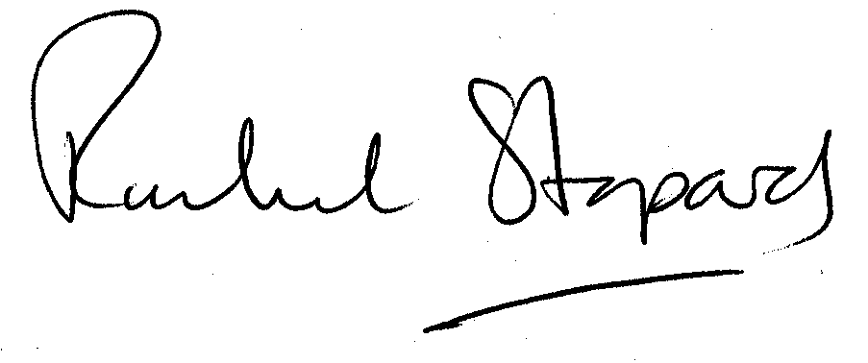
Rachel Stopard
Executive Director Supporting Communities

