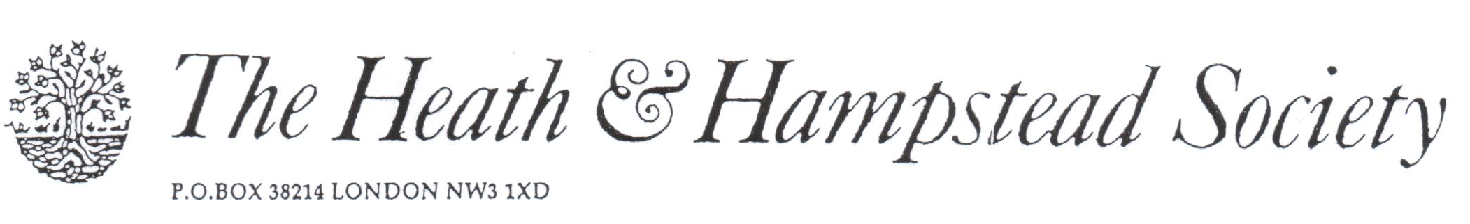
The Society examines all Planning Applications relating to Hampstead, and assesses them for their impact on conservation and on the local environment.

To London Borough of Camden, Development Control Team

Planning Ref: 2016/5613/P
Address: Hillview Vale of Health NW3
Description: Rear extension
Case Officer: Kristina Smith Date: 14 November 2016

This small house is wedged in between its neighbours, overlooking the Vale of Health Pond, and any alteration to it will affect its neighbours more than normally would be the case.

This proposal, which includes a full-width terrace, or balcony, would be disruptive of the character of this part of the Vale, and lead to overlooking of and intrusion to adjoining gardens.
It would also constitute an unwelcome alteration to the rear elevation facing the Pond.

Please refuse.

