Mr Trevor Jones
Trevor Jones
Meadow Bank Cottage
Springwood Road
Rawdon
Leeds
LS19 6BH
Application Ref: 2016/5478/P
Please ask for: Catherine Bond
Telephone: 020 7974 2669
11 November 2016

Dear Sir/Madam

DECISION

Town and Country Planning Act 1990 (as amended)

Full Planning Permission Granted

Address:
52 Brunswick Centre
London
WC1N 1AE

Proposal:
Removal of an external ATM, post box and projecting sign.
Drawing Nos: Site Plan; 50961166-AREX-E1-0200; 50961166-AREX-B1-0101; 50961166-AREX-B1-0102; 50961166-AREX-00-0100; 50961166-AREX-00-0110; 50961166-AREX-00-0210; Design and Access Statement; Heritage Statement; Photo Sheets 1-5.

The Council has considered your application and decided to grant permission subject to the following condition(s):

Condition(s) and Reason(s):

1 | The development hereby permitted must be begun not later than the end of three years from the date of this permission.  Reason: In order to comply with the provisions of Section 91 of the Town and Country Planning Act 1990 (as amended).
2 | All new external work shall be carried out in materials that resemble, as closely as possible, in colour and texture those of the existing building, unless otherwise specified in the approved application.  Reason: To safeguard the appearance of the premises and the character of the immediate area in accordance with the requirements of policy CS14 of the London Borough of Camden Local Development Framework Core Strategy and policy DP24 [and DP25 if in CA] of the London Borough of Camden Local Development Framework Development Policies.
3 | The development hereby permitted shall be carried out in accordance with the following approved plans: Site Plan; 50961166-AREX-E1-0200; 50961166-AREX-B1-0101; 50961166-AREX-B1-0102; 50961166-AREX-00-0100; 50961166-AREX-00-0110; 50961166-AREX-00-0210; Design and Access Statement; Heritage Statement; Photo Sheets 1-5.  Reason:  For the avoidance of doubt and in the interest of proper planning.

Informative(s):

Reasons for granting planning permission:

This application is for the removal of the existing ATM, post box, and a projecting sign associated with the former bank use of Unit 52 of the grade II listed Brunswick Centre, which is situated in the Bloomsbury Conservation Area.

Since the bank use is no longer functioning and the tenant is vacating the property, it is necessary to remove all signage, fixtures and fittings from the unit, which is a non-original element of the listed megastructure. The proposals also include making good in a like-for-like manner the remaining frontage and associated fabric. It is anticipated that a new tenant will apply separately to the Council for new signage and associated changes.

The proposed works are not considered to cause harm to the special interest of the grade II listed building or to the character and appearance of the Bloomsbury Conservation Area.

Public consultation was undertaken by placement of a press notice and site notice, and no responses were received. The site's planning history was taken into account when coming to this decision.

Special regard has been attached to the desirability of preserving the listed building and its features of special architectural or historic interest, and the character and appearance of the Bloomsbury Conservation Area, under s.16 and s.72 of the Listed Buildings and Conservation Areas Act 1990 as amended by the Enterprise and Regulatory Reform Act (ERR) 2013.

As such, the proposal is in general accordance with policy CS14 of the London Borough of Camden Local Development Framework Core Strategy, and policy DP25 of the London Borough of Camden Local Development Framework Development Policies. The proposed development also accords with policy 7.8 of The London Plan 2015 consolidated with alterations since 2011, and paragraphs 14, 17 and 126-141 of the National Planning Policy Framework.

Your proposals may be subject to control under the Building Regulations and/or the London Buildings Acts which cover aspects including fire and emergency escape, access and facilities for people with disabilities and sound insulation between dwellings. You are advised to consult the Council's Building Control Service, 5 Pancras Square, London N1C 4AG, (tel: 020-7974 6941).

Noise from demolition and construction works is subject to control under the Control of Pollution Act 1974. You must carry out any building works that can be heard at the boundary of the site only between 08.00 and 18.00 hours Monday to Friday and 08.00 to 13.00 on Saturday and not at all on Sundays and Public Holidays. You are advised to consult the Council's Compliance and Enforcement team [Regulatory Services], 5 Pancras Square, London N1C 4AG (Tel. No. 020 7974 4444 or on the website http://www.camden.gov.uk/ccm/content/contacts/council-contacts/environment/contact-the-environmental-health-team.en or seek prior approval under Section 61 of the Act if you anticipate any difficulty in carrying out construction other than within the hours stated above.

The Mayor of London introduced a Community Infrastructure Levy (CIL) to help pay for Crossrail on 1st April 2012. Any permission granted after this time which adds more than 100sqm of new floorspace or a new dwelling will need to pay this CIL. It will be collected by Camden on behalf of the Mayor of London. Camden will be sending out liability notices setting out how much CIL will need to be paid if an affected planning application is implemented and who will be liable.

The proposed charge in Camden will be £50 per sqm on all uses except affordable housing, education, healthcare, and development by charities for their charitable purposes. You will be expected to advise us when planning permissions are implemented. Please use the forms at the link below to advise who will be paying the CIL and when the development is to commence. You can also access forms to allow you to provide us with more information which can be taken into account in your CIL calculation and to apply for relief from CIL.

http://www.planningportal.gov.uk/planning/applications/howtoapply/whattosubmit/cil

We will then issue a CIL demand notice setting out what monies needs to paid when and how to pay. Failure to notify Camden of the commencement of development will result in a surcharge of £2500 or 20% being added to the CIL payment. Other surcharges may also apply for failure to assume liability and late payment. Payments will also be subject to indexation in line with the construction costs index.

Please send CIL related documents or correspondence to CIL@Camden.gov.uk

In dealing with the application, the Council has sought to work with the applicant in a positive and proactive way in accordance with paragraphs 186 and 187 of the National Planning Policy Framework.

You can find advice about your rights of appeal at:

http://www.planningportal.gov.uk/planning/appeals/guidance/guidancecontent

Yours faithfully
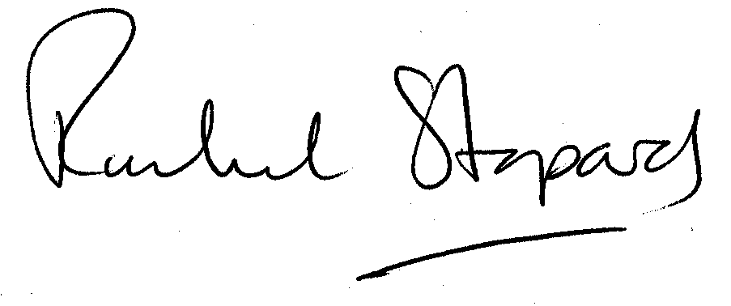
Rachel Stopard
Executive Director Supporting Communities

