Mr Conor O Sullivan
CLIVE SALL ARCHITECTURE
2 Providence Yard
Ezra Street
London
E2 7RJ
2 Providence Yard  Ezra Street  London  E2 7RJ |  | Application Ref: 2016/2715/P
 |  | Please ask for: Gideon Whittingham
 |  | Telephone: 020 7974 5180
 |  | 8 November 2016

Dear Sir/Madam

DECISION

Town and Country Planning Act 1990 (as amended)

Householder Application Granted Subject to a Section 106 Legal Agreement

Address:
29 Prince of Wales Road
London
NW5 3LH

Proposal:
Conversion of dwelling into 3 flats (1x 3 bedroom, 1x2 bedroom and 1 x 1 bedroom) and provision of refuse and cycle storage within front yard.
Drawing Nos: 1001 P1; 001; 002; 003; 004; 005; 007; 008; 009; 011 P1; 1001 P1; 1002 P1; 1003 P1; 1004 P1; 1005 P1; 1008 P1; 1009 P1; 1011 P1; 1012 P2; 1013 P1; 1014 P2;

The Council has considered your application and decided to grant permission subject to the following condition(s):

Condition(s) and Reason(s):

1 | The development hereby permitted must be begun not later than the end of three years from the date of this permission.  Reason: In order to comply with the provisions of Section 91 of the Town and Country Planning Act 1990 (as amended).
2 | All new external work shall be carried out in materials that resemble, as closely as possible, in colour and texture those specified in the approved application.  Reason: To safeguard the appearance of the premises and the character of the immediate area in accordance with the requirements of policy CS14 of the London Borough of Camden Local Development Framework Core Strategy and policy DP24 [and DP25 if in CA] of the London Borough of Camden Local Development Framework Development Policies.
3 | The development hereby permitted shall be carried out in accordance with the following approved plans [1001 P1; 001; 002; 003; 004; 005; 007; 008; 009; 011 P1; 1001 P1; 1002 P1; 1003 P1; 1004 P1; 1005 P1; 1008 P1; 1009 P1; 1011 P1; 1012 P2; 1013 P1; 1014 P2;]  Reason: For the avoidance of doubt and in the interest of proper planning.
4 | The secure and covered cycle storage area for 5 cycles hereby approved shall be provided in its entirety prior to the first occupation of any of the new units, and permanently retained thereafter.  Reason: To ensure the development provides adequate cycle parking facilities in accordance with the requirements of policy CS11of the London Borough of Camden Local Development Framework Core Strategy and policy DP17of the London Borough of Camden Local Development Framework Development Policies.
5 | The refuse storage area hereby approved shall be provided in its entirety prior to the first occupation of any of the new units, and permanently retained thereafter.  Reason: To ensure that sufficient provision for the storage and collection of waste has been made in accordance with the requirements of policy CS18 of the London Borough of Camden Local Development Framework Core Strategy and policies DP26 and DP28 of the London Borough of Camden Local Development Framework Development Policies.

Informative(s):

Your proposals may be subject to control under the Building Regulations and/or the London Buildings Acts which cover aspects including fire and emergency escape, access and facilities for people with disabilities and sound insulation between dwellings. You are advised to consult the Council's Building Control Service, Camden Town Hall, Argyle Street WC1H 8EQ, (tel: 020-7974 6941).

Noise from demolition and construction works is subject to control under the Control of Pollution Act 1974. You must carry out any building works that can be heard at the boundary of the site only between 08.00 and 18.00 hours Monday to Friday and 08.00 to 13.00 on Saturday and not at all on Sundays and Public Holidays. You are advised to consult the Council's Compliance and Enforcement team [Regulatory Services], Camden Town Hall, Argyle Street, WC1H 8EQ (Tel. No. 020 7974 4444 or on the website http://www.camden.gov.uk/ccm/content/contacts/council-contacts/environment/contact-the-environmental-health-team.en or seek prior approval under Section 61 of the Act if you anticipate any difficulty in carrying out construction other than within the hours stated above.

Reasons for granting permission:

The proposal would see the conversion of the 5 bedroom dwellinghouse to provide a 3 bedroom flat at basement and ground floor levels, a 2 bedroom flat at first and second floor levels and a 1 bedroom at third floor level.

The loss of a single dwellinghouse is considered acceptable as the proposal includes the creation of a 3 residential dwellings, 1 of which would be of high priority for Camden's Housing Stock. Each flat would comply with Camden's Planning Guidance and new national space standards. The flats would enjoy dual aspect outlook, in addition to plenty of openings providing good levels of natural light and ventilation.

The external alterations within the front garden are consistent with the local townscape and of limited intervention so that their impact will be minimal and sympathetic, helping to preserve the character and appearance of the building and wider streetscene.

The site has a PTAL rating of 6a (excellent level of accessibility by public transport). The 2 units shall be car-free, secured by way of a S106 planning obligation. The development provides 5 x secure cycle parking spaces and sizeable refuse bins in the front garden, which meets London Plan standards and Camden's design requirements.

The proposal involves limited external alterations that are not considered to cause detrimental harm to neighbouring amenity in terms of daylight, outlook or loss of privacy.

A total of 3 comments have been received. Along with the planning history of the site, all matters were taken into account when coming to this decision. The subject property is not within a Conservation Area nor is the building listed or within the setting of a Listed Building. Reference has been made to the emerging The Kentish Town Neighbourhood Plan.

As such, the proposed development is in general accordance with policies CS5, CS6 and CS14 of the London Borough of Camden Local Development Framework Core Strategy, policies DP2, DP5, DP16, DP17, DP18, DP24, and DP26 of the London Borough of Camden Local Development Framework Development Policies, policies 3.5, 7.4, and 7.6 of the London Plan 2016; and paragraphs 14, 17, 47, 49, 50, and 56-66 of the National Planning Policy Framework.

In dealing with the application, the Council has sought to work with the applicant in a positive and proactive way in accordance with paragraphs 186 and 187 of the National Planning Policy Framework.

You can find advice about your rights of appeal at:

http://www.planningportal.gov.uk/planning/appeals/guidance/guidancecontent

Yours faithfully
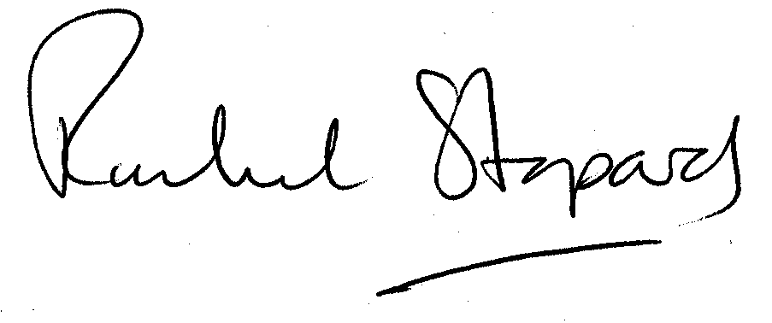
Rachel Stopard
Executive Director Supporting Communities

