Miss Alice Broomfield
DP9 Ltd
100 Pall Mall
London
SW1Y 5NQ
100 Pall Mall  London  SW1Y 5NQ |  | Application Ref: 2016/1231/P
 |  | Please ask for: Rob Tulloch
 |  | Telephone: 020 7974 2516
 |  | 4 November 2016

Dear Sir/Madam

DECISION

Town and Country Planning Act 1990 (as amended)

Approval of Details Granted

Address:
31-32 and 33-34 Alfred Place
London
WC1E 7DP

Proposal:
Details of Environmental Noise Survey and Plant Noise Assessment in relation to condition 4 of planning permission 2015/4464/P dated 08/01/2016, for; alterations and refurbishment of existing building.
Drawing Nos: Environmental Noise Survey and Plant Noise Assessment by Hann Tucker Associates February 2016

The Council has considered your application and decided to grant permission subject to the following condition(s):

Condition(s) and Reason(s):

Informative(s):

Reasons for granting approval of details.

The submitted noise survey and plant noise assessment have been assessed by the Council's environmental health noise officer and the details provide indicate that the proposed plant would comply with the Council's noise standards and would not harm the amenity of any adjoining occupiers.

The full impact of the proposed development has already been assessed.

As such, the proposed details are in general accordance with policies CS5 of the London Borough of Camden Local Development Framework Core Strategy and policy DP26 and DP28 of the London Borough of Camden Local Development Framework Development Policies.

You are advised that all conditions relating to listed building consent granted on 08/01/2016 (Ref. 2015/4464/P) which need details to be submitted, have been approved.

In dealing with the application, the Council has sought to work with the applicant in a positive and proactive way in accordance with paragraphs 186 and 187 of the National Planning Policy Framework.

You can find advice about your rights of appeal at:

http://www.planningportal.gov.uk/planning/appeals/guidance/guidancecontent

Yours faithfully
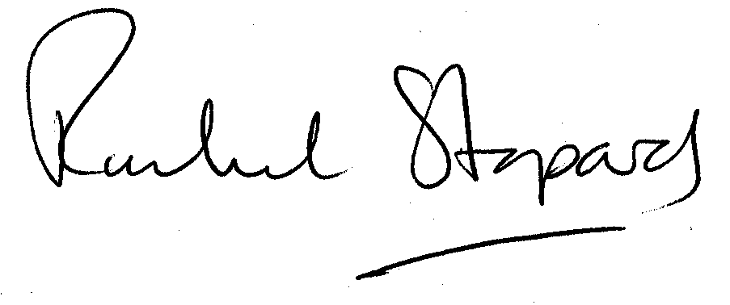
Rachel Stopard
Executive Director Supporting Communities

