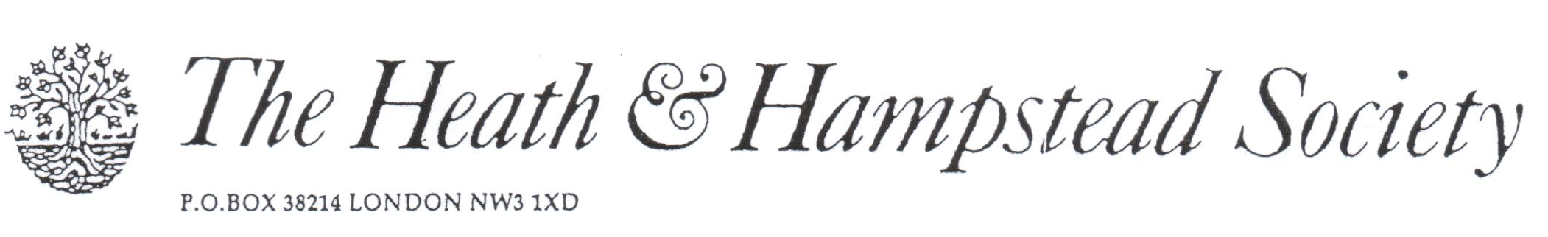
The Society examines all Planning Applications relating to Hampstead, and assesses them for their impact on conservation and on the local environment.

To London Borough of Camden, Development Control Team

Planning Ref: 2016/5380/P
Address: 115 Frognal NW3
Description: New house Demolition of existing house.
Case Officer: Kate Phillips Date 28 October 2016

We must oppose this replacement of a decent house, which makes a positive impact on the Conservation Area, by one of lower architectural merit.

The existing house is a typical example of 1930’s architecture, in the neo-Georgian style, well designed and detailed, and stands prominently on the corner of Oak Hill Way. It is described in the Conservation Area Statement as “neutral” in character; this is quite unfair: it makes a positive impact, and is perfectly in character with most of the Frognal area. Its demolition would be a loss.

The proposed new house would not only be considerably larger in plan and bulk, but would close off the gaps between it and the two adjoining houses; it would thereby lose its detached character, and harm that of the adjoining houses. The perspective drawing attached to the application is designed to minimise this effective enlargement. It is of a much lower quality of architecture, being neither Neo-Georgian nor modernist in style: a sort of hybrid.

The Conservation Area would be damaged by it, and we ask you to refuse.

