Design and Access Statement

27 Marquis Road

London

Nw1 9ud

23rd Oct 2016

Context

The property is a terraced, brick built property with a slate roof. At the rear there is a long garden with shrubs and a large bay and willow tree as well as a lilac and a myrtle.

At the bottom of the garden there are two sheds, a patio and a large structural support for a swing that spans the garden from one side to the other.

Unfortunately I began demolishing the shed before I realised that, if I was going to have a green roof, the shed was going to be above 2.5m high and therefore I needed planning permission So it looks pretty grotty at the moment but perhaps you have photographs of it on file as I had to apply for retrospective planning permission after it was. (The shed when I built it had too large a volume for the planning regulations of the day).

This is the only photograph I have of it in its heyday.

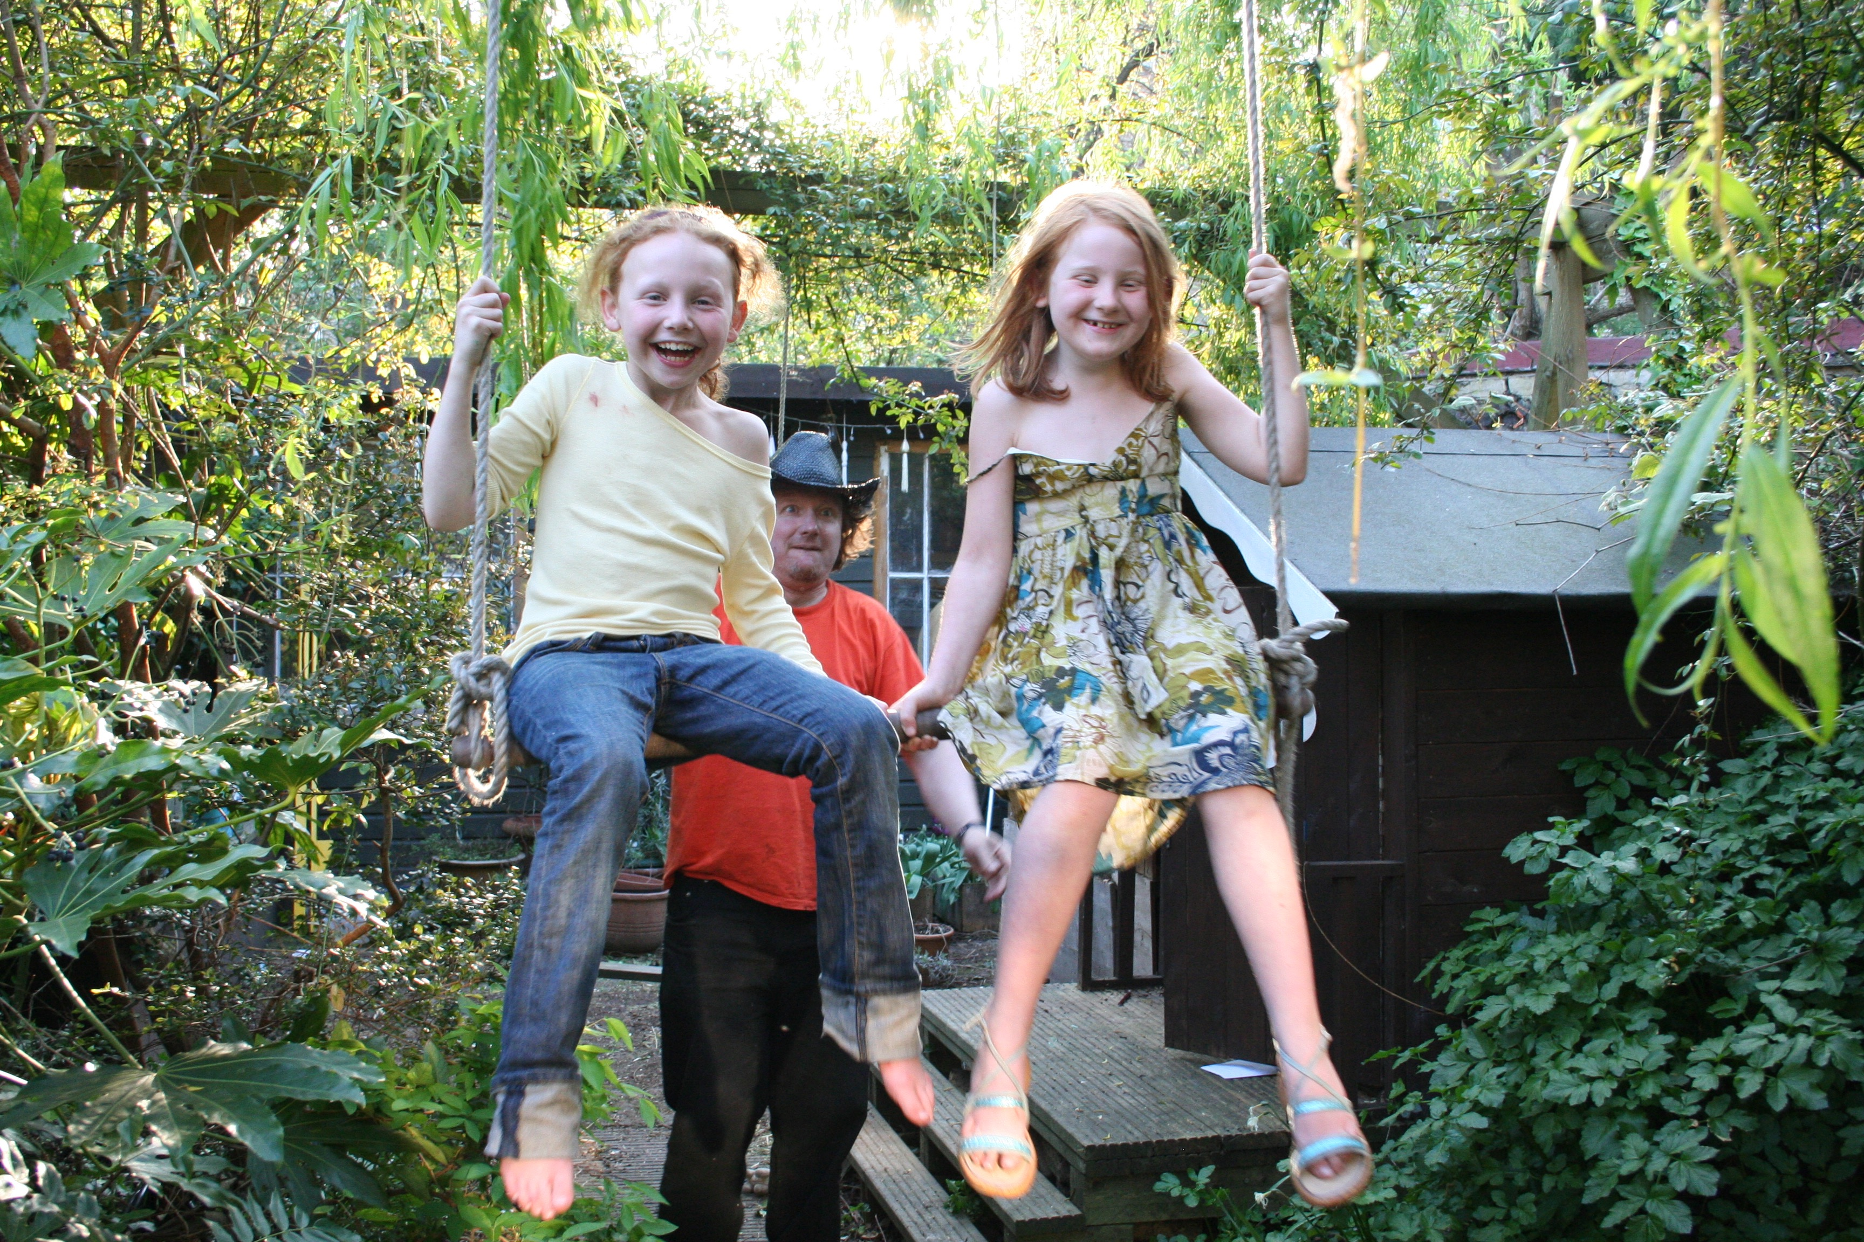

You can just make out the large shed in the background . the patio as well as the wendy house which later became a shed and the swing support.

PROPOSAL

I propose the design of the façade of the new shed would be of very much the same as that of the old shed. I would re-use the windows which were initially reclaimed from a house in Camden Square and I would again clad the exterior walls in ship lap timber.

The new shed will be narrower but longer than the previous shed and a little bit taller (though shorter at the back enabling the neighbours in St Augustine’s road to have a bit more light. ) It would take up most of the brick patio that used to be in front of the old shed. That patio now feels rather claustrophobic as the neighbours at 25 Marquis Road have just built an enormous shed at the end of their garden which runs the whole length of my shed and patio and must be over 3m high in places.

The old shed I think was in keeping with the conservation area

Materials

The shed would be built almost entirely out of timber – recycling as much of the timber from the two other sheds as possible. (minimising waste and skip expense!) Instead of the present decking roof I would plant a green roof (probably sedum perhaps grass). Either way it will increase the green footprint of the garden.

Access

The alterations have no impact on access to the site or property.