Mr Terry Girdler
Conisbee
1-5 Offord Street
London N1 1DH
1-5 Offord Street  London N1 1DH |  | Application Ref: 2016/4081/L
 |  | Please ask for: Catherine Bond
 |  | Telephone: 020 7974 2669
 |  | 27 October 2016

Dear Sir/Madam

DECISION

Planning (Listed Building and Conservation Areas) Act 1990

Listed Building Consent Granted

Address:
46 Well Walk
London
NW3 1BX

Proposal:
Various structural works including the insertion of stainless steel bars into the external masonry walls and ties into the timber floors and landings.
Drawing Nos: Site Location Plan; Site Location Plan for Wall Strengthening; SK009; Revised Repair Proposals Report dated 19 July 2016; Interim Report on Investigation 14 September 2014.

The Council has considered your application and decided to grant Listed Building Consent subject to the following condition(s):

Conditions And Reasons:

1 | The works hereby permitted shall be begun not later than the end of three years from the date of this consent.  Reason: In order to comply with the provisions of Section 18 of the Planning (Listed Buildings and Conservation Areas) Act 1990.
2 | All new external and internal works and finishes and works of making good to the retained fabric, shall match the existing adjacent work with regard to the methods used and to material, colour, texture and profile, unless shown otherwise on the drawings or other documentation hereby approved or required by any condition(s) attached to this consent.  Reason: In order to safeguard the special architectural and historic interest of the building in accordance with the requirements of policy CS14 of the London Borough of Camden Local Development Framework Core Strategy and policy DP25 of the London Borough of Camden Local Development Framework Development Policies.
3 | The works hereby approved are only those specifically indicated on the drawing(s) referred to above.  Reason: In order to safeguard the special architectural and historic interest of the building in accordance with the requirements of policy CS14 of the London Borough of Camden Local Development Framework Core Strategy and policy DP25 of the London Borough of Camden Local Development Framework Development Policies.

Informative(s):

Reasons for granting listed building consent:

The application property is a grade II* listed end-of-terrace house which is situated on rising land at the corner of Well Walk and Gainsborough Gardens within the Hampstead Conservation Area.

This application is for various structural works including the insertion of stainless steel bars into the external masonry walls and ties into the timber floors and landings. It proposes amendments to the listed building consent ref 2016/0242/L granted on 15 March 2016 for structural works to strengthen grade II* listed building comprising insertion of stainless steel bars into masonry and ties into timber floor.

The consented works comprise the insertion of Cintec stainless steel anchors into masonry at various levels and Helifix bow ties into second-floor timber floor joists, on the front and flank elevations of the property. However, since commencing works it has been discovered that underground cables run in the pavement adjacent to the house in the precise location of the proposed drilling. It has been concluded that the least damaging alternative is to insert stainless steel reinforcement behind the facing brick skin, in short lengths, fixed together with proprietary screw couplers. Access to place the reinforcement will require the face brickwork to be carefully cut around the mortar joints, removed and then replaced.

Although by their very nature the works are invasive, the harm to historic fabric will be limited and have minimal visual impact due to sensitive making good works. Any harm will be outweighed by the structural works which will prolong the life of the listed building.

Public consultation was undertaken by placement of a press notice and site notice, whereby no responses were received. Historic England was consulted, whereby a response was received on 3 August 2016 (stamped and authorised by the NPCU on 10 August 2016) authorising the London Borough of Camden to determine this application in accordance with national and local policy guidance and on the basis of its specialist conservation advice. The site's planning history was taken into account when coming to this decision.

Special regard has been attached to the desirability of preserving the listed building and its features of special architectural or historic interest, under s.16 of the Listed Buildings and Conservation Areas Act 1990 as amended by the Enterprise and Regulatory Reform Act (ERR) 2013.

As such, the proposal is in general accordance with policy CS14 of the London Borough of Camden Local Development Framework Core Strategy, and policy DP25 of the London Borough of Camden Local Development Framework Development Policies. The proposed development also accords with policy 7.8 of The London Plan 2015 consolidated with alterations since 2011, and paragraphs 14, 17 and 126-141 of the National Planning Policy Framework.

Your proposals may be subject to control under the Building Regulations and/or the London Buildings Acts which cover aspects including fire and emergency escape, access and facilities for people with disabilities and sound insulation between dwellings. You are advised to consult the Council's Building Control Service, 5 Pancras Square, London N1C 4AG (tel: 020-7974 6941).

You can find advice about your rights of appeal at:

http://www.planningportal.gov.uk/planning/appeals/guidance/guidancecontent

Yours faithfully
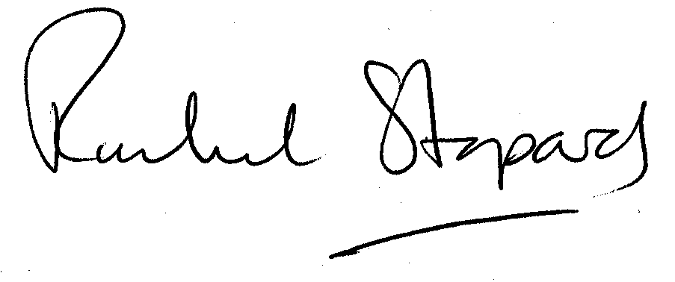
Rachel Stopard
Executive Director Supporting Communities

