
- Menu
- Search

What are you looking for?

Click anywhere to close (ESC)

- Listing
  - Search the List
  - Enrich the List
  - Apply for Listing
  - What is Listing?
  - Listing Guidance
- Advice
  - Your Home
  - Planning
  - Latest Advice & Guidance
  - Caring for Heritage
  - Technical Guidance
  - Heritage at Risk
  - Constructive Conservation
  - Heritage Protection Guide
- Research
  - Research Approaches
  - Current Research
  - Research Results
  - Support & Collaboration
  - Inclusive Heritage
  - Heritage Counts
- Images & Books
  - Find Photos
  - Search All Publications
  - Buy Books
  - The Historic England Archive
  - Be an Archive Detective
- Services & Skills
  - Education
  - Grants
  - Our Planning Services
  - Training & Skills
  - Archive Services
  - Heritage Action Zones
- Get Involved
  - Be a Volunteer
  - Protect Your Heritage
  - Help Write History
  - Visit Your Heritage
- What's New 💀
  - News
  - Halloween 👻
  - In Your Area
  - Latest Listings
  - Latest Research
  - Heritage Online Debate
  - Statements
  - Stay Up To Date
  - Angel Awards
  - FWW Centenary
  - Meet the Georgians

  - What We Do
  - How We Are Run
  - Jobs
  - Contact Us
  - Volunteer with Historic England

  - Website Terms and Conditions
  - Data Protection
  - Privacy and Cookies
  - Links Policy
  - Historic England Blog: House Rules
  - Halloween Reader Event Competition Terms and Conditions

  - About The Project
This browser is not fully supported by Historic England. Please update your browser to the latest version so that you get the best from our website.
We use cookies to give you the best possible experience online. By using this website, you consent to cookies being used in accordance with our Cookie Policy.
- Home
- ...
- Listing
- Search the List
- List Entry
- Section Navigation
  - Map Search
  - Minor Amendments
  - Download Designation Data
  - Non-Listed Sites
  - About The List
  - Enrich the List
  - Understanding List entries

39-73, MARCHMONT STREET

List Entry Summary
This building is listed under the Planning (Listed Buildings and Conservation Areas) Act 1990 as amended for its special architectural or historic interest.
Name: 39-73, MARCHMONT STREET
List entry Number: 1113112

Location
39-73, MARCHMONT STREET
The building may lie within the boundary of more than one authority.
County: Greater London Authority
District: Camden
District Type: London Borough
Parish:
National Park: Not applicable to this List entry.
Grade: II
Date first listed: 14-May-1974
Date of most recent amendment: Not applicable to this List entry.

Legacy System Information
The contents of this record have been generated from a legacy data system.
Legacy System: LBS
UID: 477490

Asset Groupings
This list entry does not comprise part of an Asset Grouping. Asset Groupings are not part of the official record but are added later for information.

List entry Description

Summary of Building
Legacy Record - This information may be included in the List Entry Details.

Reasons for Designation
Legacy Record - This information may be included in the List Entry Details.

History
Legacy Record - This information may be included in the List Entry Details.

Details
CAMDEN
TQ3082SW MARCHMONT STREET 798-1/95/1106 (West side) 14/05/74 Nos.39-73 (Odd)
GV II
Terrace of 18 houses with later shops. c1801-6. Yellow stock brick; Nos 45, 61 and 63 stucco. 4 storeys and cellars. 2 windows each. Mostly altered later C19 and C20 shopfronts. Gauged brick, (mostly reddened), flat arches to recessed sash windows, some with original glazing bars. Parapets. No.43: original wooden shopfront with pilasters and brackets carrying projecting cornice. Shop window altered. Round-arched house doorway with fluted jambs, lionhead stops, cornice-head, fanlight and panelled door. Shop doorway with fanlight and panelled door. No.45: architraved, recessed sash windows. Stucco cornice and blocking course. Nos 57 & 59: mid C19 wooden shopfronts with pilasters carrying entablature with dentil cornice flanked by enriched consoles. Shop window of No.59 with segmental-arched lights. Square-headed house doorways with overlights and panelled doors (No.57, C20). No.57 with wrought-iron sign bracket at 1st floor level. Nos 61 & 63: recessed sash windows with architraves and cornices. Bracketed stucco cornices at 3rd floor. Nos 65-73: with enriched fascia consoles. No.69: with plaque "St. G.B. 1817". No.71: with plaque "S PP 1791". INTERIORS: not inspected.
Listing NGR: TQ3013382376

Selected Sources
Legacy Record - This information may be included in the List Entry Details
National Grid Reference: TQ 30144 82349

Map
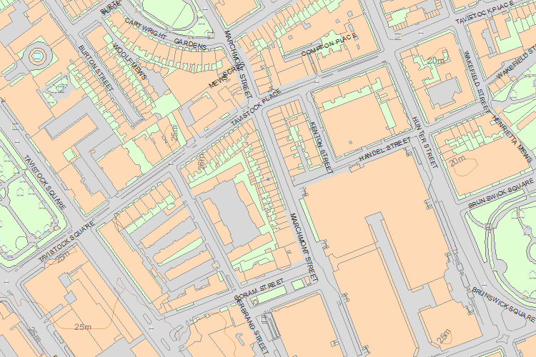© Crown Copyright and database right 2016. All rights reserved. Ordnance Survey Licence number 100024900.
© British Crown and SeaZone Solutions Limited 2016. All rights reserved. Licence number 102006.006.
Use of this data is subject to Terms and Conditions.
The above map is for quick reference purposes only and may not be to scale. For a copy of the full scale map, please see the attached PDF - 1113112 .pdf
The PDF will be generated from our live systems and may take a few minutes to download depending on how busy our servers are. We apologise for this delay.
This copy shows the entry on 27-Oct-2016 at 12:40:27.
End of official listing

Your Contributions

