Ms Priscilla Seminario
Russell Taylor Architects
85 Blackfriars Road
London SE1 8HA
85 Blackfriars Road  London SE1 8HA |  | Application Ref: 2016/4680/L
 |  | Please ask for: Antonia Powell
 |  | Telephone: 020 7974 2648
 |  | 20 October 2016

Dear Sir/Madam

DECISION

Planning (Listed Building and Conservation Areas) Act 1990

Listed Building Consent Granted

Address:
The Georgian Group
6 Fitzroy Square
London
W1T 5DX

Proposal:
Installation of a fireplace in the main entrance hall
Drawing Nos:
Design and Access Statement, For a Fireplace in the Entrance Hall, by Russell Taylor Architects dated August 2016;
6231-10 Site Plan;
6231-11 Location Plan;
6231-1B Fireplace.

The Council has considered your application and decided to grant Listed Building Consent subject to the following condition(s):

Conditions And Reasons:

1 | The works hereby permitted shall be begun not later than the end of three years from the date of this consent.  Reason: In order to comply with the provisions of Section 18 of the Planning (Listed Buildings and Conservation Areas) Act 1990.
2 | All new work and work of making good shall be carried out to match the original work as closely as possible in materials and detailed execution.  Reason: In order to safeguard the special architectural and historic interest of the building in accordance with the requirements of policy CS14 of the London Borough of Camden Local Development Framework Core Strategy and policy DP25 of the London Borough of Camden Local Development Framework Development Policies.
3 | The works hereby approved are only those specifically indicated on the drawing(s) referred to above.  Reason: In order to safeguard the special architectural and historic interest of the building in accordance with the requirements of policy CS14 of the London Borough of Camden Local Development Framework Core Strategy and policy DP25 of the London Borough of Camden Local Development Framework Development Policies.

Informative(s):

Reasons for granting listed building consent:

This application concerns the installation of a fireplace in the entrance hall of No. 6 Fitzroy Square which is owned and occupied by the Georgian Group. No. 6 Fitzroy Square is grade I listed and is within the Fitzroy Square Conservation Area.

The neighbouring houses along the east side of Fitzroy Square all appear to have had fireplaces in their hallways and there is evidence that there was originally a fireplace in the hallway of No. 6 also. The original flue appears to be retained and there are indications of the fire surround in the stone paving of the hall and the wall plaster.

The design of the proposed fireplace is taken from Adam details found within the neighbouring architecture. The proportions are to match the historic fireplace evidence found in the hallway and the new chimney piece will be made of fine-grained Portland stone.

By reinstating an important architectural element this application is considered to enhance this very fine historic entrance hall.

Public consultation was undertaken by placement of a press notice and site notice, and no responses were received. Historic England wrote with a letter of flexible authorisation stamped and dated by National Planning Casework Unit.

The site's planning history was taken into account when coming to this decision.

Special regard has been attached to the desirability of preserving the listed building and its features of special architectural or historic interest, under s.16 of the Listed Buildings and Conservation Areas Act 1990 as amended by the Enterprise and Regulatory Reform Act (ERR) 2013.

As such, the proposal is in general accordance with policy CS14 of the London Borough of Camden Local Development Framework Core Strategy, and policy DP25 of the London Borough of Camden Local Development Framework Development Policies. The proposed development also accords with policy 7.8 of The London Plan 2016 consolidated with alterations since 2011, and paragraphs 14, 17 and 126-141 of the National Planning Policy Framework.

Your proposals may be subject to control under the Building Regulations and/or the London Buildings Acts which cover aspects including fire and emergency escape, access and facilities for people with disabilities and sound insulation between dwellings. You are advised to consult the Council's Building Control Service, 5 Pancras Square, London N1C 4AG (tel: 020-7974 6941).

You can find advice about your rights of appeal at:

http://www.planningportal.gov.uk/planning/appeals/guidance/guidancecontent

Yours faithfully
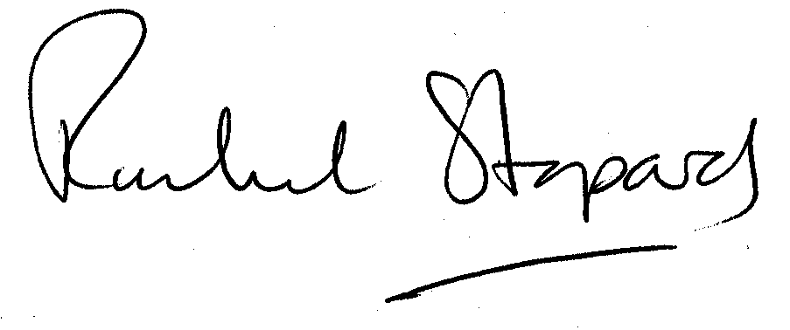
Rachel Stopard
Executive Director Supporting Communities

