
- Menu
- Search

What are you looking for?

Click anywhere to close (ESC)

- Listing
  - Search the List
  - Enrich the List
  - Apply for Listing
  - What is Listing?
  - Listing Guidance
- Advice
  - Your Home
  - Planning
  - Latest Advice & Guidance
  - Caring for Heritage
  - Technical Guidance
  - Heritage at Risk
  - Constructive Conservation
  - Heritage Protection Guide
- Research
  - Research Approaches
  - Current Research
  - Research Results
  - Support & Collaboration
  - Inclusive Heritage
  - Heritage Counts
- Images & Books
  - Find Photos
  - Search All Publications
  - Buy Books
  - The Historic England Archive
  - Be an Archive Detective
- Services & Skills
  - Education
  - Grants
  - Our Planning Services
  - Training & Skills
  - Archive Services
  - Heritage Action Zones
- Get Involved
  - Be a Volunteer
  - Protect Your Heritage
  - Help Write History
  - Visit Your Heritage
- What's New
  - News
  - Halloween
  - In Your Area
  - Latest Listings
  - Latest Research
  - Heritage Online Debate
  - Statements
  - Stay Up To Date
  - Angel Awards
  - FWW Centenary
  - Meet the Georgians

  - What We Do
  - How We Are Run
  - Jobs
  - Contact Us
  - Volunteer with Historic England

  - Website Terms and Conditions
  - Data Protection
  - Privacy and Cookies
  - Links Policy
  - Historic England Blog: House Rules
  - Halloween Reader Event Competition Terms and Conditions

  - About The Project
This browser is not fully supported by Historic England. Please update your browser to the latest version so that you get the best from our website.
We use cookies to give you the best possible experience online. By using this website, you consent to cookies being used in accordance with our Cookie Policy.
- Home
- ...
- Listing
- Search the List
- List Entry
- Section Navigation
  - Map Search
  - Minor Amendments
  - Download Designation Data
  - Non-Listed Sites
  - About The List
  - Enrich the List
  - Understanding List entries

4, ST MARKS SQUARE, 36, REGENTS PARK ROAD

List Entry Summary
This building is listed under the Planning (Listed Buildings and Conservation Areas) Act 1990 as amended for its special architectural or historic interest.
Name: 4, ST MARKS SQUARE, 36, REGENTS PARK ROAD
List entry Number: 1245875

Location
36, REGENTS PARK ROAD
4, ST MARKS SQUARE
The building may lie within the boundary of more than one authority.
County: Greater London Authority
District: Camden
District Type: London Borough
Parish:
National Park: Not applicable to this List entry.
Grade: II
Date first listed: 14-May-1974
Date of most recent amendment: Not applicable to this List entry.

Legacy System Information
The contents of this record have been generated from a legacy data system.
Legacy System: LBS
UID: 477950

Asset Groupings
This list entry does not comprise part of an Asset Grouping. Asset Groupings are not part of the official record but are added later for information.

List entry Description

Summary of Building
Legacy Record - This information may be included in the List Entry Details.

Reasons for Designation
Legacy Record - This information may be included in the List Entry Details.

History
Legacy Record - This information may be included in the List Entry Details.

Details
CAMDEN
TQ2883NW REGENT'S PARK ROAD 798-1/75/1520 (South side) 14/05/74 No.36
GV II
See under: No.4 ST MARK'S SQUARE.
CAMDEN
TQ2883NW ST MARK'S SQUARE 798-1/75/1520 (North side) 14/05/74 No.4
GV II
Includes: No.36 REGENT'S PARK ROAD. 2 semi-detached villas. No.4 formed by the return and rear of No.36 Regent's Park Road. Mid C19. Stucco with rusticated ground floor and quoins. Slated hipped roof with dormers and projecting bracketed eaves. 3 storeys, attics and basements. Double fronted with 3 windows. No.36 Regent's Park Road with side portico having arched entrance, fanlight and half glazed door. No.4 with central portico having arched entrance flanked by Ionic three quarter columns and brackets carrying dentil cornice which continues around the house at 1st floor level; doorway with fanlight, sidelights and half glazed door. No.36 with ground floor bay window; No.4 with canted bay window having cast-iron balcony. Round-arched, recessed 1st floor casements with patterned heads; central window with stucco balustraded balcony and flanked by pilasters carrying entablature. Right hand window with cast-iron balcony. 2nd floor with architraved segmental headed sashes with cast-iron balconies on large console bracket supports, the centre console forming a keystone to the window below on the outer bays. Tall slab chimney-stacks. INTERIORS: not inspected.
Listing NGR: TQ2818683784

Selected Sources
Legacy Record - This information may be included in the List Entry Details
National Grid Reference: TQ 28186 83784

Map
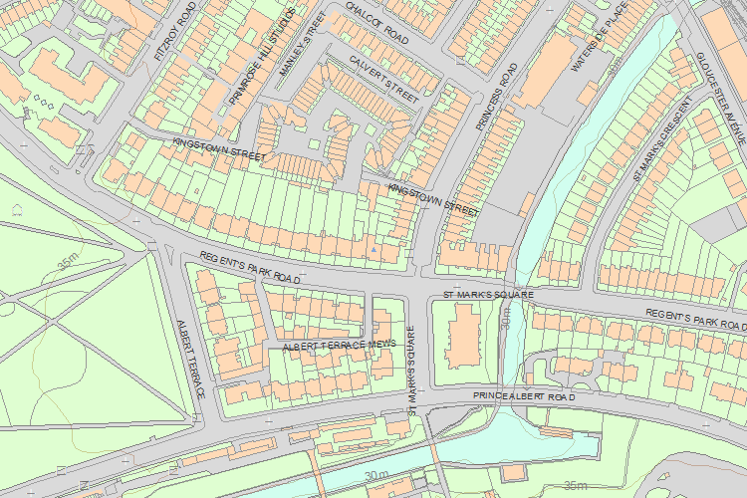© Crown Copyright and database right 2016. All rights reserved. Ordnance Survey Licence number 100024900.
© British Crown and SeaZone Solutions Limited 2016. All rights reserved. Licence number 102006.006.
Use of this data is subject to Terms and Conditions.
The above map is for quick reference purposes only and may not be to scale. For a copy of the full scale map, please see the attached PDF - 1245875 .pdf
The PDF will be generated from our live systems and may take a few minutes to download depending on how busy our servers are. We apologise for this delay.
This copy shows the entry on 20-Oct-2016 at 03:12:37.
End of official listing

