Mr Stephen Levrant
Heritage Architecture Ltd
62 British Grove
Chiswick
London
W4 2NL
62 British Grove  Chiswick  London  W4 2NL |  | Application Ref: 2015/6952/P
 |  | Please ask for: Antonia Powell
 |  | Telephone: 020 7974 2648
 |  | 18 October 2016

Dear Sir/Madam

DECISION

Town and Country Planning Act 1990 (as amended)

Approval of Details Granted

Address:
41 Chester Terrace
London
NW1 4ND

Proposal:
Details of methodology of removal and repairs of railings required by condition 6 of planning permission granted on 10/12/2014 (reference: 2014/4977/P for the amendments to approved applications 2013/1888/L and 2013/1426/P, including proposed changes to demolition schedule, internal alterations, external repairs including repairs to exterior walls, boundary walls, adjustment to rooflight, bespoke metal grilles over lightwell, ship ladder to external hatch, balcony railings, boundary railings and the installation of 5 X security cameras to external facades of building.)
Drawing Nos:

Supporting Statement to discharge condition 6 of LBC 2014/4977/P (Repair of railings to external boundary wall) dated December 2015 by Stephen Levrant Heritage Architecture Ltd;
Method Statement Proforma dated 09/12/2015;
Site set up plan, SICL-CT-001 REV 3;
Sherlock Interiors Ltd correspondence dated 28/07/2014.

The Council has considered your application and decided to grant permission subject to the following condition(s):

Condition(s) and Reason(s):

Informative(s):

Condition 6 (Amendments to Planning Permission 2014/4977/P granted 10/12/2014) requires ""Prior to works commencing on site, a methodology of removal and repair of railings to external boundary wall will need to be submitted to the local authority for written approval. This methodology would need to demonstrate how the railings would be dismantled and reassembled as part of the overall construction process."

This application is for the removal and repair works to the external boundary wall and railings and reflects the on site discussions between the conservation officer, the applicant and Historic England.

The site's planning history, including Listed Building Consent 2014/4921/L granted 17/10/2014 for the temporary removal of the railings, was taken into account when coming to this decision. The CAAC initially objected to the lack of detailed information however further details were then provided. No other objections were received as a result of public consultation. Historic England responded with a letter of flexible authorisation.

Special regard has been attached to the desirability of preserving the listed building and its features of special architectural or historic interest, under s.16 of the Listed Buildings and Conservation Areas Act 1990 as amended by the Enterprise and Regulatory Reform Act (ERR) 2013.

As such, the proposal is in general accordance with policy CS14 of the London Borough of Camden Local Development Framework Core Strategy, and policy DP25 of the London Borough of Camden Local Development Framework Development Policies. The proposed development also accords with policy 7.8 of The London Plan 2015 consolidated with alterations since 2011, and paragraphs 14, 17 and 126-141 of the National Planning Policy Framework.

This application is therefore granted.

You are advised that all conditions relating to Planning Permission ref:2014/4977/P granted 10/12/2014, which require details to be submitted to and approved in writing by the council as local planning authority, have been discharged.

In dealing with the application, the Council has sought to work with the applicant in a positive and proactive way in accordance with paragraphs 186 and 187 of the National Planning Policy Framework.

You can find advice about your rights of appeal at:

http://www.planningportal.gov.uk/planning/appeals/guidance/guidancecontent

Yours faithfully
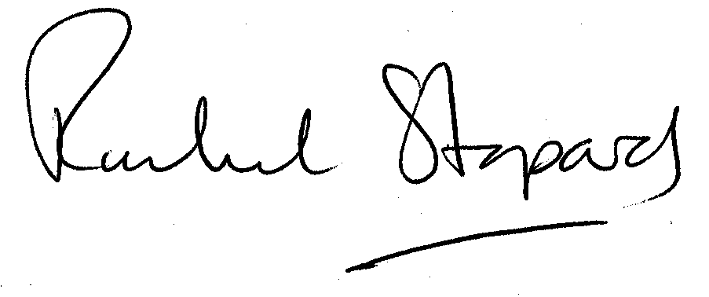
Rachel Stopard
Executive Director Supporting Communities

