
- Menu
- Search

What are you looking for?

Click anywhere to close (ESC)

- Listing
  - Search the List
  - Enrich the List
  - Apply for Listing
  - What is Listing?
  - Listing Guidance
- Advice
  - Your Home
  - Planning
  - Latest Advice & Guidance
  - Caring for Heritage
  - Technical Guidance
  - Heritage at Risk
  - Constructive Conservation
  - Heritage Protection Guide
- Research
  - Research Approaches
  - Current Research
  - Research Results
  - Support & Collaboration
  - Inclusive Heritage
  - Heritage Counts
- Images & Books
  - Find Photos
  - Search All Publications
  - Buy Books
  - The Historic England Archive
  - Be an Archive Detective
- Services & Skills
  - Education
  - Grants
  - Our Planning Services
  - Training & Skills
  - Archive Services
  - Heritage Action Zones
- Get Involved
  - Be a Volunteer
  - Protect Your Heritage
  - Help Write History
  - Visit Your Heritage
- What's New
  - News
  - In Your Area
  - Latest Listings
  - Latest Research
  - Heritage Online Debate
  - Statements
  - Stay Up To Date
  - Angel Awards
  - FWW Centenary
  - Meet the Georgians

  - What We Do
  - How We Are Run
  - Jobs
  - Contact Us
  - Volunteer with Historic England

  - Website Terms and Conditions
  - Data Protection
  - Privacy and Cookies
  - Links Policy
  - Historic England Blog: House Rules

  - About The Project
This browser is not fully supported by Historic England. Please update your browser to the latest version so that you get the best from our website.
We use cookies to give you the best possible experience online. By using this website, you consent to cookies being used in accordance with our Cookie Policy.
- Home
- ...
- Listing
- Search the List
- List Entry
- Section Navigation
  - Map Search
  - Minor Amendments
  - Download Designation Data
  - Non-Listed Sites
  - About The List
  - Enrich the List

NUMBERS 1-8 AND ATTACHED RAILINGS

List Entry Summary
This building is listed under the Planning (Listed Buildings and Conservation Areas) Act 1990 as amended for its special architectural or historic interest.
Name: NUMBERS 1-8 AND ATTACHED RAILINGS
List entry Number: 1258106

Location
NUMBERS 1-8 AND ATTACHED RAILINGS, 1-8, CHAMBERLAIN STREET
The building may lie within the boundary of more than one authority.
County: Greater London Authority
District: Camden
District Type: London Borough
Parish:
National Park: Not applicable to this List entry.
Grade: II
Date first listed: 11-Jan-1999
Date of most recent amendment: Not applicable to this List entry.

Legacy System Information
The contents of this record have been generated from a legacy data system.
Legacy System: LBS
UID: 476876

Asset Groupings
This list entry does not comprise part of an Asset Grouping. Asset Groupings are not part of the official record but are added later for information.

List entry Description

Summary of Building
Legacy Record - This information may be included in the List Entry Details.

Reasons for Designation
Legacy Record - This information may be included in the List Entry Details.

History
Legacy Record - This information may be included in the List Entry Details.

Details
CAMDEN
TQ2784SE CHAMBERLAIN STREET 798-1/63/195 (South side) Nos.1-8 (Consecutive) and attached railings
GV II
Symmetrical terrace of 8 houses. Mid C19. Yellow stock brick with blue brick bands and stucco dressings. Slated roofs with overhanging bracketed eaves. Nos 1 & 11 have pediments and slightly project. 3 storeys and basements. 2 windows each. Prostyle porticos; panelled doors with overlights. Ground floor tripartite sashes have channelled stucco voussoirs, keystones and triglyph with guttae drops; cast-iron window guards to bracketed cornice sills. Architraved 1st floor sashes with bracketed cornices and pediments, cast-iron window guards and continuous sill band. 2nd floor sashes have bracketed sills, continuous sill band and are flanked at the top by the large enriched eaves brackets. INTERIORS: not inspected. SUBSIDIARY FEATURES: attached cast-iron railings with spearhead finials to areas. The houses in Chamberlain Street form a very complete group.
Listing NGR: TQ2783884072

Selected Sources
Legacy Record - This information may be included in the List Entry Details
National Grid Reference: TQ 27838 84072

Map
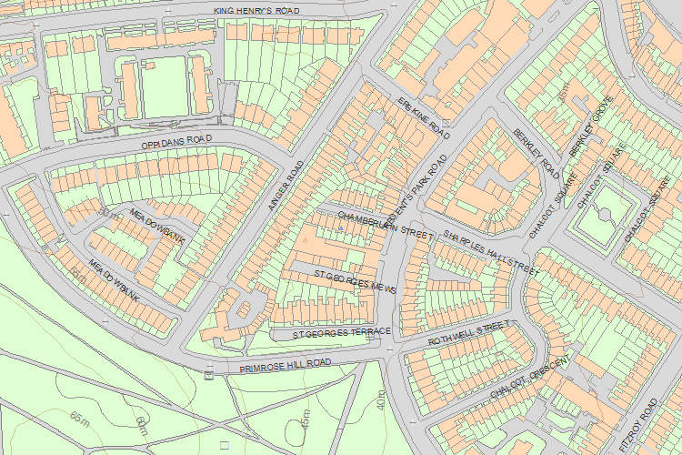© Crown Copyright and database right 2016. All rights reserved. Ordnance Survey Licence number 100024900.
© British Crown and SeaZone Solutions Limited 2016. All rights reserved. Licence number 102006.006.
Use of this data is subject to Terms and Conditions.
The above map is for quick reference purposes only and may not be to scale. For a copy of the full scale map, please see the attached PDF - 1258106 .pdf
The PDF will be generated from our live systems and may take a few minutes to download depending on how busy our servers are. We apologise for this delay.
This copy shows the entry on 03-Oct-2016 at 11:05:31.
End of official listing

