Mount Anvil (Kidderpore) Ltd

Mount Anvil project office

Former Kings College Hampstead Campus

Kidderpore Avenue

Hampstead

NW3 7ST

28th of September 2016

FAO Rachael Parry

Conservation officer

Regeneration & Planning

London Borough of Camden

Floor 2

5 Pancras Square

N1C 4AQ

Dear Rachael

**RE: Brick Cleaning Sample**

Following our site visit today, MA write to inform confirm on the Bricks cleaning sample proposed.

For the cleaning we adopted a DOFF system.

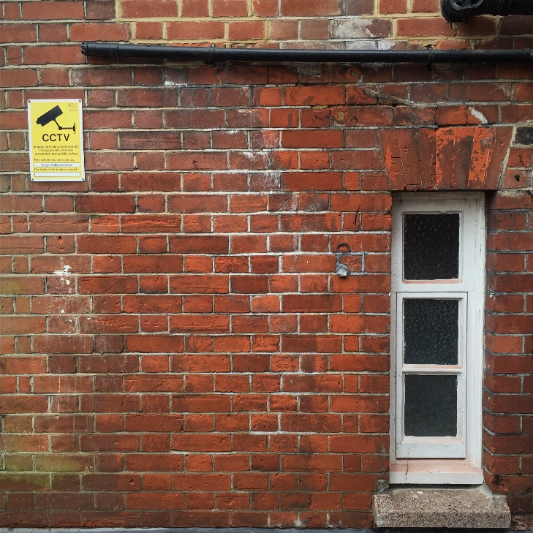DOFF system cleans stonework and masonry using high temperature steam The DOFF cleaner is an expertly engineered system that utilises a normal water supply to remove some of the more resistant moss, algae, fungi and other biological matter forms of dirt or markings from stonework and masonry, without the need to use a chemical biocide.

The water supply is fed into a hot-box where it is subjected to temperatures as high as 150℃. The resultant heated water, or vapour, is then filtered through the heat resistant hoses to the nozzle at a rate of between 3 to 10 litres per minute. Whilst the temperature in the system is high, the pressure on the surface being cleaned is very gentle and the volume of water is low. The surface is therefore not saturated.

Once cleaned, the surface dries within minutes to prevent any long-term damage as a result of trapped moisture.

We have opted for a medium level clean, the nozzle is held between 1" and 6" away from surface and both temp and pressure is regulated by specialist so that the combination of nozzle position, pressure and temperature produces a uniform reduction in grime depending on the overall level of dirt and isolated stains, passing over the area once with a vertical sweep of approx. 500mm.

Your sincerely.

**Marco Liberace**

Technical Manager