Access Statement
Address: 175 Highgate Road, NW5 1PQ
Property description:
Detached Georgian House. Grade II listed. Date of listing: 1974. Early/ mid C19 yellow stock brick with plain stucco 1st floor sill band. Hipped slated roof with projecting bracketed eaves having bargeboards. 2 storeys and basement level. Double fronted with 3no windows. Late C19 stucco portico approached by steps. Round- arched doorway with patterned radial fanlight and double panelled doors. Gauged flat brick arches to recessed sashes.
The Proposal includes:
The building is currently a therapy centre for children with psychological, physical, or developmental disabilities. The unique qualities of music as therapy can enhance communication, support change, and enable people to live more resourcefully and creatively. The impending appointment of a Teacher who is a full time wheelchair user has focused the need to afford more accessible ways of accessing the building.
Currently there are three main points of access: a) The main entrance is accessed via 7no steps, flanked on either side by low level walls. b) The basement entrance is accessed via two sets of steps on either side terminating at a level platform, in order to access basement entry door. c) The rear of the property, which not viable to consider adapting to promote wheelchair access due to the complexity of modifications required.
Access rationale:
Installation of a platform inclining lift will be fixed to the left side of the steps, as a stanchion frame will support the lift and when not in use will be stationed at the top of at the bottom of the steps on a level platform, being folded up to maximise the unobstructed access to the main entrance. Alighting the lift will not require any turning space as the wheelchair will exists at the end of the platform and not from the side. Both the external and internal double doors at the top of the stairs will remain open for the whole time the building is open.
It is recognised that the inclining lift platform has dimensions that are slightly narrower than required by Part M. We are however proposing that the installation still take place as the benefits will outweigh this as it will give access to our student who is a wheelchair user. This wheelchair user also uses a small manual chair and so will have no problems with this size platform. His condition is not degenerative so we are confident that the lift will continue to meet his requirements for the duration of his studies.
Providing suitable access, facilities and escape from the property are important factors in the production of the proposal to which this statement relates.
A full evacuation policy and personal evacuation plan for the student will be developed and document including the installation of an evacuation chair at the top of the stairs. Staff in this building have already received training in the use of such a chair.
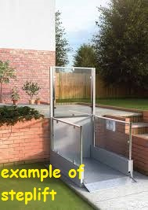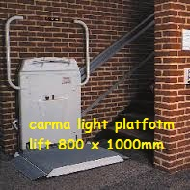
In order to counteract the restraints due to the differential in levels, we will retain the character of the building, provide level access into the main access, while affording both stepped and wheelchair platform access into the main and side basement entrances, providing a more user friendly and efficient of gaining access in and out of the building.
Assessment:
The proposal overall will provide a more coherence and sympathetic solution, regarding access end user and maximise circulation space while encouraging a wider range of clientele, meeting DDA requirements.
The proposal is in keeping with the Council's philosophy to promote independence at work and facilitate learning for all regardless of any adverse circumstances.



