COMPLETE TREE CARE

BS5837 Survey: 6a Ospringe Road

Appendix 2: Photographs

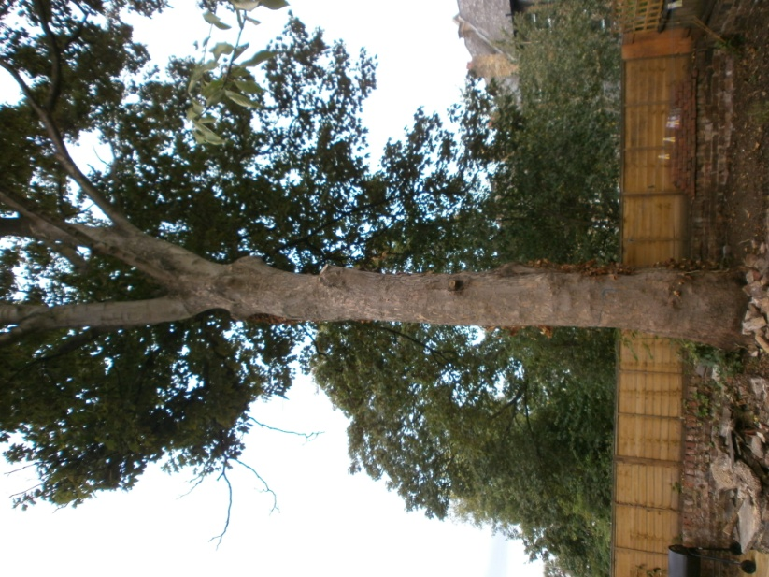

T1 - Sycamore

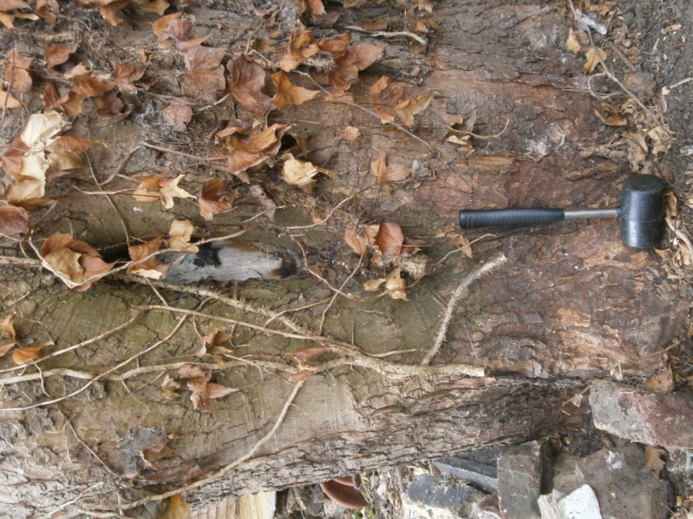

T1 – showing trunk wound

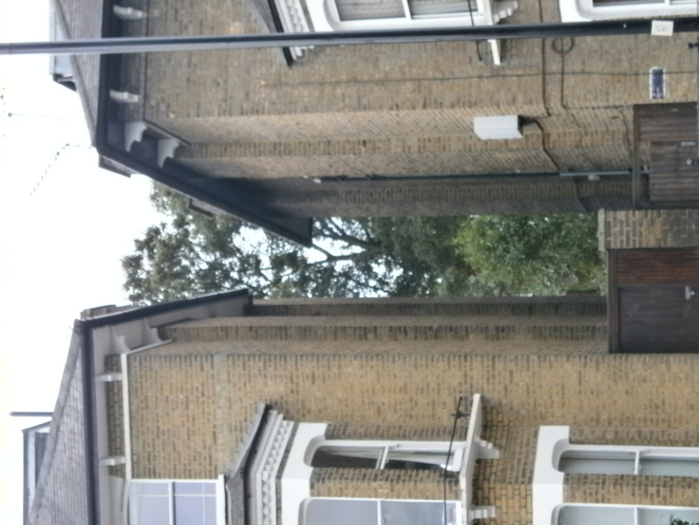

T1 seen from Brecknock Road

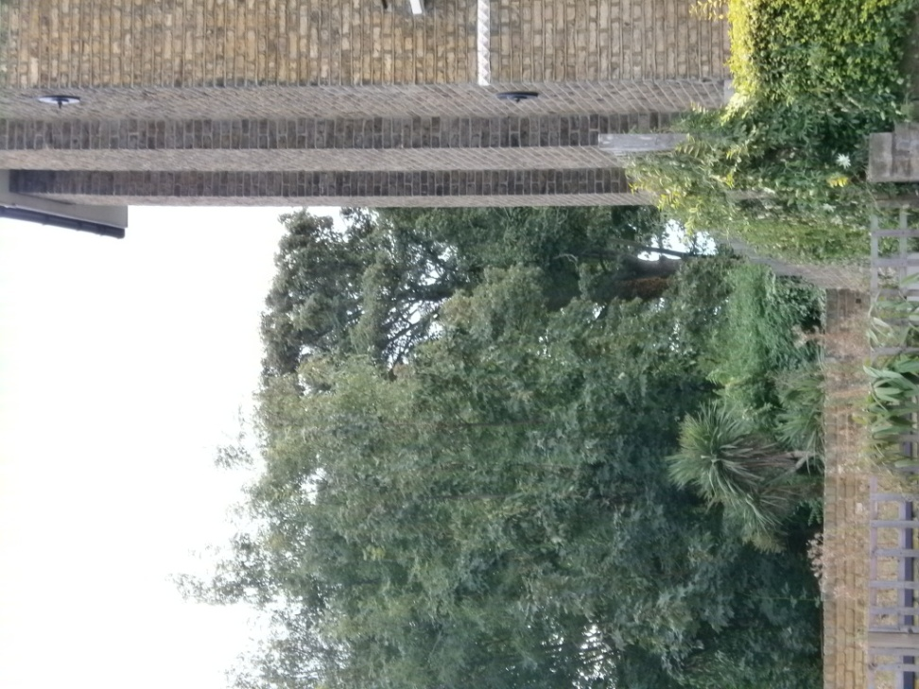

T1 seen from Lady Margaret Road

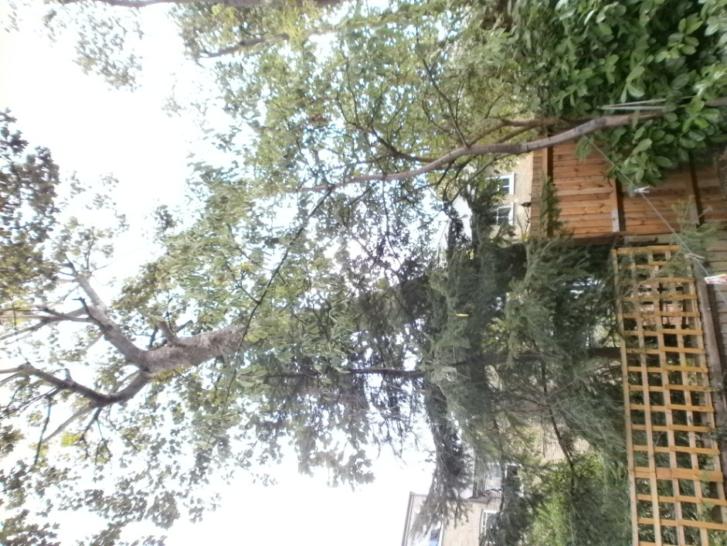

T2 (Pine, on left behind lattice fence); T4 (large Sycamore in background); T3 (Cherry – in front of fence)