Mr Luke Emmerton
DP9 Ltd
DP9 Ltd
100 Pall Mall
London SW1Y 5NQ UK
DP9 Ltd  100 Pall Mall  London SW1Y 5NQ UK |  | Application Ref: 2016/2788/L
 |  | Please ask for: Antonia Powell
 |  | Telephone: 020 7974 2648
 |  | 20 September 2016

Dear Sir/Madam

DECISION

Planning (Listed Building and Conservation Areas) Act 1990

Approval of Details (Listed Building) Granted

Address:
Senate House - North Block
Malet Street
WC1E 7HU

Proposal:
Detailed of windows and doors (drawings) as required by condition 5f & 5g of listed building consent granted on 02/07/2014 ref: 2013/4478/L for the external alterations to inner courtyard.
Drawing Nos: 27831-SOAS-A-DET-GEN-00-438;
27831-SOAS-A-PLN-DEM-00-192;
27831-SOAS-A-PLN-FRE-00-252;
27831-SOAS-A-PLN-GEN-00-292;
27831-SOAS-A-SHL-GEN-XX-912;
27831-SOAS-A-SHL-GEN-XX-914;
27831-SOAS-A-SKE-XXX-XX-157;
27831-SOAS-A-SKE-XXX-XX-158;
27831-SOAS-A- SKE-XXX-XX-159;
27831-SOAS-A- SKE-XXX-XX-160;
27831-SOAS-A- SKE-XXX-XX-162;

The Council has considered your application and decided to grant Approval of Details (Listed Building) subject to the following condition(s):

Conditions And Reasons:

Informative(s):

The fire doors and window have been viewed on site and the submitted details are considered satisfactory. The relevant parts of the conditions are therefore discharged.

The site's planning history was taken into account when coming to this decision. No objections were received as a result of public consultation.

Special attention has been paid to the desirability of preserving the special interest of the listed building under s.16 of the Listed Buildings and Conservation Areas Act 1990 as amended by the Enterprise and Regulatory Reform Act (ERR) 2013.

As such, the proposed development is in general accordance with policies CS5 and CS14 of the London Borough of Camden Local Development Framework Core Strategy, and policies DP24, DP25 and DP26 of the London Borough of Camden Local Development Framework Development Policies. The proposed development also accords with policies 7.4, 7.6 and 7.8 of the London Plan March 2015, consolidated with alterations since 2011; and paragraphs 14, 17, 56-66 and 126-141 of the National Planning Policy Framework.

Please be advised that all conditions relating to Listed Building Consent ref:2013/ 4478/L granted 02/07/2014, which require details to be submitted to, and approved in writing by the council as local planning authority, have been discharged.

You can find advice about your rights of appeal at:

http://www.planningportal.gov.uk/planning/appeals/guidance/guidancecontent

Yours faithfully
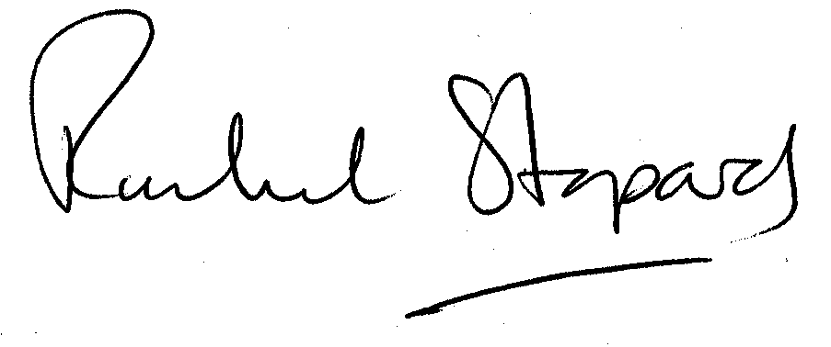
Rachel Stopard
Executive Director Supporting Communities

