**ENCLOSURE 1: NOTIFICATION OF PROPOSED WORKS TO TREES IN A CONSERVATION AREA**

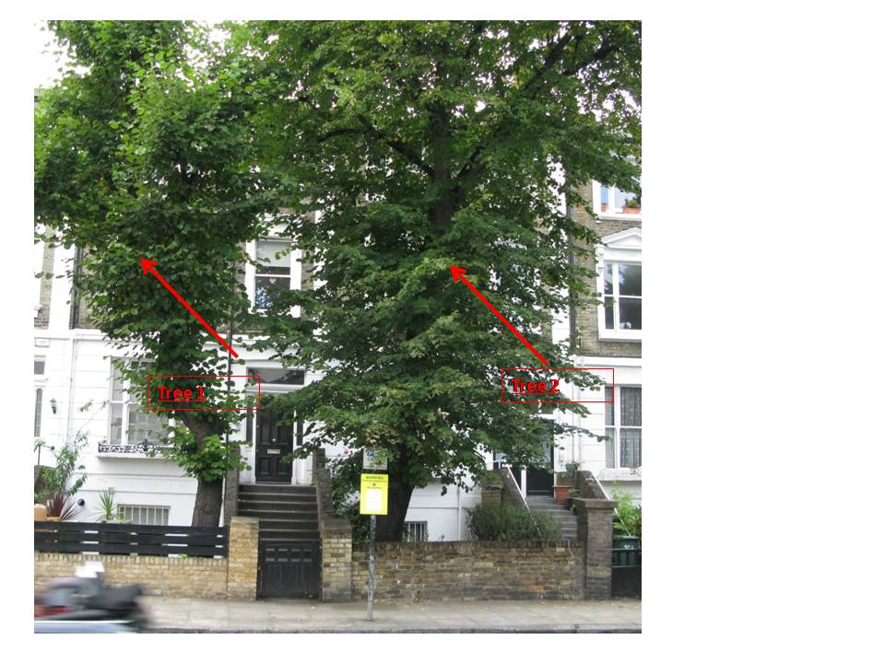

**Photo 1: Overview of the two trees. Oversized for garden, with shallow roots and close to the buildings**

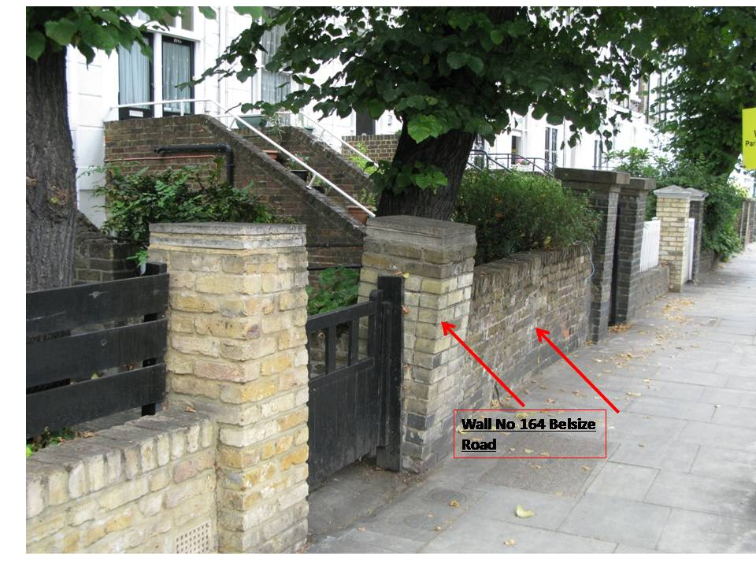

**Photo 2: Leaning pillar and wall caused by Tree 2**

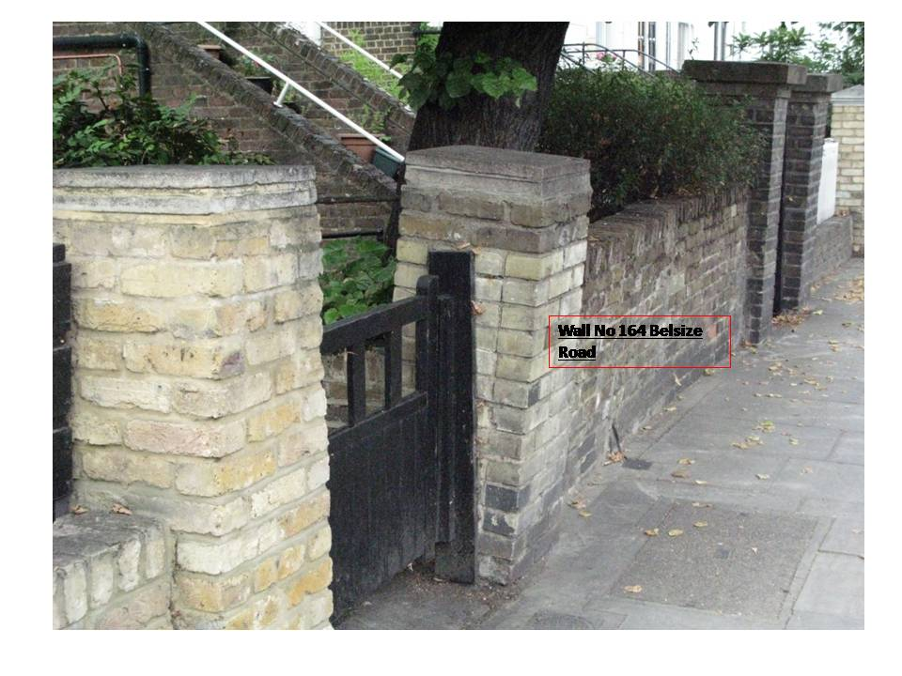

**Photo 3: Leaning pillar and wall caused by Tree 2**

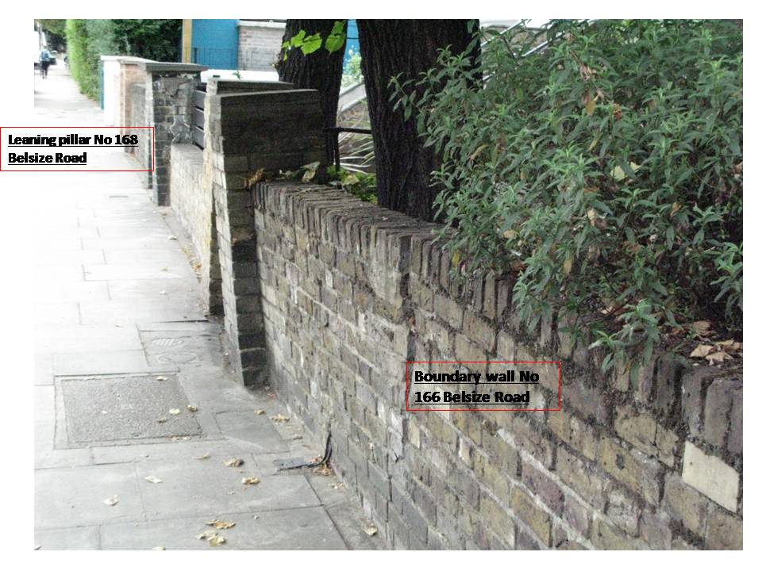

**Photo 4: Fractured wall caused by Tree 2**

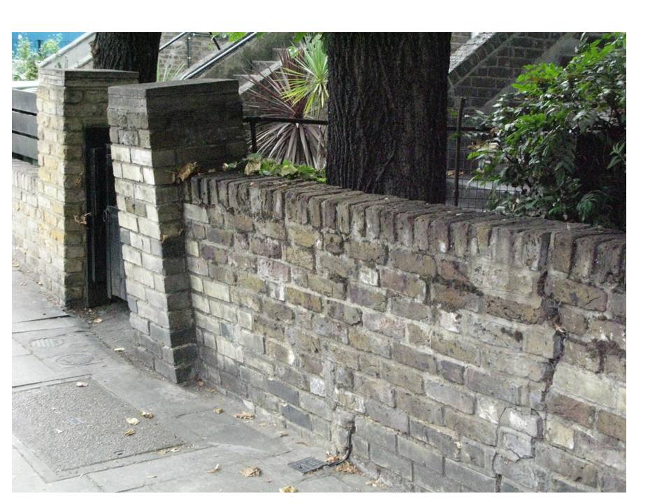

**Photo 6: Fractured wall caused by Tree 2**

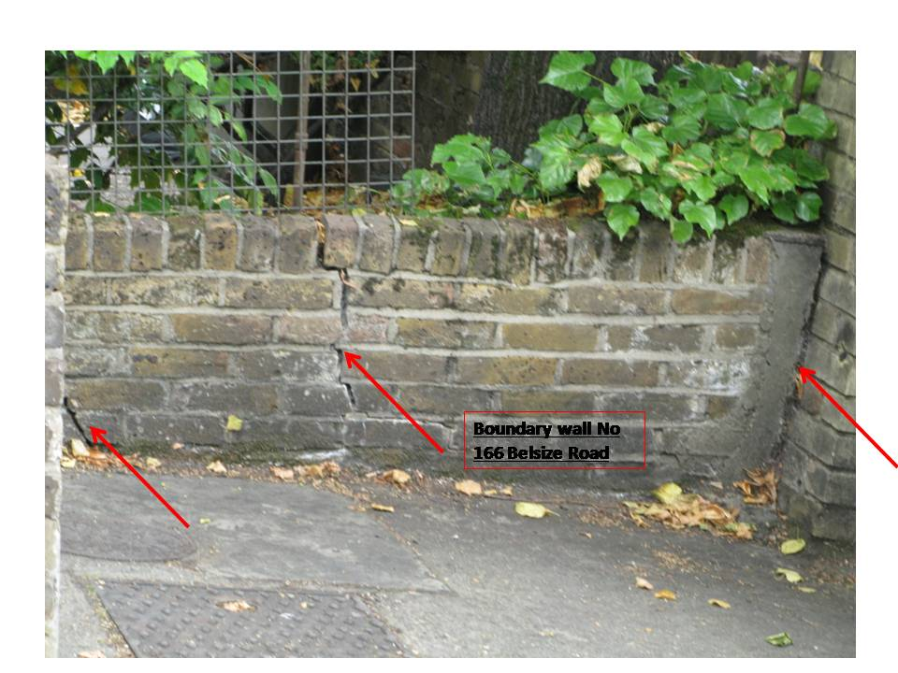

**Photo 7: Boundary wall of 166 Belsize Road fractured in several places by Tree 1**

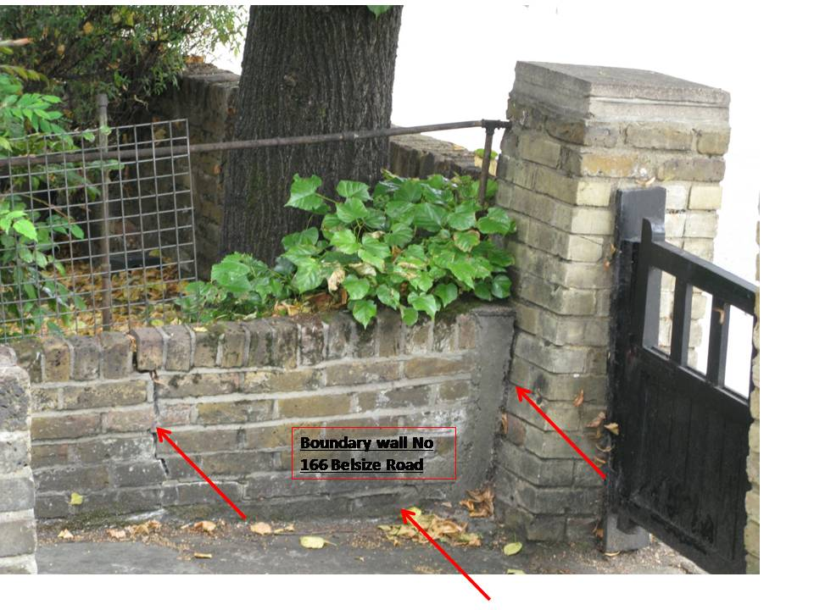

**Photo 8: Boundary wall for 166 Belsize Rd fractured in several places by Tree 1**

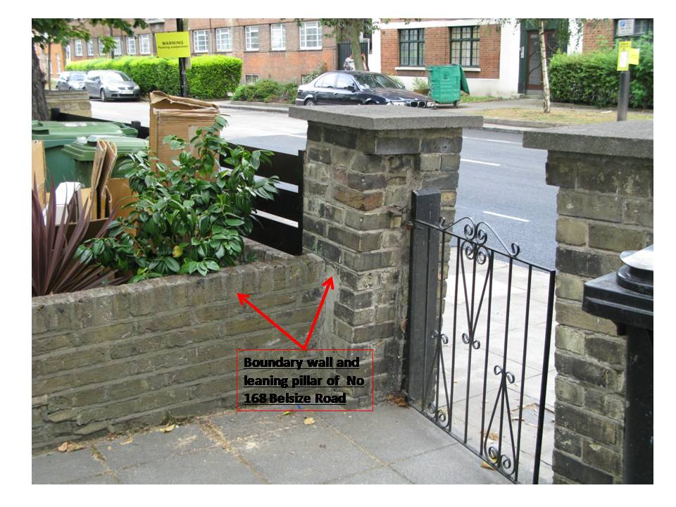

**Photo 9: Boundary wall and leaning pillar for 168 Belsize Rd Wall fractured in several places by Tree 1**

**Proposed work to trees in a Conservation Area**

Species of trees: Not known but I am told by my neighbours that these trees have little scientific value. Given the size they have grown to, the heavy pedestrian and vehicle traffic on Belsize Road, they are completely unsuitable for small front gardens

**Section 7: Identification of Trees and Description of Works**

1. I would like permission to entirely remove the two trees situated in the front garden of 166 and 164 Belsize Road respectively. I am enclosing a photograph of the trees.
2. The height of these trees is approximately 60 - 80 feet high. This is disproportionate to the size of the front gardens.
3. These trees:

* Are causing severe damage to the structure and the drains of the Basement Flat, 166 Belsize Road.
* They are causing severe damage to the front, side walls and pillars of three properties (164, 166 and 168 Belsize Road)
* They have damaged the front "driveways" of no 164 and 166 Belsize Road
* I believe that 164, 166 and 168 Belsize Road are likely to suffer serious structural problems in the near future if these trees are not removed
* A local surveyor has told me that "*these trees pose a long-term risk - the foundations of buildings along Belsize Road are relatively shallow, the foundations are prone to movement from trees and that it would be better to remove them completely"*
* The very shallow foundations mean that there is a good likelihood that they will be brought down in a storm with the potential to cause serious injury to passer-bys and substantial damage to passing traffic.
* The trees are very close together so exacerbating these problems

1. **Proposed works to the trees**

I understand that last year Camden Council gave permission for the trees to be pollarded. As you can see, this has made no impact and the problem worsens with each passing month.

Legal liability remains with Camden Council for injury to people or property if we are not able to remove these trees.

The removal of these trees will be arranged by the owners of 166 and 164 Belsize Road.

This property and the surrounding property will benefit from the introduction of significantly more light.

We are all very conscious of the need for a greener environment - we all have a variety of trees, plants and shrubs in our front and rear gardens. We are also conscientious recyclers. Therefore, we do not make this request lightly but in order to prevent serious further damage occurring.

Almost all the residents agree here that the trees are causing a significant nuisance, are a danger and should be removed.

Therefore, I request that we be given permission to remove these two trees.

Thank You

Yousef Bassa