Mr Aaron Francis
Strzala Architects
Studio 103
The Courtyard
Royal Mills Ancoats
Manchester M4 5BA
Application Ref: 2016/2598/L
Please ask for: Antonia Powell
Telephone: 020 7974 2648
6 September 2016

Dear Sir/Madam

DECISION

Planning (Listed Building and Conservation Areas) Act 1990

Listed Building Consent Granted

Address:
King's Cross Station
Euston Road
King's Cross
London
N1C 4TB

Proposal:
Occupational health facilities to be located in Room 211 of the Western Range to provide two consulting rooms and a waiting area including the erection of internal partition walls, new floor finishes and fixtures and fittings.

Drawing Nos:
2535-HS02 Heritage Statement; 2535-LP01 A4 Location Plan;
2535-001 A; 2535-002 B; 2535-003 A; 2535-004 A;
2535-202 J; 2535-203 F; 2535-204 F; 2535-205 G; 2535-206 F; 2535-207 E;

The Council has considered your application and decided to grant Listed Building Consent subject to the following condition(s):

Conditions And Reasons:

1 | The works hereby permitted shall be begun not later than the end of three years from the date of this consent.  Reason: In order to comply with the provisions of Section 18 of the Planning (Listed Buildings and Conservation Areas) Act 1990.
2 | All new work and work of making good shall be carried out to match the original work as closely as possible in materials and detailed execution.  Reason: In order to safeguard the special architectural and historic interest of the building in accordance with the requirements of policy CS14 of the London Borough of Camden Local Development Framework Core Strategy and policy DP25 of the London Borough of Camden Local Development Framework Development Policies.
3 | All new partitions to be scribed around historic plaster walls, ceiling, cornices and joinery including skirting, picture rails and architraves.  Reason: In order to safeguard the special architectural and historic interest of the building in accordance with the requirements of policy CS14 of the London Borough of Camden Local Development Framework Core Strategy and policy DP25 of the London Borough of Camden Local Development Framework Development Policies.
4 | No historic joinery is to be modified or removed as a result of these consented works.  Reason: In order to safeguard the special architectural and historic interest of the building in accordance with the requirements of policy CS14 of the London Borough of Camden Local Development Framework Core Strategy and policy DP25 of the London Borough of Camden Local Development Framework Development Policies.

Informative(s):

Reason for granting consent:

This application concerns the sub division of Room 211 of the Grade I Western Range, Kings Cross Station for use as occupational health consulting rooms. The proposal involves the introduction of light weight partitions, the creation of a waiting reception and washing facilities.

After initial concerns were raised, the installation of a suspended ceiling has been removed from the scheme to allow greater appreciation of the original room proportions and all new services are to be run within the new partitions to avoid harm to the historic fabric. The proposed works do not involve invasive work to the historic fabric and are considered to be reversible in the future.

Public consultation was undertaken by placement of a press notice and site notice, and no responses were received. Historic England, after initial design concerns were resolved, wrote with a letter of flexible authorisation stamped and dated by National Planning Casework Unit.

The site's planning history was taken into account when coming to this decision.

Special regard has been attached to the desirability of preserving the listed building and its features of special architectural or historic interest, under s.16 of the Listed Buildings and Conservation Areas Act 1990 as amended by the Enterprise and Regulatory Reform Act (ERR) 2013.

As such, the proposal is in general accordance with policy CS14 of the London Borough of Camden Local Development Framework Core Strategy, and policy DP25 of the London Borough of Camden Local Development Framework Development Policies. The proposed development also accords with policy 7.8 of The London Plan 2016 consolidated with alterations since 2011, and paragraphs 14, 17 and 126-141 of the National Planning Policy Framework.

This application is therefore granted consent.

You are advised that any works of alterations or upgrading not included on the approved drawings which are required to satisfy Building Regulations or Fire Certification may require a further application for listed building consent.

You can find advice about your rights of appeal at:

http://www.planningportal.gov.uk/planning/appeals/guidance/guidancecontent

Yours faithfully
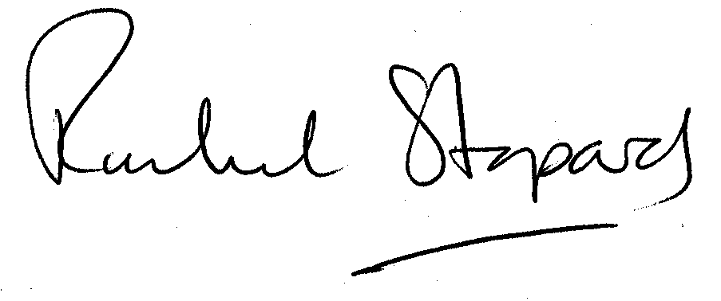
Rachel Stopard
Executive Director Supporting Communities

