**Date: 1/09/2016**

**Your ref: APP/X5210/W/16/3152238**

**Our ref: 2016/0931/P**

**Contact: Raymond Yeung**

**Direct line: 020 7974 4546**

**Email: raymond.yeung@camden.gov.uk**

**Dear Karen Robb,**

**Planning Appeal by Mr Shyham shah**

**Site at Unit 1, 109 Goldhurst Terrace**

The Council’s case for this appeal regarding refusal of Planning Permission is largely set out in the officer’s delegated report and decision notice dated 27/05/2016. This details the site and surroundings, the site history and an assessment of the evidence.

A copy of the report was sent with the questionnaire.

In addition to the information sent with the questionnaire I would be pleased if the Inspector could take into account the following information and comments before deciding the appeal.

**1.0 Summary**

1.1 The appeal relates to a 2 storey detached mews building identified as a positive contributor within the South Hampstead Conservation Area.

1.2 On 27th May 2016 planning permission was refused (ref 2016/0931/P) for the erection of a mansard roof including installation of 3 front dormer windows and 3 rear dormer windows and one rooflight on design grounds as follows:

The proposed roof extension, by virtue of its height, additional bulk, design, and siting would cause harm to the appearance of the host property and to the character and appearance of the South Hampstead Conservation Area, contrary to the council’s policies.

* 1. Relevant Planning History

2015/4386/P - Erection of a roof extension, including 4 dormers windows and one roof light. Replacement of existing windows and doors and installation of a Juliet balcony to the rear at first floor level and bi-folding doors to the rear at ground floor level. (part retrospective) – Planning permission Granted 22/12/2015. This scheme is smaller than the appeal proposal.

**2.0 Status of Policies and Guidance**

2.1 The London Borough of Camden Local Development Framework was formally adopted on the 8th November 2010. The full text of the relevant policies was sent with the questionnaire documents.

2.2 The Council also refers to supporting guidance documents: The Camden Planning Guidance has been subject to public consultation and was approved by the Council in December 2011. The South Hampstead Conservation Area Appraisal and Management Strategy was adopted in February 2011.

2.3 With reference to the National Planning Policy Framework 2012, policies and guidance contained within Camden’s LDF 2010 are up to date. There are no material differences between the Council’s policies and the NPPF in relation to this appeal. The states that development should be refused if the proposed development conflicts with the local plan unless other material considerations indicate otherwise.

**3.0 Comment on the Appellant’s Ground of Appeal**

* 1. The appellant’s grounds of appeal can be summarised in points as follows:

1. The proposed roof extension, by virtue of its height, additional bulk, design, and siting would not cause harm to the appearance of the host property and to the character and appearance of the South Hampstead Conservation Area;
2. The proposed roof extension complies with and conforms to Camden Planning Guidance – Design, CPG 1;
3. The proposed roof extension, by virtue of its height, additional bulk, design, and siting would not be contrary to Policy CS14 (Promoting high quality places and conserving our heritage) of the London Borough of Camden Local Development Framework Core Strategy;
4. The proposed roof extension, by virtue of its height, additional bulk, design, and siting would not be contrary to Policy DP24 (Securing high quality design) of the London Borough of Camden Local Development Framework; and
5. The proposed roof extension, by virtue of its height, additional bulk, design, and siting would not be contrary to Policy DP25 (Conserving Camden's Heritage) of the London Borough of Camden Local Development Framework.
   1. The substantive reasons for refusing the application are set out in the officer’s delegated report. The comments below seek to amplify the Councils position on the reasons for refusal and address the appellant’s grounds of appeal, Points 2-5 grounds of appeal by the appellant would be summarised as a while due to the nature of it all being policy related:

**Point 1 -** *The proposed roof extension, by virtue of its height, additional bulk, design, and siting would not cause harm to the appearance of the host property and to the character and appearance of the South Hampstead Conservation Area;*

* + 1. The appellant states under 5.4 in their appeal statement; *I and my client find the Council’s decision in weighing up the application, entirely inconsistent with the positive approach and encouragement given by the Council when it supplied its formal pre-application advice in July 2015.*

3.2.1.1 The applicants were clearly notified by this pre-application letter that information contained in this letter represents an officer’s opinion and is without prejudice to further consideration of this matter by the Development Management section or to the Council’s formal decision. Moreover, in this case, the pre application drawings are clearly materially different from the submitted application drawings

3.2.1.2 The proposal submitted within the application is of a different design to the one at pre-application stage. The proposal submitted at pre-application stage was hipped at both sides when facing from the front and rear elevations with two windows to the front and a window to the rear. The current however is much bulkier. It shows the hips of the dormer being flush with the house. Looking at the additional bulk to the hips together with the height, additional two windows to the front and one at the rear, such is considered to create additional harm and would detract from the original character of the property.

3.2.1.3 It must be emphasised that the roof can be seen from many of the adjoining properties not only on Goldhurst Terrace but on Fairfax Place to the east as well, some such as No.9-13 would only be within 5-7 metres away from this site. It is considered harmful to the appearance not only of the host property but to the character and appearance of the South Hampstead Conservation Area as well.

3.2.1.4 With the above taken into consideration, the council have considered this design on its merits contrary to the appellant’s statement within paragraph 5.9.

**Point 2-5 (Inclusive) -** *The proposed roof extension complies with and conforms to Camden Planning Guidance – Design, CPG 1;*

3.2.2 The appellant stated within paragraph 5.20 (5); *In objectively assessing the design quality and appropriateness of the subject proposals, the case officer and those assessing the proposals within the Council would be expected to assess the proposals against the criteria in paragraphs 5.7 and 5.8 in the Camden Planning Guidance, Design CPG 1, as outlined above. There is no evidence that this took place. At the time of writing, there is no planning officer’s report on the Council’s web-site indicating how the Planning Department assessed the application.*

3.2.2.1 An extract of paragraph 5.7 states; Additional storeys and roof alterations are likely to be acceptable where:

• Alterations are architecturally sympathetic to the age and character of the building and retain the overall integrity of the roof form;

• There are a variety of additions or alterations to roofs which create an established pattern and where further development of a similar form would not cause additional harm.

5.8 states; A roof alteration or addition is likely to be unacceptable in the following circumstances where there is likely to be an adverse effect on the skyline, the appearance of the building or the surrounding street scene:

• There is an unbroken run of valley roofs;

• Complete terraces or groups of buildings have a roof line that is largely unimpaired by alterations or extensions, even when a proposal involves adding to the whole terrace or group as a coordinated design;

3.2.2.2 The council have considered the above paragraphs but considers that as the proposal is detached to the rear of established terraces that paragraph 5.8 has little relevance, however it shall be reiterated of what was mentioned within the officer’s delegated report as it is relevant to 5.7 and 5.8 as it states;

*CPG1 Design Guidance states that: ‘Alterations should always take into account the character and design of the property and its surroundings’ while the South Hampstead Conservation Area Statement puts forward that “Uncharacteristic roof forms will be unacceptable”.*

*Goldhurst Terrace is a late 19th century terrace of townhouses. No. 109 is a building that is contemporary with the buildings along Goldhurst Terrace, possibly being a riding school in the past, and is considered to be a positive contributor to the surrounding conservation area. It’s siting to the rear of the terrace along Goldhurst Terrace makes the existing two storey house part of a wider backland development that includes the residential conversion of the garage buildings opposite the application dwelling.*

*The existing roof is a shallow dual pitched roof with a hipped finish. The roof ridge height is also just 2.5 metres above the eaves height. As a detached building, the proposed roof design would introduce two side parapet walls to enclose a mansard roof. This mansard roof would be 0.2 metres higher that the existing roof, with the parapet walls would be further 0.4 metres higher that the existing roof and would create a bulkier roof. In the absence of existing parapet walls and an adjoining terrace, a mansard roof extension would not be sympathetic to the character of the existing dwelling. The additional height and bulk of the proposed roof would also be contrary to the back-land siting of the existing dwelling. Given its siting between terraces of Goldhurst Gardens and Fairfax Place and surrounded on many different sides with other residential units, it is also considered that the existing dwelling should retain the character of a two storey dwelling as opposed to a three storey building.*

*In summary, a mansard roof extension would not be a consistent roof form with the character of the host dwelling and the proposed increase the bulk and height of roof would be inconsistent with its back-land siting and would not preserve or enhance the South Hampstead Conservation Area.*

3.2.2.3 The applicant does not state any specific policies within DP25 but reiterates the CPG1 and South Hampstead Character Appraisal and Management Strategy again. They also state that ; *There can be no doubt that the proposal would better preserve the character and appearance of the conservation area, compared with the approved hipped roof design incorporating 4 dormers under planning permission reference 2015/4386/P- (Erection of a roof extension, including 4 dormers windows and one roof light).*

3.2.2.4 With regards the previous permission granted in 2015, it is considered that unlike the current proposal, they are modest additions that would not overwhelm or significantly alter the scale or appearance of the host dwelling and would be in keeping with the scale and appearance of adjoining properties and the general street scene, preserving the existing relationship with neighbouring dwellings. The previous proposed single dormers on each side of the dwelling would be set down from the roof ridge and set back from the eaves line and would form subordinate additions to the main roof in line with guidance set out CPG1.

Previously approved (Front elevation)

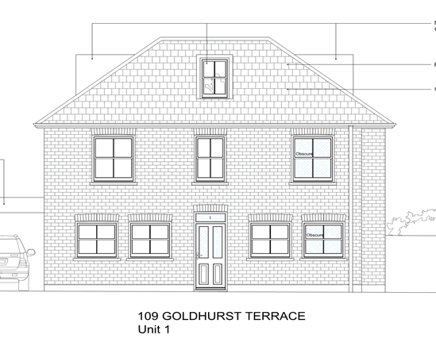

Appeal proposal

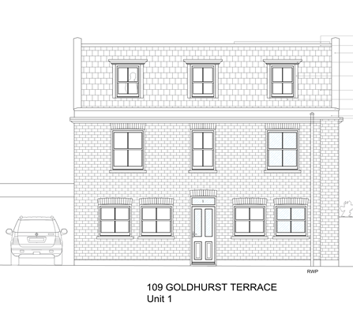

3.2.2.6 As mentioned within the officer’s report, the development fails to comply with the South Hampstead Conservation Appraisal because the design of the proposed dormer does not demonstrate careful and sensitive design taking into account the original building. The proposed dormer would be seen from the rear views of other neighbouring gardens to all sides of the dwelling within this Conservation Area. When viewed from those directions it would appear large and out of keeping with the character of the property. The result would be an increased visual bulk to the roof, a development that draws attention from existing roof slope and a roof development that is not subordinate to the host building. It must be emphasised again that it can be seen from many Fairfax Place to the east as well, some would be extremely close within 5-7 metres away from this site. It is considered harmful to the appearance not only of the host property but to the character and appearance of the South Hampstead Conservation Area as well. Therefore the proposals would not preserve or enhance the character of the host building or the Conservation Area and is unacceptable.

3.2.8 It should be noted that there have been similar recently refused applications for dormers on this road on bulk, scale, siting and design grounds within appendix 2 attached.

**4.0 Summary**

4.1 To conclude, it is considered that the appeal proposals do not comply with Camden policies CS14, DP24 and DP25, Camden Planning Guidance 1 and would neither preserve nor enhance the character and appearance of the South Hampstead Conservation Area, thereby causing harm to this designated heritage asset. This harm is considered to be less than substantial under paragraph 134 of the NPPF, which requires this harm to be ‘*weighed against the public benefits of the proposal, including securing its optimum viable use’.* It is considered that the proposed development would not result in public benefits that would outweigh the harm caused to the conservation area by its inappropriate bulk, scale, mass and detailed design.

**4.0 Other Matters**

4.1 On the basis of information available and having regard to the entirety of the Council’s submissions, including the content of this letter, the Inspector is respectfully requested to dismiss the appeal.

4.2 In the event of the appeal being allowed the conditions suggested in appendix 1 should be attached.

4.3 If any further clarification of the appeal submissions is required please do not hesitate to contact Raymond Yeung on the above direct dial number or email address.

**Yours sincerely**

**Raymond Yeung**

**Planning officer**

**Culture and Environment Directorate**

**Appendix 1**

Conditions

1. The development hereby permitted must be begun not later than the end of three years from the date of this permission.

Reason: In order to comply with the provisions of Section 91 of the Town and Country Planning Act 1990 (as amended).

1. The development hereby permitted shall be carried out in accordance with the following approved plans:

PR-LF_RF, PR-Sections, PR-Elevations, Design and Access Statement, Location Plan.

1. All new external work shall be carried out in materials that resemble, as closely as

possible, in colour and texture those of the existing building, unless otherwise

specified in the approved application.

Reason: To safeguard the appearance of the premises and the character of the

immediate area in accordance with the requirements of policy CS14 of the London

Borough of Camden Local Development Framework Core Strategy and policy

DP24 and DP25 of the London Borough of Camden Local Development

Framework Development Policies.

**Appendix 2**

**Planning History**

**Ref: 2014/7879/P - 24 Goldhurst Terrace - Erection of rear dormer to create 1 x bedroom one person unit.–Refused 21/04/2015**

Refusal reason:

*The proposed rear dormer, by virtue of its siting, scale, bulk and design would be an unsympathetic and harmful addition to the existing building and row of terraces of which it is a part and would fail to preserve the character and appearance of the South Hampstead Conservation Area contrary to policies CS14 of the Local Development Framework Core Strategy (2010) and, DP24 and DP25 of the Local Development Framework Development Policies (2010).*

**Appeal Dismissed dated 30/06/2015 - Ref: APP/X5210/W/15/3035830**

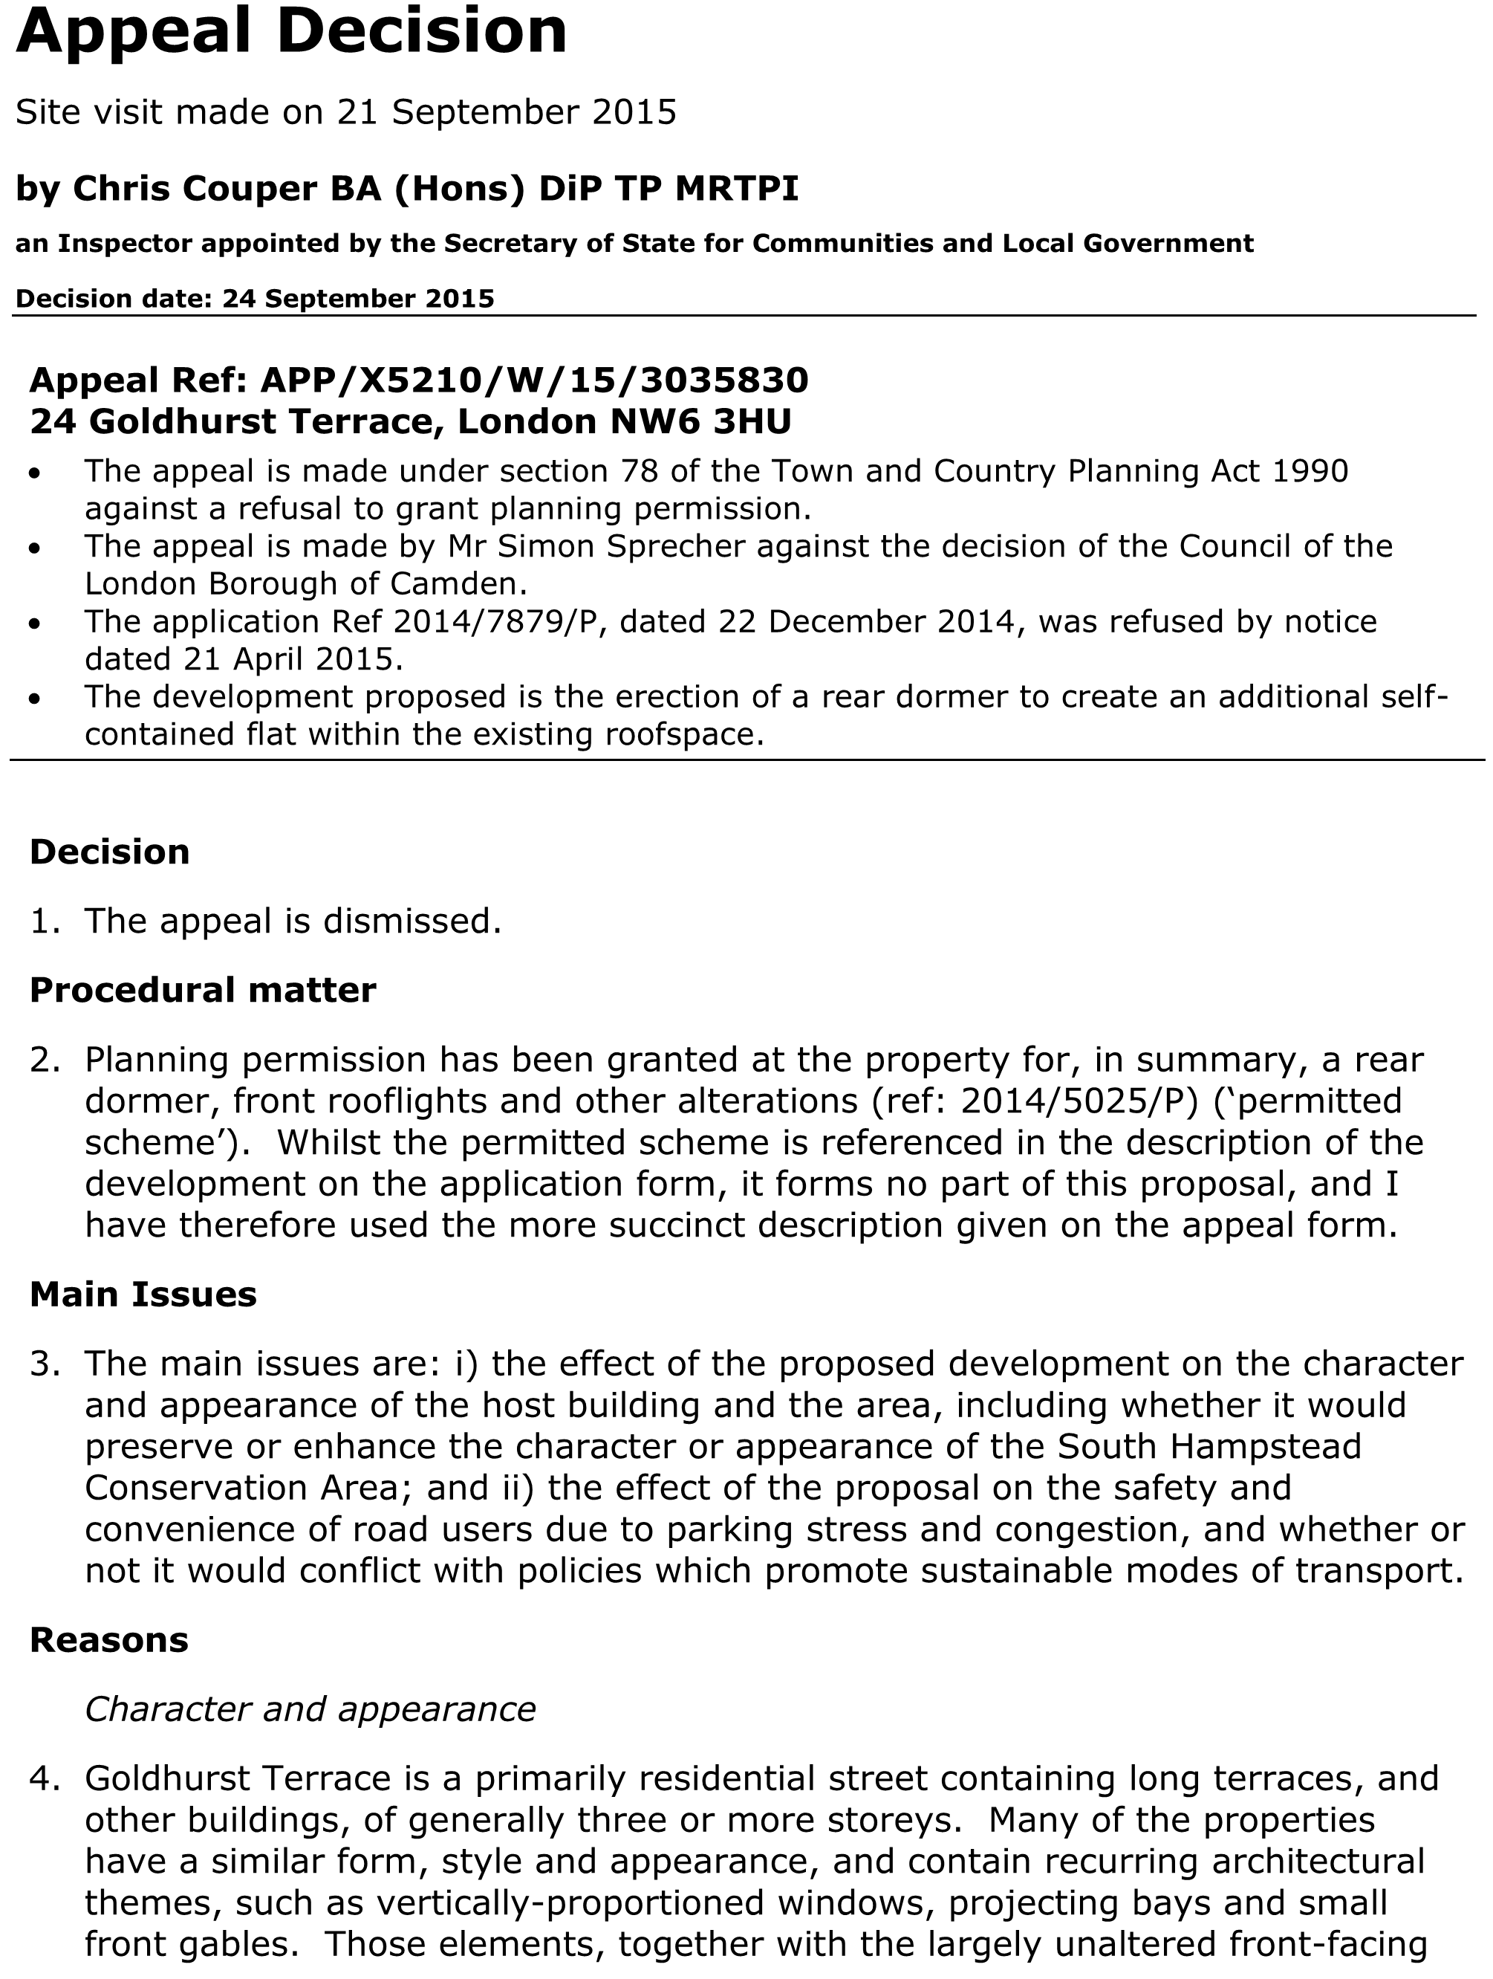

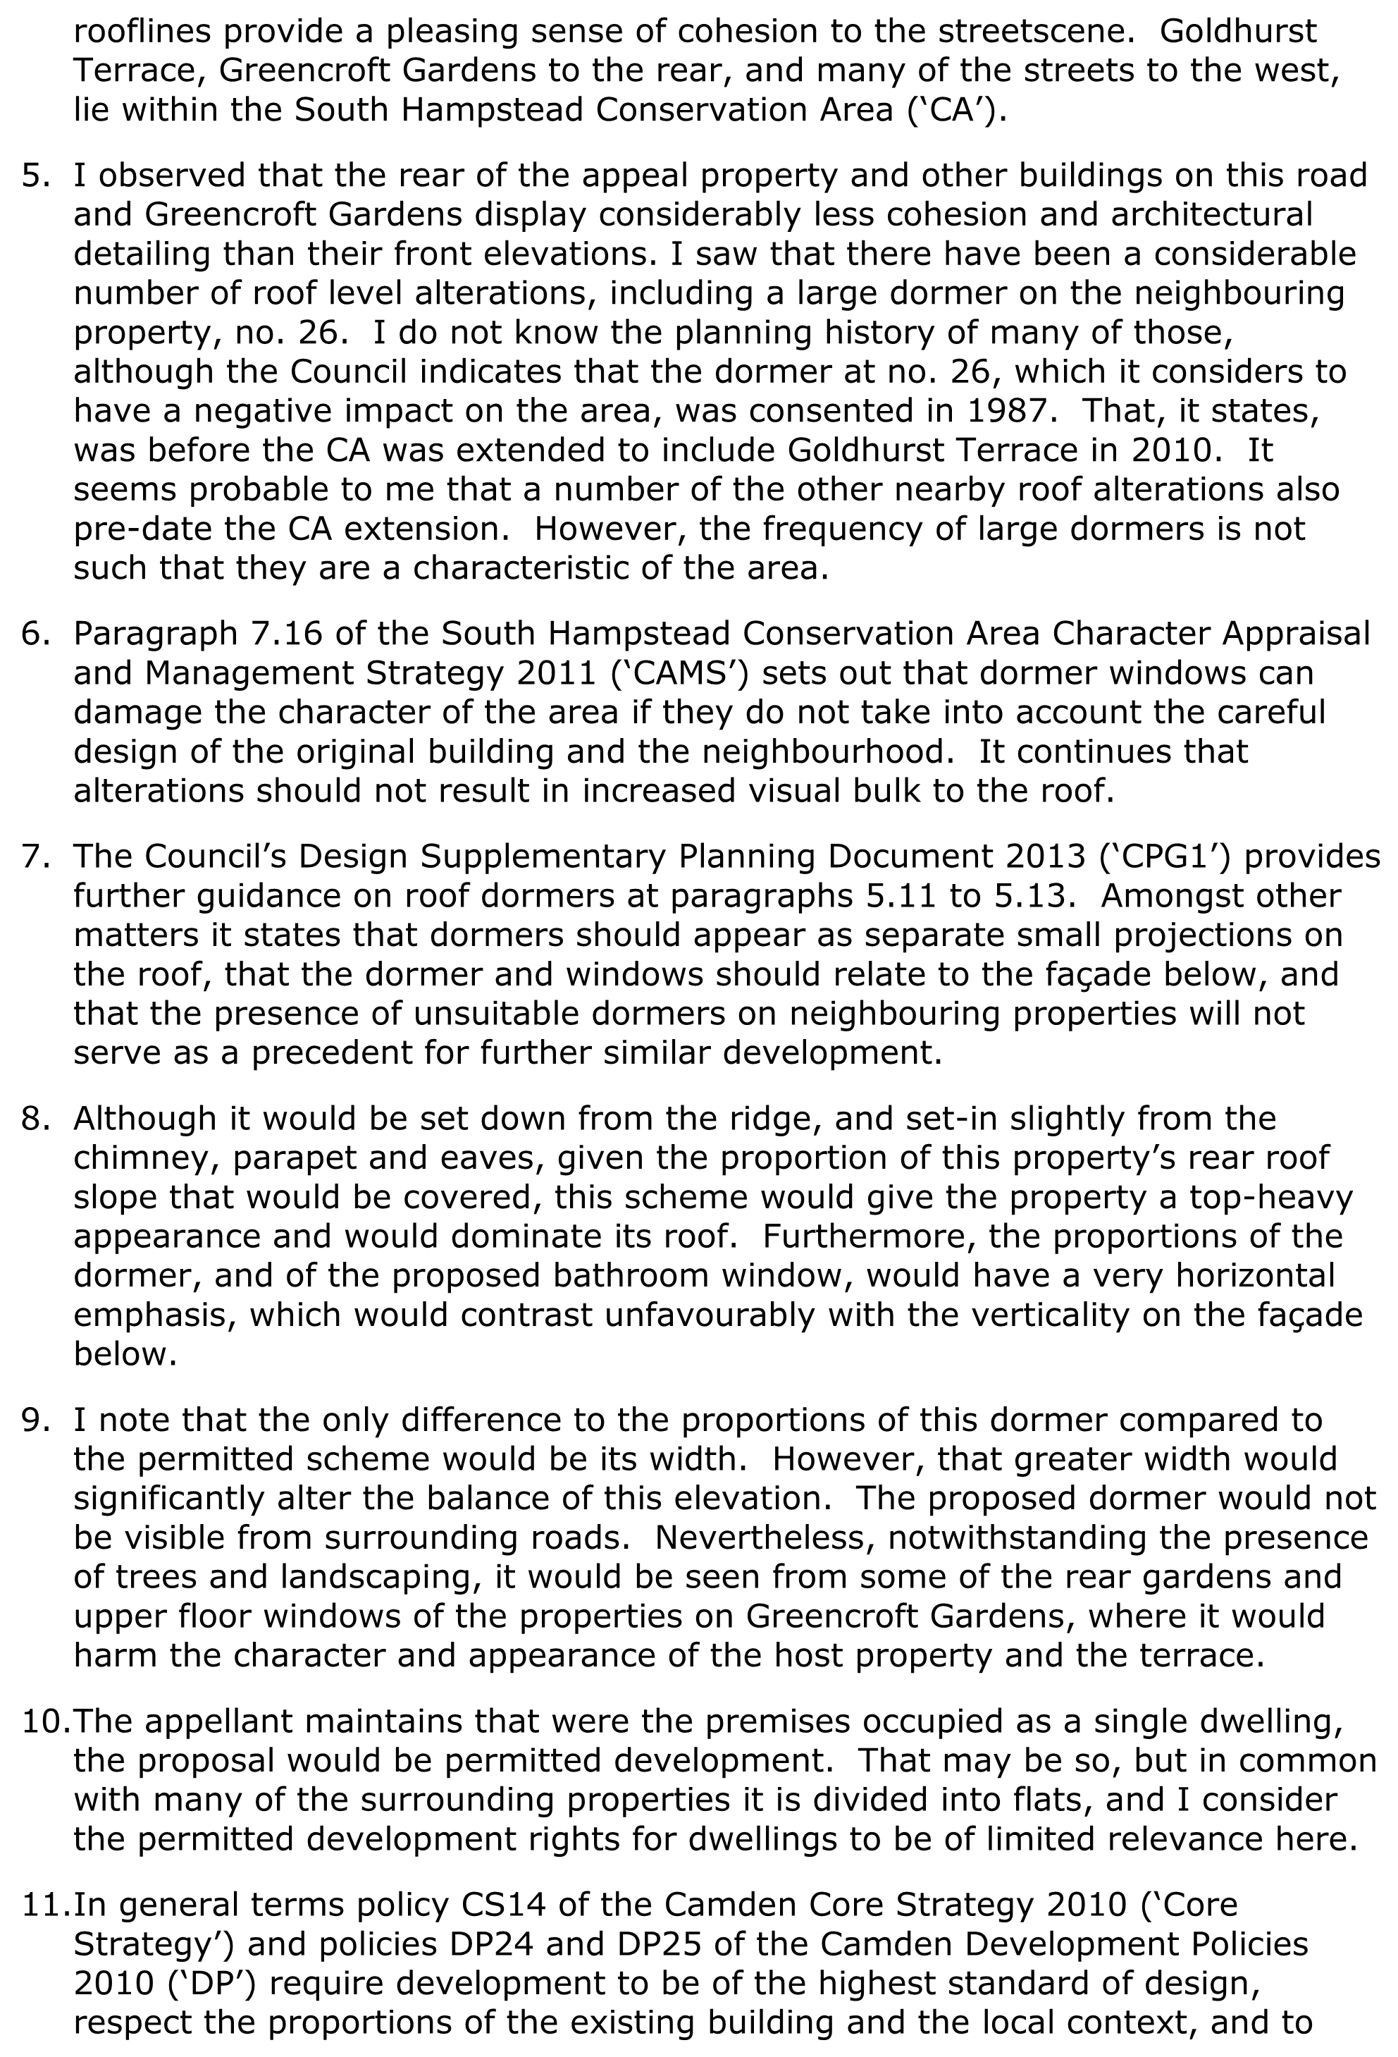

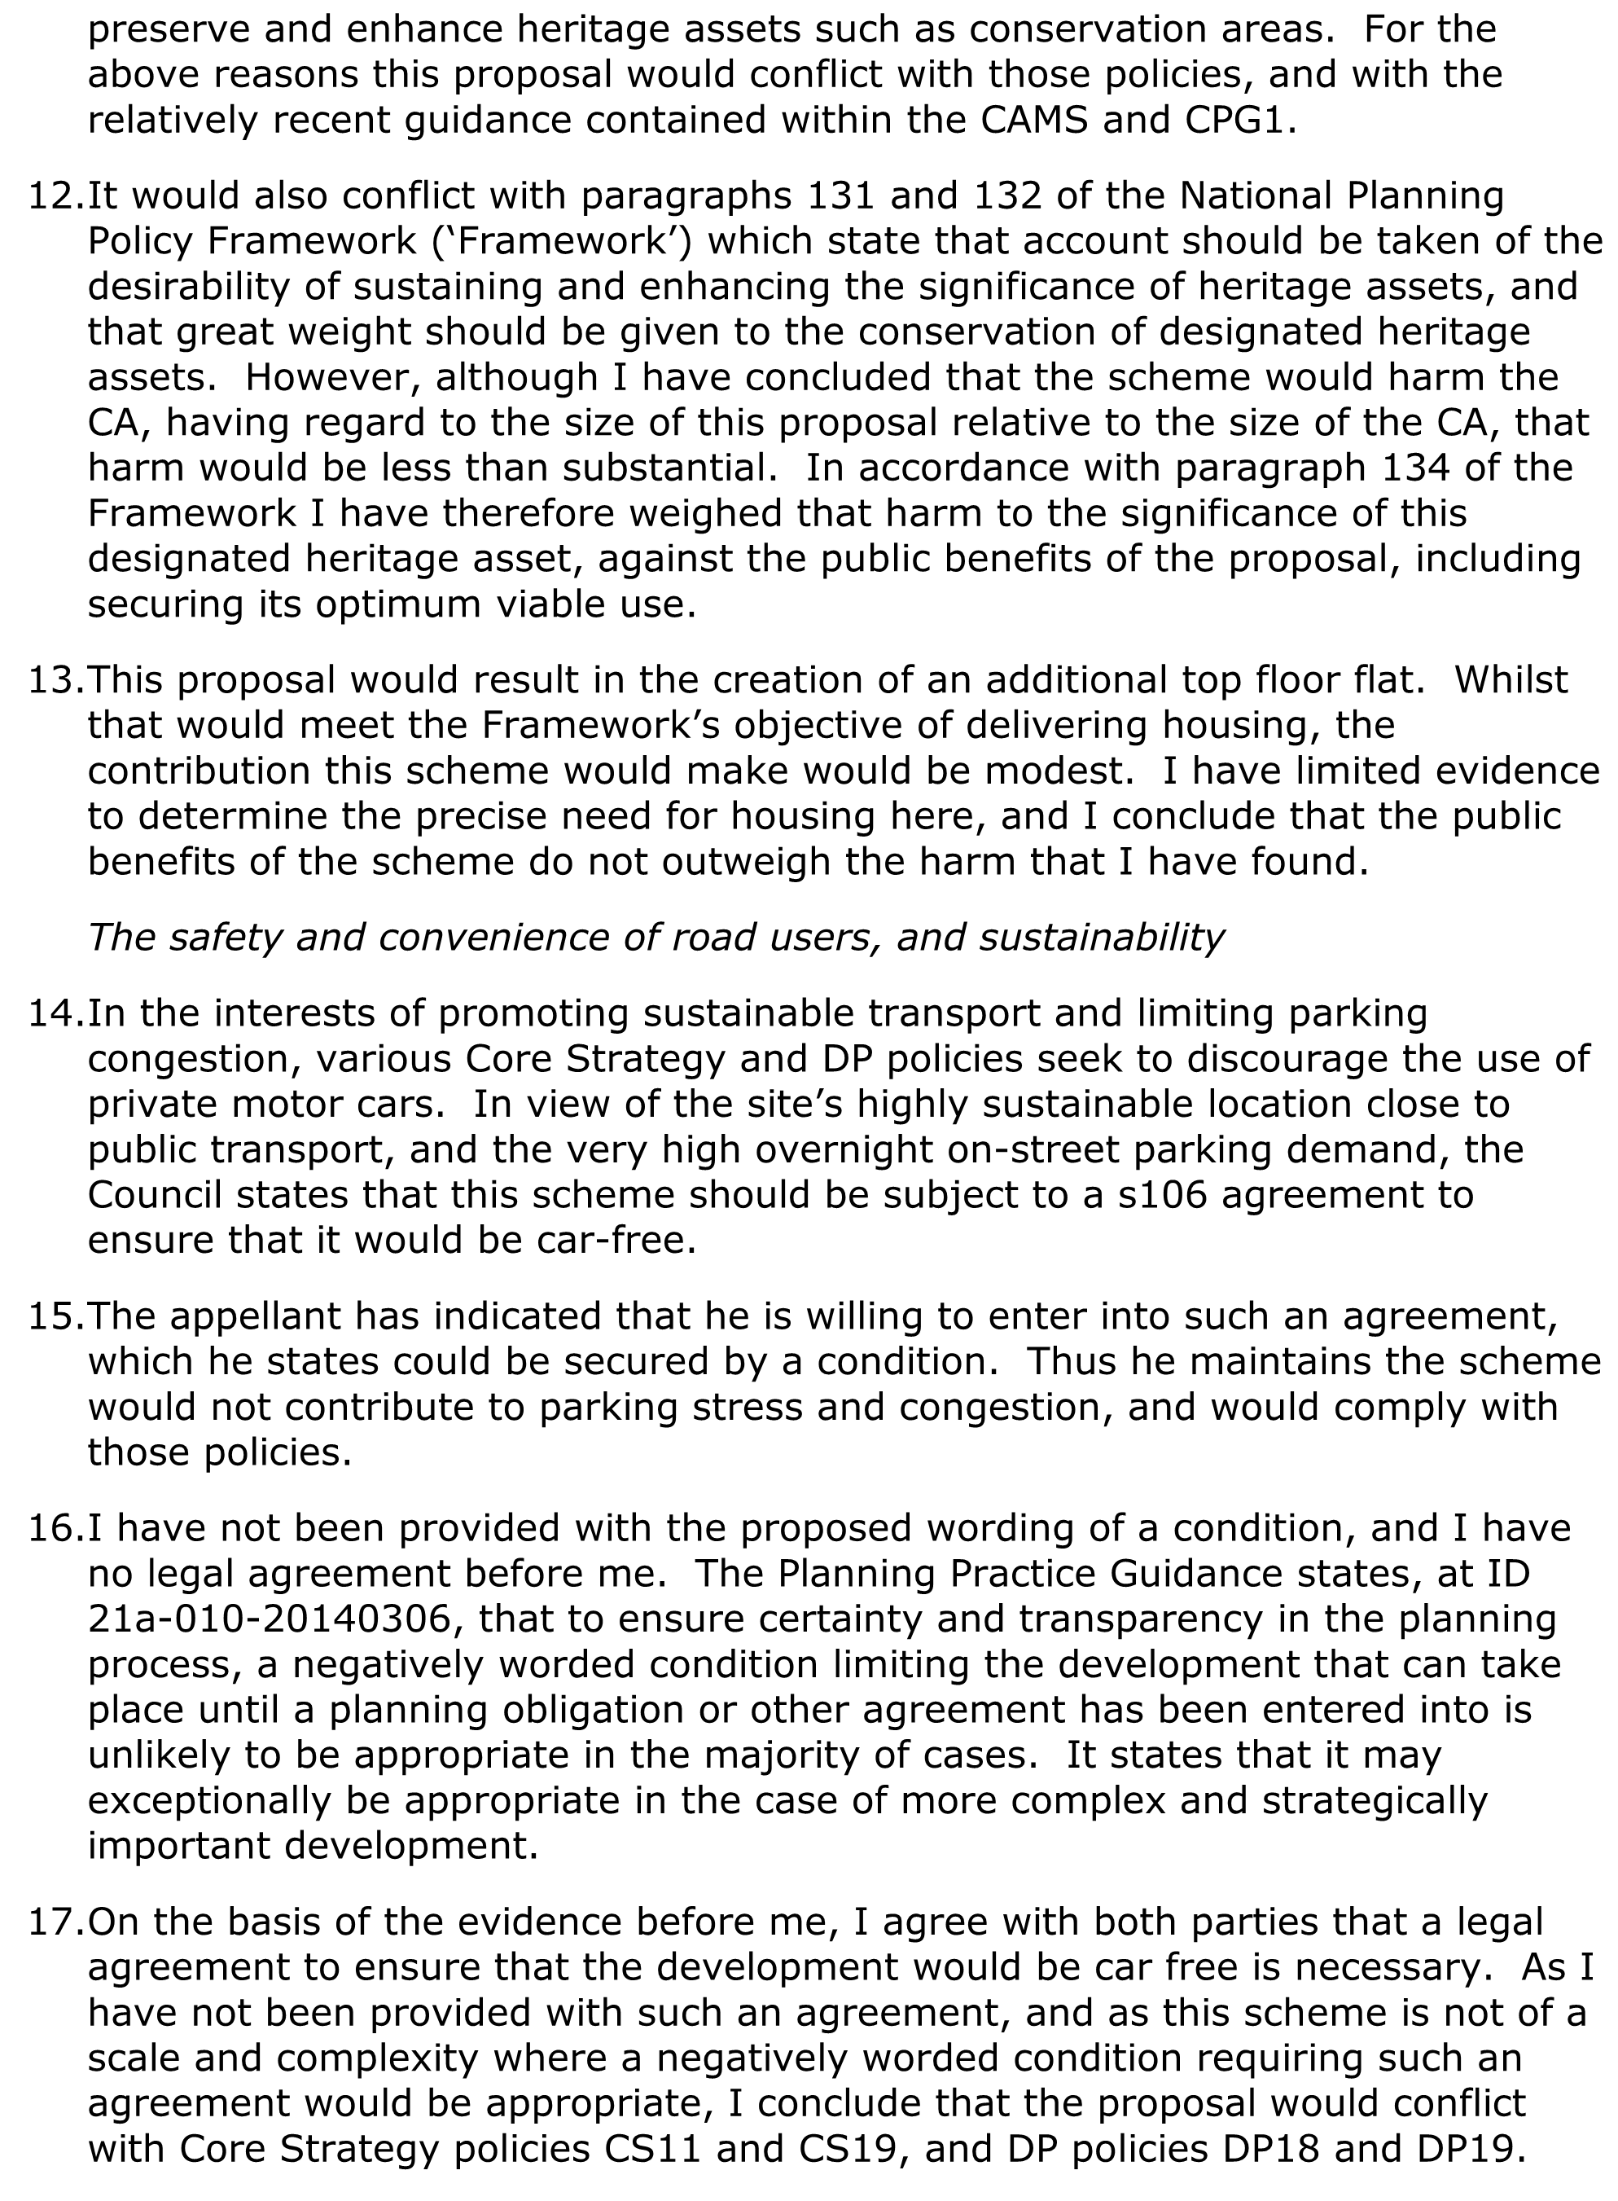

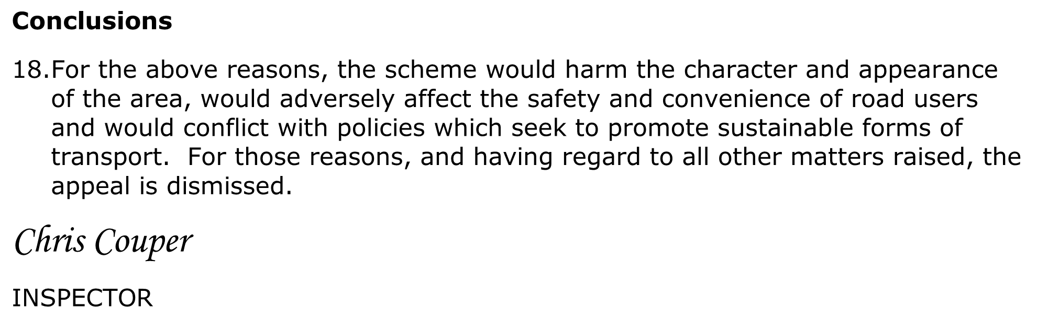

**Ref: 2014/3922/P - Flat 3, 140 Goldhurst Terrace - Erection of a rear roof extension at second floor level to create large dormer window with balcony to existing top floor flat (class C3). –Refused 14/08/2014**

Refusal reason:

*The proposed rear dormer, by virtue of its siting, scale, bulk and design would be an unsympathetic and harmful addition to the existing building, would fail to preserve the character and appearance of the South Hampstead Conservation Area or the scale, proportions and massing of the host building contrary to policies CS14 of the Local Development Framework Core Strategy(2010) and, DP24 and DP25 of the Local Development Framework Development Policies (2010).*

**Ref: 2009/4646/P - Flat 3, 47 Goldhurst Terrace - Erection of a roof extension , including a dormer to rear, roof lights to the front and the conversion of the roof from hipped to gable (Class C3). – Refused 11/02/2010**

Refusal reason:

The proposed roof extension by reason of its size, bulk and detailed design is considered to be detrimental to the character and appearance of the original building and the conservation area, contrary to the provisions of policies B1 (General design Principles), B3 (alterations and Extensions) and B7 (Conservation Areas) of the London Borough of Camden Replacement Unitary Development Plan 2006 and advice contained within Camden Planning Guidance 2006.

**Ref: 2009/5353/P - 201 Goldhurst Terrace - Erection of two dormer windows to rear roof slope of a dwelling house (Class C3). – Refused 13/01/2010**

Refusal reason:

*The proposed dormer windows, by reason of their location, size and bulk, would appear as incongruous and obtrusive additions to the existing roof profile which would unbalance the architectural composition of the building and the terrace as a whole, which currently has a largely unaltered roofline at this level. The proposal would therefore have a detrimental impact of the appearance and character of the building and fail to preserve or enhance the character and appearance of the conservation area, contrary to policies B1 (General Design Principles), and B3 (Alterations and Extensions) and B7 (Conservation Areas) of the London Borough of Camden Replacement Unitary Development Plan 2006.*