Stephen Levrant
Heritage Architecture Ltd
62 British Grove
Chiswick
London
W4 2NL
62 British Grove  Chiswick  London  W4 2NL |  | Application Ref: 2016/0146/L
 |  | Please ask for: Antonia Powell
 |  | Telephone: 020 7974 2648
 |  | 12 July 2016

Dear Sir/Madam

DECISION

Planning (Listed Building and Conservation Areas) Act 1990

Listed Building Consent Granted

Address:
41 Chester Terrace
London
NW1 4ND

Proposal:
Installation of secondary glazing to the west, south and partially the north elevation windows.
Drawing Nos:
LP-01 Site Location Plan
SP-01 Block Plan
1 X Photographic sheet of site mock up
DS-225-AC-Detailed sections
Secondary glazing technical information series 25
421_AA_6_68 Secondary glazing typical details
PL_1_02 rev A; 03 rev A; 04 rev A; 05 rev A
Design and Access/Heritage Statement by Stephen Levrant Heritage Architecture Ltd. dated Jan 2016

The Council has considered your application and decided to grant Listed Building Consent subject to the following condition(s):

Conditions And Reasons:

1 | The works hereby permitted shall be begun not later than the end of three years from the date of this consent.  Reason: In order to comply with the provisions of Section 18 of the Planning (Listed Buildings and Conservation Areas) Act 1990.
2 | All new external and internal works and finishes and works of making good to the retained fabric, shall match the existing adjacent work with regard to the methods used and to material, colour, texture and profile, unless shown otherwise on the drawings or other documentation hereby approved or required by any condition(s) attached to this consent.  Reason: In order to safeguard the special architectural and historic interest of the building in accordance with the requirements of policy CS14 of the London Borough of Camden Local Development Framework Core Strategy and policy DP25 of the London Borough of Camden Local Development Framework Development Policies.
3 | The works hereby approved are only those specifically indicated on the drawing(s) referred to above.  Reason: In order to safeguard the special architectural and historic interest of the building in accordance with the requirements of policy CS14 of the London Borough of Camden Local Development Framework Core Strategy and policy DP25 of the London Borough of Camden Local Development Framework Development Policies.

Informative(s):

This application concerns works to the windows of this Grade I building designed by John Nash. The works include the repair and overhaul of windows of historic interest, the replacement of some early sashes in poor repair and the replacement of modern sashes with new to match historic design and profile. In addition the application involves the installation of secondary glazing to reduce the levels of heat loss and traffic noise.

On the ground and first floor later shutter boxes will be replaced with new shutter boxes designed to avoid any impact on the retained historic joinery and to ensure the secondary glazing is as discreet as possible.

On the upper floors, where no shutter boxes have existed, the secondary glazing is to be installed within the window reveals.

Public consultation was undertaken by placement of a press notice and site notice, whereby no responses were received. Historic England responded with a letter of flexible authorisation duly stamped and signed by the National Planning Casework Unit.

The site's planning history was taken into account when coming to this decision. A previous scheme was granted Listed Building Consent in May 2015 (ref: 2015/0938/L) for the repair and restoration of the windows. For that application a detailed condition/significance survey of all the windows was submitted as was subsequently included as part of the approved documents.

Special regard has been attached to the desirability of preserving the listed building and its features of special architectural or historic interest, under s.16 of the Listed Buildings and Conservation Areas Act 1990 as amended by the Enterprise and Regulatory Reform Act (ERR) 2013.

As such, the proposal is in general accordance with policy CS14 of the London Borough of Camden Local Development Framework Core Strategy, and policy DP25 of the London Borough of Camden Local Development Framework Development Policies. The proposed development also accords with policy 7.8 of the London Plan 2011, and paragraphs 14, 17 and 126-141 of the National Planning Policy Framework.

The application is therefore granted approval.

You can find advice about your rights of appeal at:

http://www.planningportal.gov.uk/planning/appeals/guidance/guidancecontent

Yours faithfully
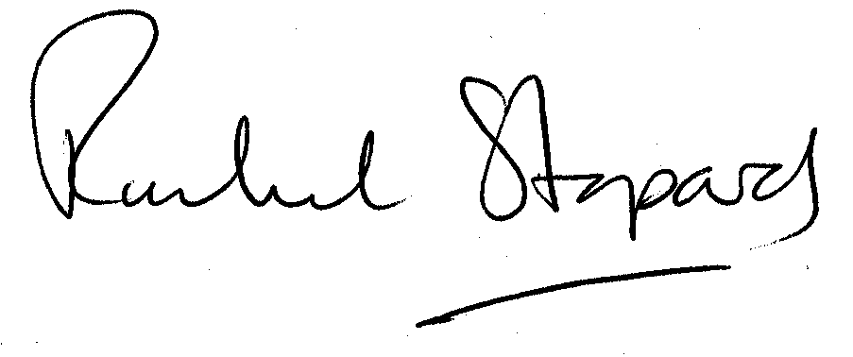
Rachel Stopard
Executive Director Supporting Communities

