Mr Stephen Levrant
Heritage Architecture Ltd
62 British Grove
Chiswick
London
W4 2NL
62 British Grove  Chiswick  London  W4 2NL |  | Application Ref: 2016/1592/L
 |  | Please ask for: Antonia Powell
 |  | Telephone: 020 7974 2648
 |  | 2 August 2016

Dear Sir/Madam

DECISION

Planning (Listed Building and Conservation Areas) Act 1990

Approval of Details (Listed Building) Granted

Address:
41& 42 Chester Terrace
London
NW1 4ND

Proposal:
Details of details as required by conditions 4 a) b) & e) of Listed Building consent granted on 12/06/2013 (reference: 2013/1888/L for the excavation of vaults at basement level and other internal and external alterations in connection with the conversion of two houses to form a single family dwelling.)
Drawing Nos:
Supporting Statement to discharge condition 4 a), b) and e) of LBC 2013/1888/L dated March 2016 by Stephen Levrant Heritage Architecture Ltd;
and drawings nos. Cornices HB -1 to14; Plaster Mouldings HB 15 to 17; Skirtings HB 18; Doors, architraves and panel moulding HB 19 to 26; Windows, architraves and shutters HB 27 to 31 and Stair Balustrade HB 32.

The Council has considered your application and decided to grant Approval of Details (Listed Building) subject to the following condition(s):

Conditions And Reasons:

Informative(s):

Reasons for granting approval of details (listed building):

Condition 4 a), b) and e) (LBC 2013/1888/L) requires the following:
"Detailed drawings, or samples of materials as appropriate, in respect of the following, shall be submitted to and approved in writing by the local planning authority before the relevant part of the work is begun:
a) Typical details of new balustrades at a scale of 1:10 with finials at 1:1, including materials, finish and method of fixing into the plinth;
b) Plan, elevation and section drawings of all new joinery at a scale of 1:10 with typical moulding and architrave details at a scale of 1:1;
e) Details of new plaster work to landings at a scale of 1:10;"

The submitted details are considered satisfactory to discharge the relevant part of condition 4 (LBC 2013/1888/L) and this application is therefore granted.

The site's planning history was taken into account when coming to this decision. No objections were received as a result of public consultation. Historic England responded with a letter of flexible authorisation.

Special regard has been attached to the desirability of preserving the listed building and its features of special architectural or historic interest, under s.16 of the Listed Buildings and Conservation Areas Act 1990 as amended by the Enterprise and Regulatory Reform Act (ERR) 2013.

As such, the proposal is in general accordance with policy CS14 of the London Borough of Camden Local Development Framework Core Strategy, and policy DP25 of the London Borough of Camden Local Development Framework Development Policies. The proposed development also accords with policy 7.8 of The London Plan 2015 consolidated with alterations since 2011, and paragraphs 14, 17 and 126-141 of the National Planning Policy Framework.

Please be advised that all conditions relating to LBC 2013/188/L, which require details to be submitted to and approved in writing by the council as local planning authority, have been discharged.

You can find advice about your rights of appeal at:

http://www.planningportal.gov.uk/planning/appeals/guidance/guidancecontent

Yours faithfully
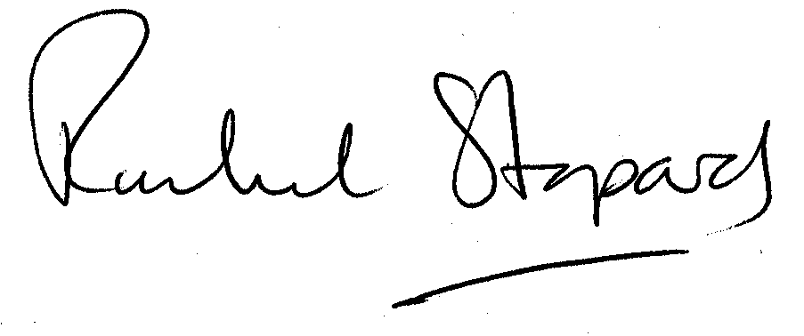
Rachel Stopard
Executive Director Supporting Communities

