Delegated Report |  |  | Analysis sheet |  |  |  |  |  | Expiry Date: |  |  | 05/09/2016
 |  |  | N/A / attached |  |  |  |  |  | Consultation Expiry Date: |  |  | 11/08/2016
Officer |  |  |  |  |  |  | Application Number(s)
Robert Lester |  |  |  |  |  |  | 2016/3309/P
Application Address |  |  |  |  |  |  | Drawing Numbers
1 Gayton Crescent  London  NW3 1TT |  |  |  |  |  |  | 1533 L 115 A, 1533 L 140 A, 1533 L 141A, 1533 L 145A, 1533 L 134 A, Front Railings Photo, Fence Layout Plan.
PO 3/4 | Area Team Signature |  |  | C&UD |  |  | Authorised Officer Signature

Proposal(s)
Construction of a rear dormer roof extension, front wall with metal railings and decorative lions adjacent to ground floor entrance (part retrospective application).
Recommendation(s): |  | Refused and Warning of Enforcement Action to be Taken
Application Type: |  | Householder Application
Conditions or Reasons for Refusal: |  | Refer to Draft Decision Notice

Informatives:

Consultations
Adjoining Occupiers: |  | No. notified |  |  | 33 | No. of responses  No. electronic |  |  |  | 01  00 | No. of objections |  | 01
Summary of consultation responses: |  | - The statues would be out of character.  - Insufficient detail on boundary fencing. Sympathetic metal rails would be acceptable.  Case Officer’s Response:  - The statues are minor garden structures.  - The front boundary railings would be acceptable.
CAAC/Local groups* comments:  *Please Specify |  | Heath and Hampstead Society Objection:  - The plans are inadequate and do not show the dormer which has been built on the site.  - The dormer is visible from the street and should be refused  Case Officer’s Response:  - Agreed. The submitted plans do not correlate with the dormer which has been constructed on the site which is much larger.  - The dormer window due to its excessive width, its fascia design, eaves design, alignment and proximity to the sides and pitch of the roof, is considered to be an overly bulky and over-dominant structure with an unsympathetic design that detracts from the character of the Conservation Area contrary to Camden Core Strategy Policy CS14, Camden Development Policies DP24 & DP25, Camden Planning Guidance 1 and the Hampstead Conservation Area Statement.

Site Description
The site is located at no. 1 Ayton Crescent, Hampstead and contains a 3 storey Victorian dwellinghouse. The site is located close to the junction with Gayton Road.

The site is located within the Hampstead Conservation Area and is identified as making a positive contribution to the character of the conservation area.

Relevant History
- 2015/7029/P - Erection of single storey rear extension at lower ground level with enlarged terrace and glazed balustrade above - Granted - 17/02/2016
- 2015/6107/P - Erection of dormer to rear slope to provide additional habitable space Withdrawn.
- EN16/0079 – Enforcement Investigation - Rear dormer roof extension (pending)

Relevant policies
LDF Core Strategy 2010-2025

CS14 – Promoting high quality places and conserving our heritage

Development Policies 2010-2025

DP24 – Securing high quality design
DP25 – Conserving Camden’s Heritage
DP26 – Managing the impact of development on occupiers and neighbours

Camden Planning Guidance 1 Design
Camden Planning Guidance 6 Amenity

Hampstead Conservation Area Statement (2001)

The London Plan (2016)

The NPPF (2012)

Assessment
This planning application is for a rear dormer roof extension which has been built on the site and proposed front boundary railings and decorative statues to be located on either side of the front raised steps.
The dormer extension which has been built on the site is located on the rear roof slope. The submitted plans do not accurately show the extension which has been constructed. These plans show a narrow dormer measuring 2.5 m width by 3.5 m height with a narrow fascia surround. The dormer which has been constructed on the site (as shown on the photo in appendix 1) is a higher and wider structure which extends to the party wall with no. 2 Gayton Crescent and up to the roof pitch. The as-built dormer also has a wider fascia surround with hanging tiles and prominent overhanging eaves. The submitted plans for this application are therefore not accurate.
The proposed front boundary railings would be mounted between the existing brick piers on the front boundary of the site.
The decorative statutes would be located on the raised staircase on either side of the access steps.
The main issues on this application are an assessment of the design and visual impact of the proposed dormer window and boundary railings and the amenity impact. The decorative statues in the front garden would be minor garden structures.
Design and Visual Impact
This dwelling has a shallow pitched hipped roof with an older small side turret dormer. The neighbouring properties at no’s 1-4 Gayton Crescent do not have dormer windows. The properties at no’s 5-7 Gayton Crescent have smaller dormer windows at the rear. Many of the properties on the adjacent Gayton Road have front dormer windows which were built in the post-war period.
Policy DP24 requires all development to be of the highest standard of design and requires consideration of the character, setting, context and the form and scale of neighbouring buildings and the character and proportions of the existing building. Policy DP26 only permits development within conservation areas that preserves and enhances the character and appearance of the area.
CPG 1 provides design guidance and requires dormer windows to be sensitive changes which maintain the structure of the roof by being set 0.5 m away from the roof pitch and eaves; full width dormers are discouraged; the scale, design and alignment of the dormer should relate to the windows below
The Hampstead Conservation Area Appraisal states that roof extensions are unlikely to be acceptable where it would be detrimental to the form and character of the existing building, the property forms part of a group or terrace which remains largely, but not necessarily completely unimpaired and the property forms part of a symmetrical composition, the balance of which would be upset.
The rear dormer window fails to adhere to these development plan policies and guidance. The dormer is a wide structure which extends up to the party wall with no. 2 at the side and up close to pitch level. The dormer also has a wide and bulky fascia with hanging tiles and prominent overhanging eaves. It fails to relate to the scale and alignment of the windows on the elevation below and disrupts a largely unimpaired roofscape on this terrace.

It is noted that there are dormer windows further along Gayton Crescent. However, these are more modest structures. The front dormers on Gayton Road built in the post war period are referenced in the Conservation Area Statement. However, this property is on Gayton Crescent which is a separate road that does not have the same character.

Overall, the dormer window due to its excessive width, its fascia design, eaves design, alignment and proximity to the sides and pitch of the roof, is considered to be an overly bulky and over-dominant structure with an unsympathetic design that detracts from the character of the Conservation Area and is contrary to Camden Core Strategy Policy CS14, Camden Development Policies DP24 & DP25, Camden Planning Guidance 1 and the Hampstead Conservation Area Statement.
The front metal boundary railings would be located and lower than the existing brick piers and would be in keeping with the character of the street scene.
Amenity Impact
The dormer window is constructed on the rear roofslope and would not impact on the amenity of neighbouring properties in accordance with policy DP26.
Recommendation:
Refused and Warning of Enforcement Action to be Taken
That the Head of Legal Services be instructed to issue an Enforcement Notice under Section 172 of the Town & Country Planning Act 1990 as amended to secure the removal of the rear dormer roof extension and the reinstatement of the roof, and to pursue any legal action necessary to secure compliance. Officers be authorised in the event of non-compliance to prosecute under section 179 or appropriate power and/or take direct action under 178 in order to secure the cessation of the breach of planning control.
The notice shall allege the following breaches of planning control: The erection of a rear dormer roof extension.

WHAT ARE YOU REQUIRED TO DO: Remove the rear dormer roof extension and replace with a pitched roof matching the original in design and materials.

PERIOD OF COMPLIANCE: 3 months
REASONS WHY THE COUNCIL CONSIDER IT EXPEDIENT TO ISSUE THE NOTICE:
The dormer window due to its excessive width, its fascia design, eaves design, alignment and proximity to the sides and pitch of the roof, is considered to be an overly bulky and over-dominant structure with an unsympathetic design that detracts from the character of the Conservation Area contrary to Camden Core Strategy Policy CS14, Camden Development Policies DP24 & DP25, Camden Planning Guidance 1 and the Hampstead Conservation Area Statement.

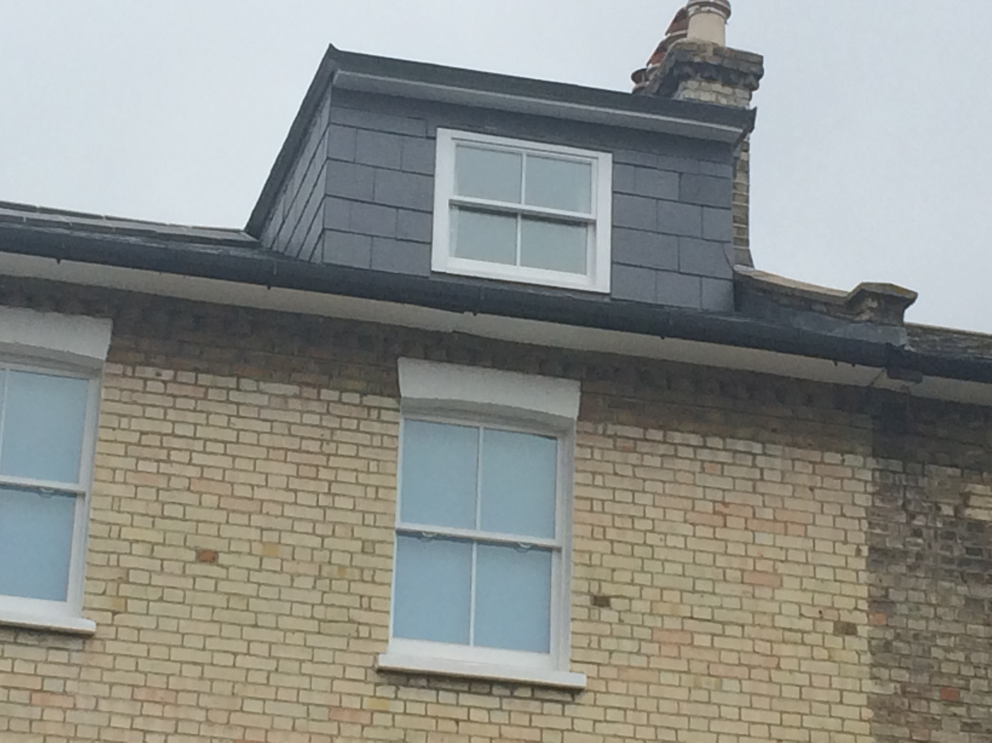
Photo: Appendix 1 – As built rear dormer on site

